How to find your Routing Number and Account Numbers

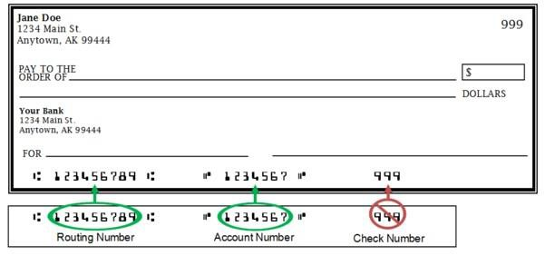
The routing number is always the first set of 9 digits on the bottom of your check starting from the left.
The account number is typically the second series of digits on the bottom of your check.

If you do not have a paper check, please contact your financial institution to find out what your account number is.

Many times, the routing numbers are made public on the financial institutions website. We have included a few examples here of common regional banks/credit unions in Alaska.

Alaska USA- 325272021
Credit Union 1- 325272063
Denali FCU- 325272047
Keybank- 125200879
Northrim Bank- 125200934
First National Bank AK- 125200060
Wells Fargo Alaska- 125200057

For many financial institutions Your routing number depends on where you open your account. Check to make sure which state you open your account number at.

This is meant to be a guide, for exact information please contact your financial institution directly.

