Skype Contacts Missing

If your Skype for Business contacts list is empty look for a yellow bar towards the top of the Skype for Business client that displays the following:

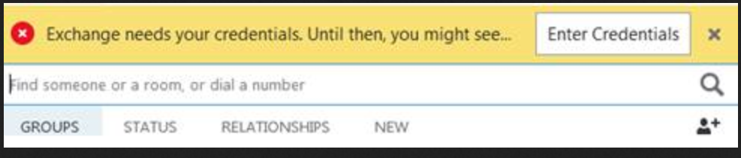

Click Enter Credentials

In the following window enter your username@alaska.edu address into the username box and enter your password. You may choose to select Save my password if you would like.

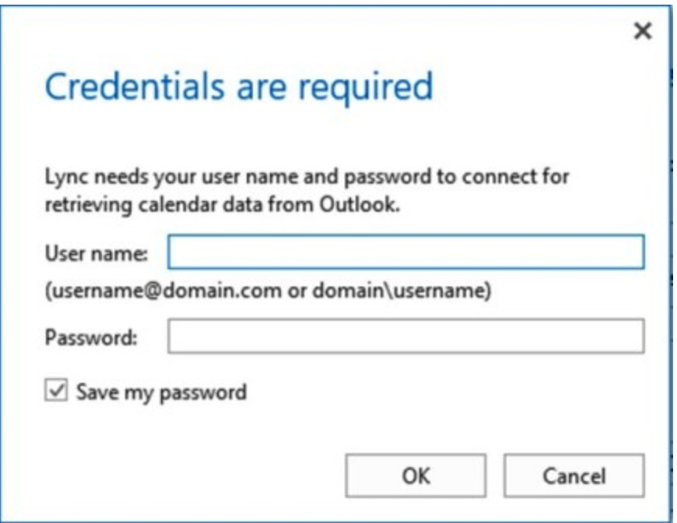

Hit ok and your contacts should show back up.

If that still doesn’t work, or you get the following message in the yellow banner bar that Skype for Business can’t connect to Exchange:

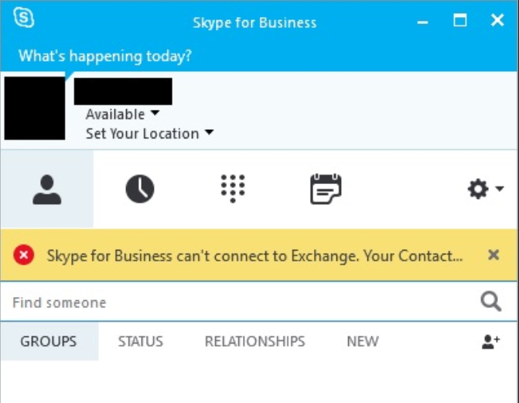

Follow the steps below for Windows Credential Manager to remove stored Skype for Business and Outlook login credentials.

Windows Credential Manager is a service on Windows 7, 8, and 10 that stores login credentials to allow Skype for Business and other services to login automatically at start up. This can sometimes cause problems logging in, so one of the first steps in troubleshooting failed logins in Windows should be removing those stored credentials from the vault.

To do that you first need to make sure you have fully exited the Skype for Business client. By right clicking on the skype icon in the bottom right corner and select exit from the menu.

• Go to the windows search and enter Credential Manager
• Click Credential Manager.
• In Windows 10 click on Windows Credentials, or for Windows 7 look in the Generic Credentials section.
• In the Windows Credentials and/or Generic Credentials section, remove any stored credentials referencing the Office 365 or ms.outlook email addresses:
- Click (Details).
- Click Remove from vault (Windows 7), or Remove (Windows 10).
- Click Yes on the warning box.
- Repeat these steps until you remove all of the credentials associated with your email address.
• Close the Control Panel window.
Reopen Skype and look for yellow banner with enter credentials button.

