 | Fall 2013 IDEA Response Rates for KPC*
 | Online classes** | Face-to-face Classes***
 | (digital IDEA surveys) | (paper IDEA surveys)
Count (n) | 124 | 143
Average Percent Response | 30.6% | 74.4%
Median Response Rate | 29% | 76%
Stnd deviation of Response Rate | 14.464 | 18.802
High Response Rate | 78% | 100%
Low Response Rate | 9% | 22%

*KPC includes two campuses: Kenai River Campus (Soldotna) and Kachemak Bay Campus (Homer) and two extended sites (Anchorage and Seward). This pilot was done across all of KPC. KPC provided surveys for all classes, not just those with 10 or more enrolled.

**Note that students in online classes are used to using Blackboard. In the final report, I will compare this pilot year data to the previous academic year, as I expect digital surveys in face-to-face classes had even lower response rates than seen in the digital surveys for KPC online classes.

***Note that seven paper FIFs were not filled out correctly by faculty therefore no response rate could be calculated. And five courses (all stacked) had too few students responding for data to be provided.

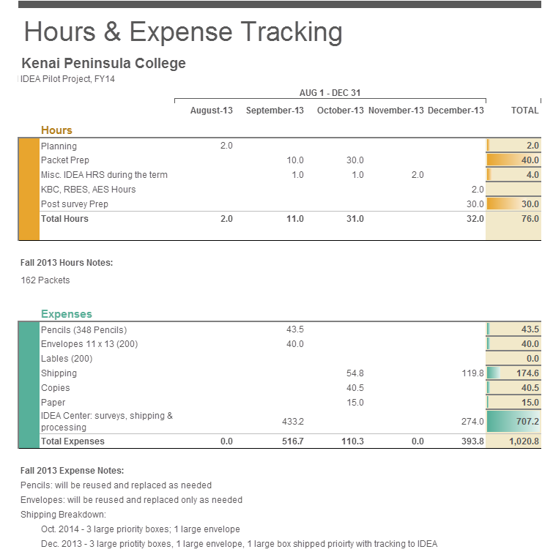

Additional information on Hours and Expense Tracking:

1. A packet was a combination of paper instructions, paper FIF, and paper IDEA surveys all within an envelope; each face-to-face section received one packet. A student returned the completed surveys in the packet envelope. We produced seven more packets than needed.
2. The IDEA Center costs are the marginal costs above the normal amount which UAA would spend on the digital IDEA surveys.

