UAA Curriculum Handbook
Table of Contents (Draft 10-18-17)

Section 1 – Introduction 3
1.1 Purpose of the Curriculum Handbook 3
1.2 Principles for Academic Review 3
1.3 Basis for Academic Board Review 3
1.4 Curriculum Review Board Evaluation Criteria 4
1.4.1 Review of course proposals 4
1.4.2 Review of program proposals 4
Section 2 - Curriculum Review Process for Courses 5
2.1 Overview 6
2.2 Review Process for Permanent Course 6
2.3 Minor Changes 7
2.4 General Education Requirements (GER) 8
2.4.1 General Education and General Course Requirements 8
2.4.2 Revision of or Request for GER Course 9
2.4.3 Revocation of General Education Requirement Designation and Deletion of a GER Course 10
2.5 Purge List 11
2.5.1 Non-GER Courses Purge List 11
2.5.2 GER Course Purge List 11
2.6 Curriculum Review Process for Noncredit (A001-A049), Continuing Education Unit (CEU) (AC001-AC049), Special Topic (-93s), Trial (-94s) and Professional Development (A500-A599) Courses 11
Section 3 - Curriculum Review Process for Programs 13
3.1 Overview 14
3.2 Program Review Process 14
3.3 Minor Changes 16
3.4 Program Student Learning Outcomes 16
3.5 Career Readiness Workforce Credential 17
3.6 Academic Program Suspension of Admissions or Deletion 17
Section 4 - Prefix Approval Process 19
4.1 Addition, Change or Inactivation of a Prefix 20
Section 5 - Policy Additions and Changes 21
Section 6 – Further Resources 22
Appendix A – Stacking Guidance 23
Appendix B – Number of Credits/CEUs and Contact Hours 25
Appendix C – Operations of UAB/GAB 27

Section 1 – Introduction

1.1 Purpose of the Curriculum Handbook
This Curriculum Handbook describes the University of Alaska Anchorage’s requirements for reviewing all curriculum. The Curriculum Handbook should be used in conjunction with Board of Regents academic policies and regulations (i.e., minimum number of credits required for a degree or certificate), academic policy in the UAA catalog (https://catalog.uaa.alaska.edu/academicpoliciesprocesses/), and accreditation requirements. The Curriculum Handbook is revised periodically to reflect policy and procedural changes.

1.2 Principles for Academic Review
- Excellence in teaching, learning, and research are at the core of the University of Alaska Anchorage (UAA) mission, goals and activities. The Undergraduate Academic Board (UAB) and the Graduate Academic Board (GAB) of the Faculty Senate are the principal peer review committees charged to initiate, develop, review and recommend curriculum and academic policies (see Appendix C for operational guidance for UAB/GAB).
- The academic boards are charged to identify areas for improvement, foster collaboration, and encourage an ethos of critical evaluation for all curriculum.
- The work of the academic boards, including the college curriculum committees, is part of the normal and continuous cycle of curricular planning, monitoring, and improvement. It is emphasized that although the curricular products of the faculty reviewed and approved by the board are useful for purposes of external review, they are primarily intended to promote and maintain excellence in teaching, learning, and research.

1.3 Basis for Academic Board Review
Academic board review is required for the following:
- New permanent courses or revisions to existing courses that will appear on the student’s transcript with academic credit.
- New degrees, program and certificates or revisions to existing degrees, programs and certificates.
- New academic policies or revisions to existing academic policies.
- Retaining any course that has not been offered at least once during the past 4 years (i.e., course on a purge list that the discipline informs the Undergraduate or Graduate Academic Board it intends to deliver. See section 2 for additional information).
- Major revision* to the academic content of a course or program such as
  - Additions, modifications or deletions of major subject areas.
  - Selection/admission procedures and standards related to academic programs and degrees.
  - Prerequisites, co-requisites, and registration restrictions.
  - Change in GER status.

*Major revisions are defined as anything that is not specified as a minor change. See section 2 for the definition of minor change.

1.4 Curriculum Review Board Evaluation Criteria
Curriculum additions and changes are reviewed for content, impact on other curriculum at the department, college, and university level, and formatting. Curriculum additions and changes are also reviewed for alignment with the mission, goals, and values of the department, college, and university

Curriculum additions and changes are reviewed de novo as described in this Curriculum Handbook. Previous approval of changes does not guarantee future approval, as policies and contexts change over time.

Although additional issues and questions may arise during the process, in general, college level and university level boards consider the following issues during curriculum review.

1.4.1 Review of course proposals
- Justification for the action
- Appropriate content, student learning outcomes, and evaluation methods
- College offering course is the appropriate academic unit
- Appropriate prerequisites for content and level
- Availability of prerequisites for course
- Frequency of scheduling of course
- Availability of resources including faculty, support staff, fiscal resources, facilities and equipment
- Justification for stacking or cross listing (see Appendix A for stacking guidance)
- Duplication of content in courses is explained
- Documented coordination with the affected departments
- Accreditation or nationally accepted practice standards
- Rationale for requiring this course in a program
- Credit hours (see Appendix B for credit hour guidance)
- Ensuring student learning outcomes are attainable wherever offered and however delivered (distance delivery, mixed delivery modality, multiple sections of the same course, across sites)
- Effect of course on other electives/selectives, including content and scheduling
- Enhancement of a program by this course

1.4.2 Review of program proposals
- Justification for the action
- Program characteristics, requirements and program student learning outcomes
- Availability of resources including faculty, support staff, fiscal resources, facilities and equipment
- Increase in specialization within the major
- Coordination with appropriate departments, colleges and community campuses.
- Impact on other affected UAA programs and courses
- Duplication of an existing program is addressed.
- Frequency of course offerings for new programs
- If a new prefix is requested, the prefix must be approved prior to developing the curriculum
- All courses used in the creation or modification of a degree or certificate program must be current or submitted for review simultaneously with the program proposal.

Section 2 - Curriculum Review Process for Courses
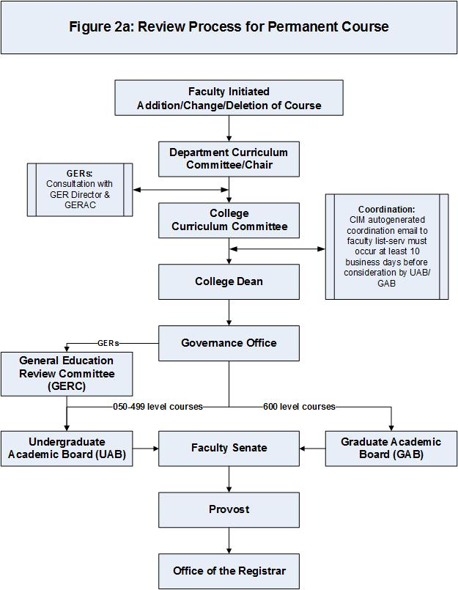

2.1 Overview
Curriculum development is a collegial process that begins with discussion at the discipline or program level and community campuses and expands to include all potentially interested stakeholders within the college, university, and community partners.

All courses follow the review process presented in this section. Any new, changed or deleted course, wherever initiated within UAA, requires approval through the Curriculum Inventory Management (CIM) system, except as noted in section 2.6. The CIM system can be accessed at: http://curric.uaa.alaska.edu/curriculum.php.

This review process is depicted in Figures 2a and 2b for specific types of courses.

Annual deadlines for completing the curriculum review process are listed on the curriculum website https://www.uaa.alaska.edu/academics/office-of-academic-affairs/curriculum/index.cshtml. Existing courses with changes may not be implemented for a term once registration for that term has opened. After appropriate reviews are complete, the course appears in the next catalog or schedule for which the publication deadline was met, unless a later implementation date has been approved.

2.2 Review Process for Permanent Course
- Faculty Initiation: New, changed, and deleted courses must be initiated by faculty (except adjunct faculty) as defined in the Faculty Senate Constitution. An adjunct faculty member who has expertise in the area may be consulted by the faculty initiator(s).

Review section 1.4 Curriculum Review Board Evaluation Criteria to prepare for the review process.

Note: Curriculum is returned to the faculty initiator within the CIM system following the college dean’s review (and following review by the General Education Review Committee, if applicable) to allow the faculty initiator to make revisions, as needed. The faculty initiator needs to “approve” the curriculum to advance the proposal to the next step in the CIM workflow.

- Department Curriculum Committee/Department Chair: Departmental review by the curriculum committee or department chair is required.

- GER Courses: Following approval at the department level, consultation with the GER Director and General Education Requirement Advisory Committee (GREAC) is required.

- College Curriculum Committee: Check with your college curriculum committee about their meeting schedule.

A coordination email is automatically generated by the system at the point at which the College Curriculum Committee chair completes the curriculum review. At least 10 business days must pass after the coordination email is generated before the program will be placed on the UAB/ GAB agenda to allow adequate time for notification of the UAA community.

Initiators should also consider—especially in the case of curriculum changes affecting other departments or colleges—sending out a direct coordination email to affected parties and the faculty listserv prior to the curriculum being submitted to their college curriculum committee.

- College Dean: This level of review is required prior to submission to the governance office.
Curriculum initiated at the community campuses must come up through the college, under which the program is listed in the catalog.
Note: If any curriculum for a credit-bearing course, program, or policy is submitted for processing and it has been disapproved at any level prior to UAB/GAB review, then that particular curricular action may be placed on the agenda of UAB/GAB for review and recommendation.

- Governance Office: The curriculum can be placed on the UAB/GAB agenda when it fulfills the 10-business day coordination e-mail requirement. Curriculum items needing UAB/GAB review must be in the Governance Office (UAB/GAB) queue by 9:00 a.m. Monday in order to be on the agenda for the Friday meeting of the same week.

- General Education Review Committee (GERC): GERs must be reviewed by the GERC prior to review by the UAB. This may be completed on the same day. GERC review will cover the items listed in section 2.4.

- Undergraduate Academic Board (UAB)/Graduate Academic Board (GAB): UAB and GAB meeting schedules are posted on the Governance website at the beginning of each academic year.

The initiating or representative tenure-track or term faculty member must present curriculum to UAB/GAB. Phone attendance is permitted. Representatives should be prepared to answer all relevant questions as described in section 1.4 of this handbook.

After the final reading by UAB/GAB, the initiating faculty member is responsible for the preparation of any necessary amendments to the text within the CIM system before UAA Faculty Senate takes action.

- Faculty Senate: Curricular actions at UAB and GAB are consolidated on to a consent agenda for faculty senate meetings that occur on the first Friday of each month September – May, except January.

10. Provost: The Provost provides the final approval for all curricular actions at UAA.

2.3 Minor Changes
Definition of a “minor change”: Minor change are defined as changes that do not substantially affect the intent or content of courses. Minor changes are reviewed up through the college curriculum committee. All changes, even minor changes, must be entered into the CIM system and the courses must be reviewed through UAB or GAB. For further assistance in determining whether a change is minor, consult with the UAB or GAB chair.

If the course has not been previously entered into CIM, all fields must be entered as in the existing approved course content guide (CCG). If entering the information from the CCG identifies additional changes that need to be made, the course proposal must go through the entire review process.

Minor changes include:
- Title change
- Course number change at the same level
- Grammatical change in course description
- Co-requisite or prerequisite changes that only affect the prefix department
- Fee change
- Course description change that does not change course intent (e.g., USSR to Russia, Word 2003 to Word 2010)
- Updating the bibliography

The initiating department is required to coordinate with all impacted departments. A coordination email is automatically generated by CIM at the point at which the college curriculum committee chair approves the curriculum.

Upon final approval by the college dean, courses with minor changes are forwarded to the Governance Office, the Office of Academic Affairs and the Office of the Registrar.

Minor changes are placed on the UAB/GAB agenda as informational items. Any UAB/GAB member may request that an information item be changed to an action item. No action can be taken on an action item until after it has been placed on the next meeting’s agenda. If there is no request to change the informational item to an action item, the Chair notes that it is a minor change and moves the change forward.

2.4 General Education Requirements (GER)
Overview: GER courses are subject to the same processes, guidelines, and procedures as permanent courses as described in the preceding sections of this chapter. Additional information, requirements, guidelines, and procedures are noted here.

2.4.1 General Education and General Course Requirements
The Associate of Arts degree program and programs at the baccalaureate level must comply with the UAA General Education Requirements specified for that program in the catalog. Associate of Applied Science degree programs and undergraduate certificate programs of 30 credits or more must have identifiable general education components in the areas of communication, computation and human relations. These components must be at the collegiate level, and their student learning outcomes must be assessed. The student learning outcomes of these general requirements may be met through specific courses or through activities embedded in the major requirements. If embedded, programs will be asked to identify the number and types of exercises used to fulfill these requirements and to describe their assessment methods.

General education courses tend to have broad subject matter. They are often taught by many different instructors on multiple campuses and/or through various modalities. In spite of this, instructors must ensure all relevant student learning outcomes are addressed and assessed, wherever offered and however delivered.

Faculty initiators should confer with the General Education Director and General Education Requirements Advisory Committee about the course prior to submission of the course (for addition OR revision) at the college-level of review.

All GER courses must have instructional goals and assessable student learning outcomes that are consistent with the current UAA catalog GER category descriptors and the appropriate GER Student Learning Outcomes. These are listed in the catalog under each category and within the CIM course template. All category outcomes and relevant GER Student Learning Outcomes should be addressed in the course (e.g. in course description, instructional goals, student learning outcomes, and/or course content outline).

The faculty initiator should consider and be prepared to answer questions, such as:
- How will the instructor convey the general education aspect of this course to the students?
- Do instructional goals tie back to relevant GER outcome(s)?
- How does this course fit with UAA’s general education values?
- How does this course play a role in the assessment of general education as an institution?
- How will consistent delivery of general education outcomes be ensured among multiple instructors and venues?
- Will this course offering affect enrollment in other GER courses?
- What programs require this course and what effect will this change have on those programs? What comments or concerns have been raised by those programs about this change?

All GER courses are subject to ongoing review and approval through the normal Governance process on a cycle, proposed by the departments and approved by the colleges, which must not exceed 7 years.

The General Education Review Committee (GERC) is a standing committee of the UAB reporting to the UAB.
Actions involving changes in GER are referred to the GERC. After GERC review and approval, the curriculum/policy change with GERC recommendations proceeds to a first reading at UAB.

GER course review process
- Faculty initiator prepares proposal within a program/department and coordinates with affected units.
- General Education Director and General Education Requirement Advisory Committee consultation.
- College curriculum committee review/approval.
- Dean review/approval.
- GER Committee of UAB review/approval.
- UAB review/approval
- Faculty Senate approval
- Administration (Office of Academic Affairs)

2.4.2 Revision of or Request for GER Course
- GER courses are approved through the curriculum approval process outlined in section 2.2.
- GER changes should have a fall implementation date. To ensure approval is received in time, the faculty initiator should consult the curriculum website https://www.uaa.alaska.edu/academics/office-of-academic-affairs/curriculum/index.cshtml.
- Additional Considerations:
- Inter-institutional coordination to facilitate transfer between campuses.
  - Courtesy coordination is recommended to determine potential transfer conflicts.
  - Check other campus’ catalogs to see if they have a course with the same prefix and number.
  - If this is the case and the non-UAA course is not a GER, consider using a new, unused (at all institutions) course number if making this course a GER at UAA. The registrar’s office can provide assistance with course number suggestions.
  - If a new number is inappropriate, please bring transfer concerns to the attention of the GERC.
- Provides rationale for retaining or adding this course to the GER menu
- Meets category definition from Board of Regents Regulation
(www.alaska.edu/bor/policy-regulations/)
- The appropriate GER outcomes (category and institutional) must be selected within the CIM system and then justified through the course content guide.
- Fulfills appropriate institutional GER student learning outcome(s) These can be found at this web address: https://catalog.uaa.alaska.edu/undergraduateprograms/baccalaureaterequirements/gers/
- Addresses and assesses GER category student learning outcomes. Note: Each category heading is also a hyperlink to the catalog site listing category outcomes.
https://catalog.uaa.alaska.edu/undergraduateprograms/baccalaureaterequirements/gers/
Oral communication skills
Quantitative skills
Written communication skills
Fine arts
Humanities
Natural sciences
Social sciences
Integrative capstone
NOTE:
- Integrative capstone outcomes relevant to each course should be explicitly reflected in course-specific student learning outcomes. For example, Integrate perspectives and experiences from previous major and GER course work to address challenges and issues associated with the project.
- Integrative capstone courses that restrict registration to completion of Tier I GERs should use the following registration restriction verbiage: Completion of Tier I (basic college-level skills) courses.

2.4.3 Revocation of General Education Requirement Designation and Deletion of a GER Course
A course’s designation as an approved general education course may be revoked if the course is not updated through the curriculum approval process at least once every 10 years or if the department offering the course does not provide requested data for the current general education assessment process relevant to that course.

The revocation process will be initiated by the GERC. The GERC will notify the department of noncompliance with UAA general education policy (published in the Curriculum Handbook) and/or assessment procedures. After notification, the department will have the next academic year to come into compliance.

If compliance is not achieved by the end of the next academic year after notification of noncompliance, GERC will initiate revocation of GER designation and the curriculum process will then be followed. Faculty wishing to reinstate general education designation for a course must submit a new proposal.

UAA policy states that a course may not remain on the GER list if it has not been offered successfully at least once during the past two academic years. The Office of the Registrar will provide the purge list of GER courses to GERC and UAB each spring. Review of the GER list will be done annually by the GERC and UAB in the spring semester.

2.5 Purge List

2.5.1 Non-GER Courses Purge List
A purge list is compiled annually for courses not offered successfully in the previous four academic years. If a course has not been successfully offered in the previous four academic years, then that course will be purged from the catalog unless the department responsible for the course provides a clear justification for retaining the course in the catalog. This justification must be submitted to UAB/GAB for review.

Reference to a purged course in impacted programs and courses will be struck from the catalog and from Banner.

2.5.2 GER Course Purge List
A course may not remain on the GER list if it has not been offered successfully at least once during the past four semesters, excluding summer. The Office of the Registrar will provide the list of GER courses to UAB each spring. Review of the GER list will be done annually by UAB in the spring semester.

2.6 Curriculum Review Process for Noncredit (A001-A049), Continuing Education Unit (CEU) (AC001-AC049), Special Topic (-93s), Trial (-94s) and Professional Development (A500-A599) Courses
These courses [non-credit, CEU, professional development, special topics courses (-93) and trial (experimental, -94)] are not entered into the CIM system. Paper-based forms are used instead. For the forms and more information on the completion of the forms, see the curriculum website https://www.uaa.alaska.edu/academics/office-of-academic-affairs/curriculum/index.cshtml.

This review process is depicted in Figure 2b.

For definitions of the courses in this section, see the UAA catalog course numbering system: https://catalog.uaa.alaska.edu/academicpoliciesprocesses/academicstandardsregulations/courseinformation/.

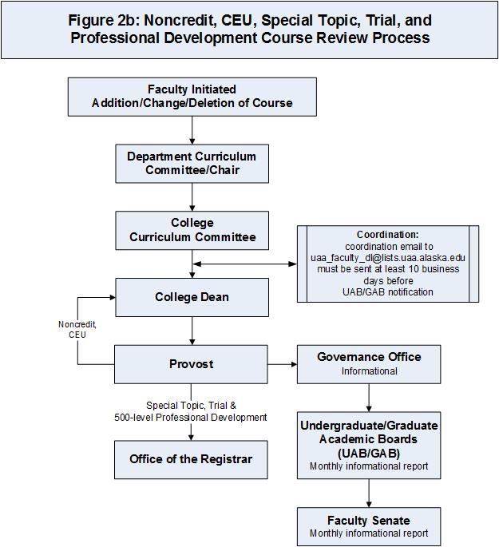

Section 3 - Curriculum Review Process for Programs
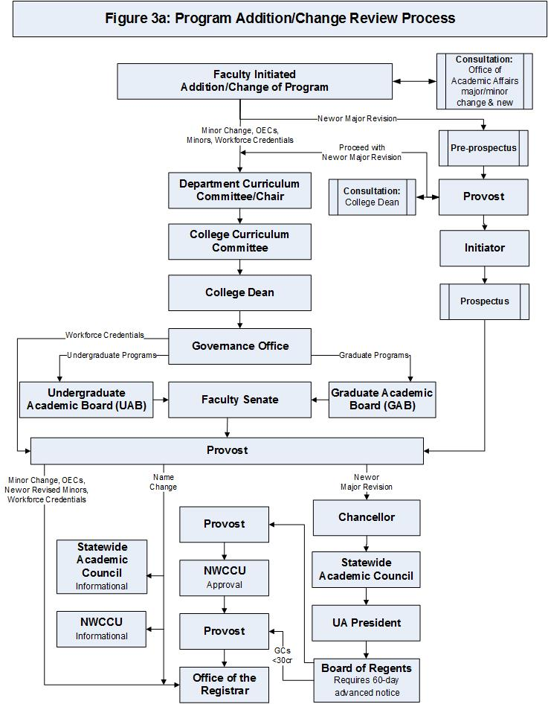

3.1 Overview
Curriculum development is a collegial process that begins with discussion at the discipline or program level and community campuses and expands to include all potentially interested stakeholders within the college, university, and community partners.

All programs follow the review process presented in this section. Any new, changed or deleted program, wherever initiated within UAA, requires approval through the Program Management system, which can be accessed at: https://nextcatalog.uaa.alaska.edu/programadmin/.

This review process is depicted in Figures 3a and 3b.

Annual deadlines for completing the curriculum review process are listed on the curriculum website https://www.uaa.alaska.edu/academics/office-of-academic-affairs/curriculum/index.cshtml. Existing programs with changes may not be implemented for a term once registration for that term has opened. New programs may have an implementation date of summer, fall, or spring. Existing programs with changes must have an implementation date of fall so that correct curriculum is in effect in current catalog. Changes to programs must be initiated in accordance with the dates posted on the curriculum website.

3.2 Program Review Process
- Faculty Initiation: faculty (except adjunct faculty) as defined in the Faculty Senate Constitution must initiate new, changed and deleted programs. The faculty initiator may consult an adjunct faculty member who has expertise in the area.

Note: Curriculum is returned to the faculty initiator within the CIM system following the college dean’s review to allow the faculty initiator to make revisions, as needed. The faculty initiator needs to “approve” the curriculum to advance the proposal to the next step in the CIM workflow.

Review section 1.4 Curriculum Review Board Evaluation Criteria to prepare for the review process.

- Consult with Office of Academic Affairs (for new programs only): Approval of a pre-prospectus by OAA is required prior to submitting curriculum to the review process for a new program (catalog copy and courses). See the curriculum website https://www.uaa.alaska.edu/academics/office-of-academic-affairs/curriculum/index.cshtml for more information on the pre-prospectus. Contact information for OAA is also available on the curriculum website.

Once the pre-prospectus is approved, faculty may submit the program and course curriculum to the curricular process. Faculty must meet the posted deadlines, which are designed to allow time for Board of Regents review and approval, as well as the Northwest Commission on Colleges and Universities (NWCCU) process.

Additionally, once the pre-prospectus is approved, faculty will receive an expanded “full prospectus,” which includes additional questions. OAA will work with the faculty initiator to develop the full prospectus and to complete the Board of Regents Program Action Request form. Ideally, by the time the curriculum is approved by the Faculty Senate, the full prospectus will be complete and ready for submission by the Provost to the Statewide Academic Council.

The University of Alaska Board of Regents Academic Policy, including the minimum number of credits required for a degree or certificate program, can be accessed at: http://www.alaska.edu/bor/policy/10-04.pdf.

- Department Curriculum Committee/Department Chair: Departmental review by the curriculum committee or department chair is required.

- College Curriculum Committee: Check with your college curriculum committee about their meeting schedule.

A coordination email is automatically generated by the system at the point at which the College Curriculum Committee chair completes the curriculum review. At least 10 business days must pass after the coordination email is generated before the program will be placed on the UAB/GAB agenda to allow adequate time for notification of the UAA community.

Initiators should also consider—especially in the case of curriculum changes affecting other departments or colleges—sending out a direct coordination email to affected parties and the faculty listserv prior to the curriculum being submitted to their college curriculum committee.

- College Dean: This level of review is required prior to submission to the governance office. Curriculum initiated at the community campuses must come up through the college, under which the program is listed in the catalog.

Note: If any curriculum for a credit-bearing course, program, or policy is submitted for processing and it has been disapproved at any level prior to UAB/GAB review, then that particular curricular action may be placed on the agenda of UAB/GAB for review and recommendation.

- Governance Office: The curriculum can be placed on the UAB/GAB agenda when it fulfills the 10-business day coordination e-mail requirement. Curriculum items needing UAB/GAB review must be in the Governance Office (GAB/UAB) queue by 9:00 a.m. Monday in order to be on the agenda for the Friday meeting of the same week.

- Undergraduate Academic Board (UAB)/Graduate Academic Board (GAB): GAB and UAB meeting schedules are posted on the Governance website at the beginning of each academic year.

The initiating or representative tenure-track or term faculty member must present curriculum to UAB/GAB. Phone attendance is permitted. Representatives should be prepared to answer all relevant questions as described in section 1.4 of this handbook.

After the final reading by UAB/GAB, the initiating faculty member is responsible for the preparation of any necessary amendments to the text within the Program Management system before UAA Faculty Senate takes action.

- Faculty Senate: Curricular actions at UAB and GAB are consolidated on to a consent agenda for faculty senate meetings that occur on the first Friday of each month September – May, except January.

- OAA/Provost: The Provost provides the final approval for all curricular actions at UAA.

- Refer to Figure 3a for the steps beyond OAA/Provost approval that are specific to the type of program review.

3.3 Minor Changes
Definition of a “minor change”: Minor change are defined as changes that do not substantially affect the intent or content of programs. Minor changes are reviewed up through the college curriculum committee. All changes, even minor changes, must be entered into the Program Management system. For further assistance in determining whether a change is minor, consult with the UAB or GAB chair.

The following catalog changes are considered minor changes and do not have to be reviewed by the UAB/GAB. If faculty initiators believe their program changes fall within the following categories, an explanation of that should be provided in the notes section of the program documentation:
  - Contact information, location, and web address
  - Career information
  - Accreditation
  - Research possibilities
  - Advising
  - Grammatical changes

The initiating department is required to coordinate with all impacted departments. A coordination email is automatically generated by CIM at the point at which the college curriculum committee chair approves the curriculum.

Upon final approval by the college dean, courses with minor changes are forwarded to the Governance Office for transmittal to the Graduate School (as applicable), the Office of Academic Affairs and the Office of the Registrar.

Minor changes are placed on the UAB/GAB agenda as informational items. Any UAB/GAB member may request that an information item be changed to an action item. No action can be taken on an action item until after it has been placed on the next meeting’s agenda. If there is no request to change the informational item to an action item, the Chair notes that it is a minor change and moves the change forward.

3.4 Program Student Learning Outcomes
- Program Student Learning Outcomes are to be clearly stated as the knowledge or abilities that students are expected to demonstrate upon successful completion of the program.

- Program Student Learning Outcomes and a plan for their assessment are to be developed in accordance with the guidance and requirements found in the Academic Assessment Handbook (https://www.uaa.alaska.edu/academics/office-of-academic-affairs/_documents/academic-assessment-handbook.pdf).

- Program Student Learning Outcomes are to be published in the catalog for student use in evaluating and selecting their academic program.

- Programs whose external accreditors require program objectives should state these clearly as the knowledge or abilities that students are expected to demonstrate after completion of the program.

- A complete and valid Academic Assessment Plan must be emailed to the Academic Assessment Committee at uaa.aac@alaska.edu in accordance with the requirements of the Academic Assessment Handbook. Note: Academic boards do not evaluate the Program Student Learning Outcomes or Academic Assessment Plan; however, the Academic Assessment Plan must be complete, approved through the Dean, and submitted to uaa.aac@alaska.edu for review by the Academic Assessment Committee when a new program is submitted to the academic boards. Following AAC review of the Academic Assessment Plan, an informational item is sent to the Faculty Senate.

- If this action requires notifying NWCCU, refer to their website at www.nwccu.org.

3.5 Career Readiness Workforce Credential
Note: This type of program does not use the Program Management system.

The development of these programs must first be discussed with the Office of Academic Affairs.
Contact information for OAA is available on the Provost’s Office website https://www.uaa.alaska.edu/academics/office-of-academic-affairs/provost_office.cshtml.

3.6 Academic Program Suspension of Admissions or Deletion
A suspension of admissions or deletion of an existing program must be discussed with the Office of Academic Affairs. Contact information for OAA is also available on Provost’s Office website https://www.uaa.alaska.edu/academics/office-of-academic-affairs/provost_office.cshtml.

Academic Program Suspension of Admissions or Deletion Guidelines are available at: https://www.uaa.alaska.edu/academics/office-of-academic-affairs/_documents/susp-admissions-or-deletion-guidelines-5-14-15.pdf.

While suspension of admissions is a management decision, deactivation of a program is submitted by faculty through the Program Management system.

This review process is depicted in Figure 3b.

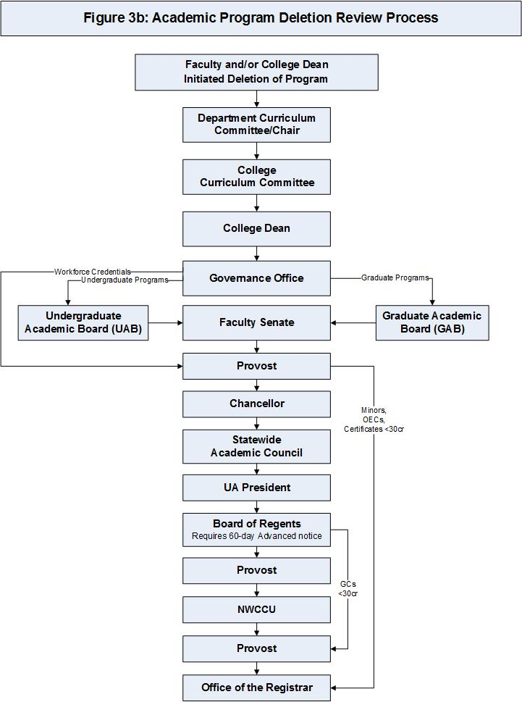

Section 4 - Prefix Approval Process
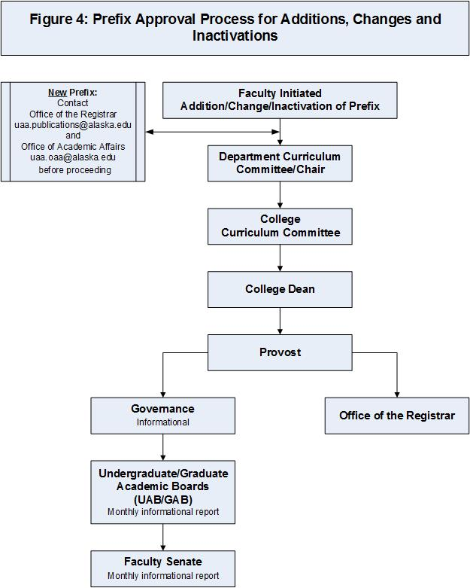

4.1 Addition, Change or Inactivation of a Prefix
The process for approval of a prefix addition, change or inactivation is depicted in Figure 4.

Section 5 - Policy Additions and Changes
New or revised academic policies are proposed to UAB and/or GAB according to the level of student impacted. If approved they will be forwarded by the Governance Office to the UAA Faculty Senate, then to OAA, and finally to the Chancellor’s Office.
UAA Academic Policy Proposals are presented to UAB/GAB in the form of a memo which should include:
- Proposed policy language (include catalog copy in Word using the track changes function if policy is revised). https://catalog.uaa.alaska.edu/academicpoliciesprocesses/
- List of documents in which proposed language will be inserted (catalog, curriculum handbook, etc.).
- Proposed implementation date.
Upon recommendation of the Provost, the Chancellor reviews and acts on academic policies.

Section 6 – Further Resources

University of Alaska Board of Regents academic policy (see part 10): http://alaska.edu/bor/policy-regulations/

UAA curriculum landing page (curriculum and program management system): http://curric.uaa.alaska.edu/curriculum.php

Annual deadlines: https://www.uaa.alaska.edu/academics/office-of-academic-affairs/dates-and-deadlines.cshtml

Office of Academic Affairs:
https://www.uaa.alaska.edu/academics/office-of-academic-affairs/academic-affairs-landing-page.cshtml

Governance Office, Undergraduate and Graduate Academic Boards, Faculty Senate, GER Committee information:
http://uaa.alaska.edu/governance

Academic Assessment Committee and plans information:
https://www.uaa.alaska.edu/about/governance/academic-assessment-committee

Distance Education Handbook:
https://docs.google.com/document/d/1qbK9gik0ZlVVoB9X7cSf3AarJ_gucYVc8sQeG5PVvhc/edit?usp=sharing

Writing Objectives with Bloom’s Taxonomy:
University of North Carolina Charlotte, The Center for Teaching and Learning

https://teaching.uncc.edu/services-programs/learning-resources/course-design/writing-measurable-course-objectives

Appendix A – Stacking Guidance
Stacking criteria:
- Stacked courses are courses from the same prefix but at different levels offered at the same time and location.

- Existing and new courses may not be stacked unless approved as stacked courses by UAB/GAB.

- Courses may not be stacked informally for scheduling purposes.

- The course description and course content guide of a stacked course must clearly articulate the difference in experience, performance and evaluation of students at different levels, including graduate students vs. undergraduate students.

- Courses that are at the 500 level may not be stacked with any other course.

- If stacking status is requested, rationale must be provided.

- Courses at the 300 level may not be stacked with 600-level courses.

All graduate-level courses must meet certain criteria established by the GAB. In addition, when 400-level courses are stacked with 600-level courses, the faculty initiator must consider the impact of stacking the course on the graduate student experience and how that affects the criteria for 600-level courses. If a graduate-level course is stacked with a 400-level course, or if undergraduate students are taking the course as part of their baccalaureate degree, the justification must clearly describe how the quality of the graduate students’ experience will be maintained in a mixed-level classroom.

The following guidelines may assist in determining whether a course is suitable for stacking according to graduate criteria:

- Do the prerequisites (not registration restrictions) differ for the 400- vs. 600-level versions of the course?
It is difficult to justify stacked courses in which the graduates and undergraduates have a significantly different knowledge base relevant to the course material. If the knowledge is required for the course, the prerequisites must be comparable. If the knowledge is only required for extra coursework performed by the graduate students, this difference should be stated explicitly and addressed in the instructional goals, student learning outcomes and course activities sections of the CCG.
- Is the course format predominantly discussion- or seminar-based?
This type of course is not likely to be suitable for stacking, as the discussion level/theoretical base can differ significantly between graduate and undergraduate students. In addition, the ratio between undergraduate and graduate students should be addressed. Courses that are evenly divided may provide a more balanced environment than a course in which only one or two graduate students are present.
- Is the course format predominantly lecture-based? (Is the main intent of the course to provide a detailed knowledge set?)
  - Is the PRIMARY source of information/reading the primary research literature of the field?
This course is not likely to be suitable for stacking, as undergraduate students generally lack the knowledge base and experience to derive all information from the primary literature.
  - Is the PRIMARY source of information/reading material derived from textbooks or other less-specialized literature?
This course is likely to be suitable for stacking. However, the performance expectations for graduate students should be explicitly defined, with special emphasis on how these expectations differ from the 400-level students.

Some suggested student learning outcomes/assessments that may be appropriate for 600-level students in a stacked course:
- Extra reading assignments based in the primary research literature, evaluated via written critical reviews and/or oral presentations
- Extra writing assignments that evince ability to synthesize research fields (comprehensive scholarly reviews or synthesis of other disciplinary areas with the course material)
- Assignments to measure the ability of graduate students to integrate course material into experimental design, such as writing formal research grant proposals, or oral or written presentation of how the course material informs the student’s own thesis research
- Separate exams for graduate students that measure not only comprehension of the lecture material but the ability to integrate and apply the material at more advanced levels, such as hypothesis formulation and experimental design, or the ability to interpret raw research data
- Teaching experiences, in which graduate students instruct undergraduates, lead discussion groups or present analysis of primary research, offer another context in which graduate students may demonstrate and more advanced knowledge and be assessed accordingly.

As a result of completing this course, students will be able to:

Student Learning Outcomes | Typical Assessments
Demonstrate the ability to conduct a literature search on the course topic material | Written critical reviews and/or oral presentation of literature reviews
Synthesize research fields | Comprehensive scholarly reviews or synthesis of other disciplinary areas with the course material produced by the student
Integrate course material into experimental design | Written formal research grant proposals, oral or written presentation of the how the course material informs the student’s own thesis research
Integrate and apply the course material at advanced levels | Exams requiring students to formulate hypothesis, design experiments, or interpret raw research data
Instruct undergraduates, lead discussion groups, or otherwise present the course material to other audiences. | Observed teaching exercises, teaching evaluations, performance of their students on examinations

Appendix B – Number of Credits/CEUError! No bookmark name given.s and Contact Hours
The number of credits/CEUs is in direct relation to the contact hours:
- Over a 15-week semester, 1 contact hour is equivalent to 50 minutes.
- One credit for a lecture course is typically equivalent to 1 contact hour/week for a total of 15 contact hours for the course (or 750 minutes of actual class time [50 minutes/contact hour x 15 contact hours = 750 minutes]).
- One credit for a supervised laboratory course is typically awarded 2 contact hours/week for a total of 30 hours (2 x 15 weeks = 30) or 1,500 total contact minutes (30 x 50 minutes/contact hour = 1,500 minutes) of supervised lab time.
- One credit of unsupervised laboratory time such as some practica, student teaching, internships, or field work credits is typically awarded 3 contact hours/week or more. Many courses, because of the nature of their subject matter or mode of delivery, require additional student time.
- For a lecture course, at least two hours of work outside the class is expected for each credit. For a supervised laboratory class, in addition to 2 contact hours/week in the laboratory, at least one additional hour of outside work is expected for each credit (or a total of 3 contact hours/week in the laboratory will satisfy this requirement).
- For courses that are provided in a period less than the standard 15-week semester, the (Lecture + Lab) section should be completed as if the course would be taught in a 15-week period.
- For CEU courses, the total number of lecture and laboratory contact hours for the course should be stated. The CEU is a unit of measure for noncredit activities. The CEU can be used to document an individual’s participation in formal classes, courses, and programs as well as in nontraditional modes of noncredit education, including various forms of independent, informal, and experiential study and learning.

- Summary
Semester = 15 weeks (standard semester length)
One (1) Contact Hour = 50 minutes per week (or 750 minutes for the course)
Outside Work = Additional time typically outside of classroom or laboratory
One (1) credit = 1 contact hour per week of lecture (15 contact hours of lecture for course)
or
2 contact hours per week of supervised laboratory (or practica) if outside work is needed (30 contact hours for the course)
or
3 contact hours per week of supervised laboratory (or practica) if no outside work is needed (45 contact hours for the course)
(Lecture + Laboratory) = refers to the number of contact hours for lecture and laboratory per week based on a 15-week semester

- Credit Examples
- (3+0) = A typical lecture-only course. Equivalent to a 3-credit course with 3 contact hours of lecture and 0 hours of laboratory per week for a total of 135 hours for the course [45 contact hours of lecture (3 contact lecture hours/week x 15 weeks = 45) plus 90 hours outside work (6 hours outside lecture/week x 15 weeks = 90) for a total of 135 hours].
- (2+2) = A combined lecture and laboratory course. Equivalent to a 3-credit course with 2 contact hours of lecture and 2 hours of supervised laboratory per week for a total of 135 hours for the course (30 contact hours of lecture and 60 hours outside lecture plus 30 hours lab plus 15 hours outside lab).
- (3+2) = A combined lecture and laboratory course. Equivalent to a 4-credit course with 3 contact hours of lecture and 2 hours of supervised laboratory per week for a total of 180 hours for the course (45 contact hours of lecture and 90 hours outside lecture plus 30 hours of lab and 15 hours outside of lab).
- (3+3) = A combined lecture and laboratory course. Equivalent to a 4-credit course with 3 contact hours of lecture and 3 hours of laboratory (supervised or unsupervised) per week for a total of 180 hours for the course (45 contact hours of lecture and 90 hours outside lecture plus 45 hours of lab and 0 hours outside of lab).
- (0+9) = A practicum or fieldwork type course. Equivalent to a 3-credit course with 0 contact hours of lecture and 9 hours of practicum or field work laboratory (supervised or unsupervised) per week for a total of 135 hours for the course (0 contact hours of lecture plus 135 hours of lab and 0 hours outside of lab).

- CEU Examples
- 0.1 CEU = 1 hour of instruction and no additional hours of work for the course.
- 1.0 CEU = 10 hours of instruction and no additional hours of work for course.
- 1.5 CEU = 15 hours of instruction and no additional hours of work for course.
- 3.5 CEU = 20 hours of instruction and 15 hours of required additional work appropriate to the objectives of the course for course.
- 2.0 CEU = 20 hours of instruction and no additional work, or 40 hours of laboratory or clinical work.

- Minimum Course Length (Compressibility Policy) – The Compressibility Policy states, “Courses scheduled for less than a full semester may not be offered for more than one credit each week (seven days).” Two credits require a minimum of eight days and 3 credits require a minimum of 15 days.

Appendix C – Operations of UAB/GAB
UAB and GAB Values - Values Statement:
The Undergraduate and Graduate Academic Boards are dedicated to a shared, rigorous, open, and critical inquiry of curricular excellence in a collegial framework that fosters intellectual vitality and creativity. It is a priority of the Boards to represent the academic values of our peers across the University. We endeavor to serve UAA’s diverse and intellectually curious faculty in the creation of opportunities for student success. In our efforts to both represent and support our peers, it is our goal to work collaboratively with faculty initiators and to offer respectful and constructive feedback as we review curriculum, programs, and policy changes or adoptions.

Our values are grounded in both academic integrity and process integrity.
Academic integrity encompasses the values of inclusiveness and innovation, as well as intellectual excellence, rigor and vitality/currency/relevance.
Process integrity includes the values of inclusiveness, fairness and transparency, as well as collaboration, honesty, respect and constructive feedback.

Membership
- Eligibility
The Constitution of the Faculty Senate, Article 5 Section 3 defines the faculty status required to serve on UAB/GAB. https://www.uaa.alaska.edu/about/governance/faculty-senate/constitution.cshtml

- Composition
The Bylaws of the Constitution of the Faculty Senate, Section 3 subsection A and C define the composition of UAB and GAB, respectively. https://www.uaa.alaska.edu/about/governance/faculty-senate/constitution.cshtml

Functions and Responsibilities of UAB/GAB
- The Bylaws of the Constitution of the Faculty Senate, Section 3 subsection B and D define the authority and responsibilities conferred upon UAB and GAB, respectively, by the Faculty Senate. https://www.uaa.alaska.edu/about/governance/faculty-senate/constitution.cshtml

Operational Responsibilities and Procedures
- Members
- Members are responsible for attending all meetings.
- Phone attendance is permitted.
- If a member is unable to attend, that member is responsible for providing a replacement.
- Members act as a liaison between the UAB/GAB and the member’s department/school/college.
- Members must inform departments in their school/college when their proposals are on the agenda.
- Members must review the agenda and attachments prior to each meeting.

- Chair
- The presiding chairs of UAB/GAB are elected by their respective boards and must have served on the respective board for a minimum of one year.
- The chair is responsible for attending all meetings.
- If the chair is unable to attend, he/she appoints an acting chair.
- The chair acts as a liaison between UAB/GAB and others as necessary.
- The chairs sign CARs and represent UAB/GAB at UAA Faculty Senate meetings.
- The chairs serve as members of UAA Faculty Senate Executive Board and may represent UAA in system governance issues.
- The chairs may represent the faculty on an ad hoc basis during the year and attend special meetings (such as meeting prospective employee candidates, meeting the Board of Regents, or serving on special task forces).

- Meeting Schedule
- Regular Meetings
  - Undergraduate Academic Board: During the academic year, UAB meets at 2 p.m. each Friday, except for the first Friday of each month which is the day the UAA Faculty Senate meets. Meetings commence the first week after faculty contracts begin. The schedule is given to UAB members at the beginning of each academic year and posted on the Governance website.
  - Graduate Academic Board: During the academic year, GAB meets at 9:30 a.m. the second and fourth Fridays of each month. Meetings commence the first week after faculty contracts begin. The schedule is given to GAB members at the beginning of each academic year and posted on the Governance website.
- Summer Meetings
Neither UAB/GAB meets during June or July. If any curricular items need action during the summer, the UAB/GAB chair or designee reviews the paperwork with a volunteer group of continuing UAB/GAB members. Under such circumstances, the UAA Faculty Senate Executive Committee acts on behalf of the UAA Faculty Senate (UAA Faculty Senate Constitution Article IV Section 11). Approved actions must be reported to UAB/GAB at the first UAB/GAB meeting of the academic year. No policy changes are considered during the summer.
- Meeting Notification
All meetings are public meetings. Meeting announcements, agendas, and locations are posted on the Governance webpage.

- Agenda and Summary
- Structure
  - Date, Time, and Location: The agenda lists the date, time, and place of the meeting. Meetings may be teleconferenced if necessary.
  - Sections
- Roll
- Approval of the Agenda
- Approval of Meeting Summary
- Administrative Report
- Chair’s Report
- Course Action Request (CAR) or Program/Prefix Action Request (PAR)-Second Reading
- CAR or PAR-First Reading
- Old Business
- New Business
- Informational Items
- Adjournment
- Definitions
  - Meeting Summary: The meeting summary includes the roll, all action items, a list of information items, and time of adjournment.
  - First Reading
- Representatives from the department/school/college must attend the UAB/GAB meeting when their proposal is discussed. If no representative is present, the proposal is tabled.
- All proposals are routinely accepted for First Reading unless tabled (for a specific length of time and for a stated purpose), removed from the agenda (usually by the department/school/college that initiated the item) or formally not accepted for First Reading (usually the item is then sent back to the department/school/college for revision).
- Proposals not properly coordinated before First Reading will be tabled.
- Actions involving changes in General Education Requirements (GER) are referred to the General Education Review Committee (GERC).
- Proposals accepted for First Reading are usually placed on the next agenda for Second Reading. Proposals can be accepted with suggested changes. UAB/GAB, administration, or the submitting department may suggest changes.
- No vote is necessary to accept an item for First Reading.
- Acceptance for First Reading does not predetermine automatic approval at Second Reading.
- Board members should work closely with their department/school/college regarding all recommendations made at UAB/GAB meetings and assist their colleagues in the preparation of the proper paperwork.
  - Academic Policy: A variety of sources including individuals, departments, schools, colleges, administration, and other boards and committees may initiate new or revised academic policy proposals. Revised policy proposals should include a copy of both the old and new policies with rationale/justification for the new policy or revision. All policy proposals are reviewed and must be approved by UAB/GAB, UAA Faculty Senate, and the administration.
  - Second Reading
- Second readings usually occur at the next regularly scheduled meeting. All proposals placed on the agenda for Second Reading are voted on by a show of hands or yes/no if audio-conferenced.
- UAB/GAB usually act on proposals at Second Reading but may postpone action if further deliberation or information is necessary.
  - Informational Items: The Board may discuss these items and/or request that the items be placed on a future agenda for action.

- Meeting Procedure
- UAB/GAB meetings are governed by Robert’s Rules of Order.
- A quorum is a majority of the voting members present.
- Voting is done by a show of hands or yes/no if audio-conferenced.
- Votes are recorded as For, Against, Abstain, or Unanimous.
- A simple majority carries the vote.
- In the event of a tie, the chair casts the deciding vote.
- Proxy voting is not permitted by any UAA faculty boards and committees. Proxy voting is incompatible with the essential characteristics of a deliberative assembly in which membership is individual, personal, and nontransferable, in that voting should take place subsequent to discussion and deliberation.

- Administrative Support
The Governance Office provides administrative support to UAB/GAB. The Governance Office works closely with the chairs of the boards and prepares and posts the agendas, summaries, and reports on the governance webpage at https://www.uaa.alaska.edu/about/governance/. In addition, the office will work with appropriate departments to provide guidance in the preparation and approval of all required actions. The Governance Office, the UAB/GAB chairs and representatives from the Office of Academic Affairs act as liaisons between the Undergraduate Academic Board, the Graduate Academic Board, the Office of Academic Affairs, the Chancellor, and other UAA departments as necessary.

