2014-2015 ACDLITe Committee Membership
Name | Campus / College or School / Department
Dave Fitzgerald (co-chair) * | ANC / CBPP / Computer Information Systems
Bruno Kappes (co-chair) * | ANC / CAS / Psychology
Chef Naomi Everett | ANC / CTC / Culinary Arts and Hospitality
Lynn Paterna | ANC / CAS / Human Services
Lynn Senette* | ANC / COH / School of Nursing
Getu Hailu | ANC /COEng / Mechanical Engineering
Jane Haigh | KPC / History
Ed McLain | ANC / COE / Graduate Studies and MEd
Barbara Harville | ANC / CAS / Journalism and Communication
Annette Rearden | ANC / COH / School of Nursing
Todd Petersen | ANC / COEng / Electrical Engineering
Ammie Tremblay* | ANC / COH / School of Nursing
Matt Kupilik | ANC / CoEng/ Electrical Engineering
Amy Green* | ANC/ / CTC / Culinary Arts and Hospitality
* Faculty Senate Member

http://www.uaa.alaska.edu/acdlite/

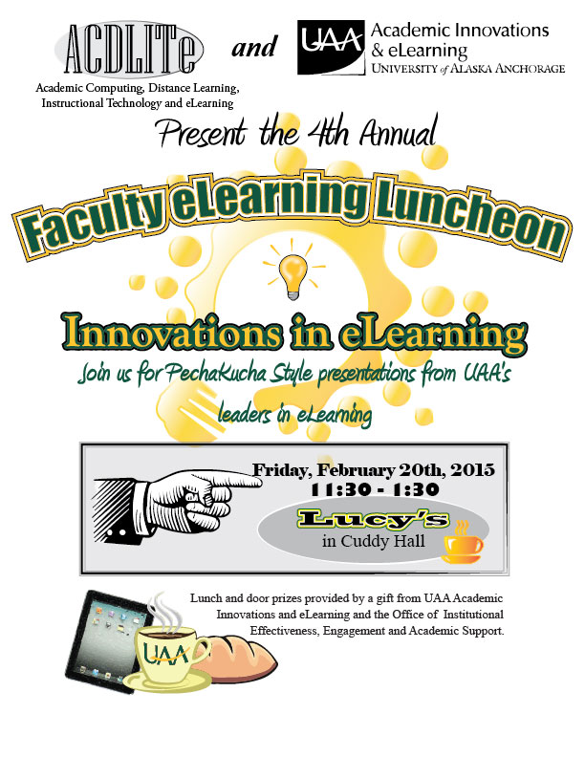
4th Annual eLearning Luncheon  Hosted by ACDLITe and AI&e:  “Innovations in eLearning”  Welcome and Introductions:  - David Fitzgerald, Co-Chair of ACDLITe  - Dave Dannenburg, AI&e  Presenters:    “Enhancing Evidence-Based eLearning Performance by Teaching eFolio Thinking Competencies”  Dr. Bruno Kappes  Professor  Psychology, CAS   |  | 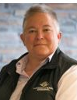  “Native Ways of Knowing: Building Relationships with Self, Others and the Earth”  Dr. Ginger Blackmon  Asst. Professor  College of Education    “Bridging the Digital Literacy Gap: Embedding 21st Century Skills into Coursework"  Lara Madden  Instructional Designer, AI&e  Adjunct, CBPP    “Lesson Learned: Distance  Delivery and Beyond”
“Language as a Tool in eLearning”  Patricia Jenkins  Assoc. Professor,  English, CAS |  | Ira Rosnel  Assoc. Professor,  Dept. Human Services  College of Health
Special thanks to UAA’s Academic Innovations and eLearning for sponsoring this event

