Annual Academic Assessment Survey

Construction Management
Bachelor of Science

Educational Effectiveness
Assessment Plan

Adopted by:

The Division of Construction, Design and Safety (CDS)
Construction Management Program
April 1, 2016

Submitted to:
Institutional Research / SharePoint:

https://nextcatalog.uaa.alaska.edu/courseleaf/courseleaf.cgi?page=/programadmin/216/index.html&step=editrecord&id=216&_=1497550145491

April 1, 2019

Contents
Construction Management Mission Statement 3
Introduction 3
BSCM PROGRAM STUDENT LEARNING OUTCOMES 4
STUDENT LEARNING OUTCOME 1 5
STUDENT LEARNING OUTCOME 2 7
STUDENT LEARNING OUTCOME 3 10
STUDENT LEARNING OUTCOME 4 12
STUDENT LEARNING OUTCOME 5 14
STUDENT LEARNING OUTCOME 6 15
STUDENT LEARNING OUTCOME 7 16
STUDENT LEARNING OUTCOME 8 18
STUDENT LEARNING OUTCOME 9 20
STUDENT LEARNING OUTCOME 10 23
STUDENT LEARNING OUTCOME 11 26
STUDENT LEARNING OUTCOME 12 27
STUDENT LEARNING OUTCOME 13 29
STUDENT LEARNING OUTCOME 14 30
STUDENT LEARNING OUTCOME 15 32
STUDENT LEARNING OUTCOME 16 33
STUDENT LEARNING OUTCOME 17 35
STUDENT LEARNING OUTCOME 18 37
STUDENT LEARNING OUTCOME 19 38
STUDENT LEARNING OUTCOME 20 39

Construction Management Mission Statement
The mission of the Construction Management program is to prepare future industry employees with the education, skills, and training for entry-level professional positions in construction management.
Goals
- Provide an educational program of distinction that prepares individuals for professional careers in the construction industry.
- Provide a challenging learning environment that seeks to maximize the strengths and capabilities of each individual student.
- Strive for consistent improvement and modernization of the academic and technical quality of the degree program.
- Build a strong and mutually beneficial relationship between the program, the alumni, and the local, regional and national construction industry.

Introduction

This Bachelor of Science in Construction Management (BSCM) Educational Effectiveness Assessment Plan identifies the twenty student learning outcomes (SLO) required to be assessed by the American Council for Construction Education (ACCE) and provides a plan for the assessment of each SLO.

All core construction courses in the BSCM program are used to provide assessment data. All data shall be collected, reviewed, and used to identify recommendations for constant improvement in the BSCM program in accordance with the BSCM Assessment Implementation Plan.

BSCM PROGRAM STUDENT LEARNING OUTCOMES

- Create written communications appropriate to the construction discipline.
- Create oral presentations appropriate to the construction discipline.
- Create a construction project safety plan.
- Create construction project cost estimates.
- Create construction project schedules.
- Analyze professional decisions based on ethical principles.
- Analyze construction documents for planning and management of construction processes.
- Analyze methods, materials, and equipment used to construct projects.
- Apply construction management skills as a member of a multi-disciplinary team.
- Apply electronic-based technology to manage the construction process.
- Apply basic surveying techniques for construction layout and control.
- Understand different methods of project delivery and the roles and responsibilities of all constituencies involved in the design and construction process.
- Understand construction risk management.
- Understand construction accounting and cost control.
- Understand construction quality assurance and control.
- Understand construction project control processes.
- Understand the legal implications of contract, common, and regulatory law to manage a construction project.
- Understand the basic principles of sustainable construction.
- Understand the basic principles of structural behavior.
- Understand the basic principles of mechanical, electrical and piping systems

STUDENT LEARNING OUTCOME 1

1. Create written communications appropriate to the construction discipline.
1.1 Source Course – CM A301 Construction Project Management II

Assessment Data 1.1 –

Assignment: The Humanity of It All

Construction Project Management II continues to examine construction project management methods and processes. Students build upon knowledge gained from previous classes. This assignment presents students with six questions focusing on ethics in the construction industry. Students are expected to provide clear and concise responses. The essay questions should effectively convey the information in written form.

This assignment is worth 25 points.

STUDENT LEARNING OUTCOME 1 (Continued)

1.2 Source Course – CM A422 – Sustainability in the Built Environment

Assessment Data 1.2 –

Assignment: Research Project 1-5

A significant portion of the students’ grade for this course was based on a research project in which they were asked to identify an area within the realm of sustainability that interested them. Students were asked to conduct extensive research into their chosen topic and make an original contribution to the field. Students were encouraged to develop functional prototype models if their research led them to discover a new product or create an invention. Some students investigated systems and processes currently used in the construction industry, focusing on ways to improve efficiency and contribute to more sustainable practices. Student progress was monitored through a series of research reports documenting weekly activity and a grading rubric that scored key research processes. A final written document was submitted that included an abstract, an introduction, a description of the project methodology, and a discussion of research results.

The final write up was evaluated on the basis of the following rubric:

- Depth and Sophistication of Research Initiative 50 points
- Quality of Project Results 50 points
- Project Write Up / Structure and Process 50 points
- Depth and Breadth of Research Sources 50 points
- Presentation: Spelling, Grammar, Graphics, Format 50 points

STUDENT LEARNING OUTCOME 2

2. Create oral presentations appropriate to the construction discipline.
2.1 Source Course - CM A301 Construction Project Management II

Assessment Data 2.1 –

Assignment: Final Project

For the Final Project in the Construction Project Management II course, the students were assigned one of six construction management-related topics: Analyze Construction Documents; Project Delivery; Legal Aspects, Project Controls, Multi-disciplinary Teams, and Communication.

In a fictitious scenario, the students receive a request from their boss to prepare an oral presentation, which is to be delivered at the construction management company’s training retreat for new employees. The presentation must include a Powerpoint slide show to enhance the oral presentation.

Oral presentations should be approximately 10 to 15 minutes in duration. Elements of POLC and either the demonstration or valuation of at least one of the following: the Pareto Principle and/or Sensitivity Analysis; Communication; Time Management, and Decision Analysis must be included in the presentation. This assignment is worth 250 points.

This assignment is worth 250 points.

STUDENT LEARNING OUTCOME 2 (Continued)

2.2 Source Course – AET A142 – Mechanical & Electrical Technology

Assessment Data 2.2 –

Assignment: Project 9: Innovative Mechanical and Electrical Systems

Project 9 asked students to investigate an innovative mechanical or electrical technology that interested them. A list of innovative technologies was given to students although they were free to choose a subject of special interest to them. In addition to a 750 word research paper, students were required to present their findings to the class using PowerPoint or other presentation media. Approximately 20% of the grade for this project was based on the oral presentation using the following rubric:

Student_________________________________________________________

Oral Communication Rubric
15 points possible

CRITERIA | POINTS POSSIBLE | POINTS
Organization | 5
Delivery | 5
Graphics | 5

15-13.5 A
13.5-12 B
12-10.5 C
10.5-9 D

STUDENT LEARNING OUTCOME 3

3. Create a construction project safety plan.
3.1 Source Course –OSH A405 Construction Industry Outreach Training, effective Spring 2018.

Assessment Data 3.1 –

Assignment: OSHA 30-hour Construction Safety and Health Training Course

In Fall of 2018, students were presented with safety plan requirements via lectures, printed materials, videos, and Illness & Injury Prevention Program (IIPP) requirements from the OSHA, Army Corps of Engineers & American National Standards Institute (ANSI). Students were also provided with a copy of an IIPP that was developed for CM A205.

Effective as of the Spring 2018 semester, CM A205 was replaced with OSH A405 Construction Industry Safety Management. This course, offered through the UAA Community and Technical College’s Occupational Safety and Health program (OSH) and taught by a certified OSH instructor, provides students with a more robust and comprehensive understanding of potential workplace hazards and prevention strategies.

Students enrolled in the OSH A405 class are presented with the curriculum of the OSHA 30-Hour Construction Industry Outreach Program. This training program provides training for workers and employers on the recognition, avoidance, abatement, and prevention of safety and health hazards in workplaces. The program specifically addresses the OSHA Focus Four Hazards (Falls, Struck-by, Electrocution and Caught-in or Between).
Successful completion of all thirty (30) contact hours of the OSHA 30-Hour Construction Industry Outreach Training program is considered to have met the student learning outcome and is used to assess this student learning outcome for both semesters. Students receive a course certification card to document successful completion of this course.

STUDENT LEARNING OUTCOME 3 (continued)

3.2 Source Course – CM A301 – Construction Project Management II

Assessment Data 3.2 –

Assignment: Home Safety Plan

Construction Project Management II begins to expose students to a deeper understanding of how planning and preparation impact the management of a construction project. Since this is the first assignment in this class, students are asked to prepare a home safety plan that answer the “why, when, where, how, and who” questions of any safety plan. The assignment must be submitted in a MS document format via Blackboard.

This assignment is worth 66.67 points.

STUDENT LEARNING OUTCOME 4

4. Create construction project cost estimates.
4.1 Source Course – CM A163 – Building Construction Cost Estimating

Assessment Data 4.1 –

Assignment: Outhouse Cost Estimate

The Building Construction Cost Estimating course focuses on the basics of developing a cost estimate for a structural construction project. The Outhouse Cost Estimate assignment provides students with an opportunity to learn and understand the fundamentals of preparing a cost estimate for a basic structure. Students are asked to review the drawing and specifications, and then prepare a Quantity Sheet to estimate the cost of the materials required to complete construction of this building.

This assignment is worth 100 points.

STUDENT LEARNING OUTCOME 4 (Continued)

4.2 Source Course – CM A163 – Building Construction Cost Estimating

Assessment Data 4.2 –

Assignment 8 – Steel Quantity Takeoff

(50 points) Perform a quantity takeoff of structural steel, steel decking, structural metal stud framing, and miscellaneous metals for the Office of Aircraft Services facility. Relevant sections of the drawings (architectural, structural, and mechanical) and specifications have been provided for your use in completing this QTO.

Perform your takeoff such that you will end up with quantities (using appropriate units of measure) for each of the following items, at a minimum:

- Structural steel (using line item 05 12 23.77)
  - Columns
  - Girders
  - Beams
  - Braces
  - Supports around openings in floor/roof
  - Floor deck pour stops (bent plates at perimeter of floor/floor openings)
  - Bent plates for connection of cold-formed curtain wall framing/CMU wall to structural steel at second floor and roof
  - Add additional tonnage for column baseplates/gussets/bolts as discussed in lecture
- Steel decking (05 31)
  - Roof decking
  - Floor decking
- Structural metal stud framing (05 41 13)
  - Exterior (curtain) walls; including bridging (see Specification Section 05400 for spacing requirements), boxed headers over openings (assume headers for all openings are doubled 16 gauge, six inch deep members), and stud wall framing
  - Entry canopy fascia framing (see details 5 and 6/A2.0)
  - Supports for rooftop air handler (see detail 5/S6.2)
- Miscellaneous metals (05 50)
  - Metal pan stairs and landings
  - Pipe railings along exposed sides of 2nd floor landings (see detail C/A3.0, for example)
  - Wall-mounted handrails (note that handrails are required on both sides of stairs in commercial buildings; the sides of each stairway that don’t have pipe railing will require wall-mounted handrails)
  - Ship’s ladder (see detail B/A3.0; price using Means section 05 51 33.16)
  - Floor gratings for elevator pit sump (see 10/S5.1), entrance gratings at doors 1 (vestibule) and 11 (west side of building) (see ground level floor plan, sheet A1.0)

Once you have completed you QTO, recap quantities, and price the work using RS Means unit costs. Submit your QTO sheet(s) and your recap/pricing sheet(s) in Microsoft Excel file format via Blackboard. In addition, submit a PDF file of your pricing sheet, with all line item quantities, unit prices, and a total price (sum of all line item prices) clearly indicated.

STUDENT LEARNING OUTCOME 5

5. Create construction project schedules.

5.1 Source Course – CM A202 – Project Planning and Scheduling

Assessment Data 5.1 -

Assignment 1: Creating a Gantt Chart – 30 points

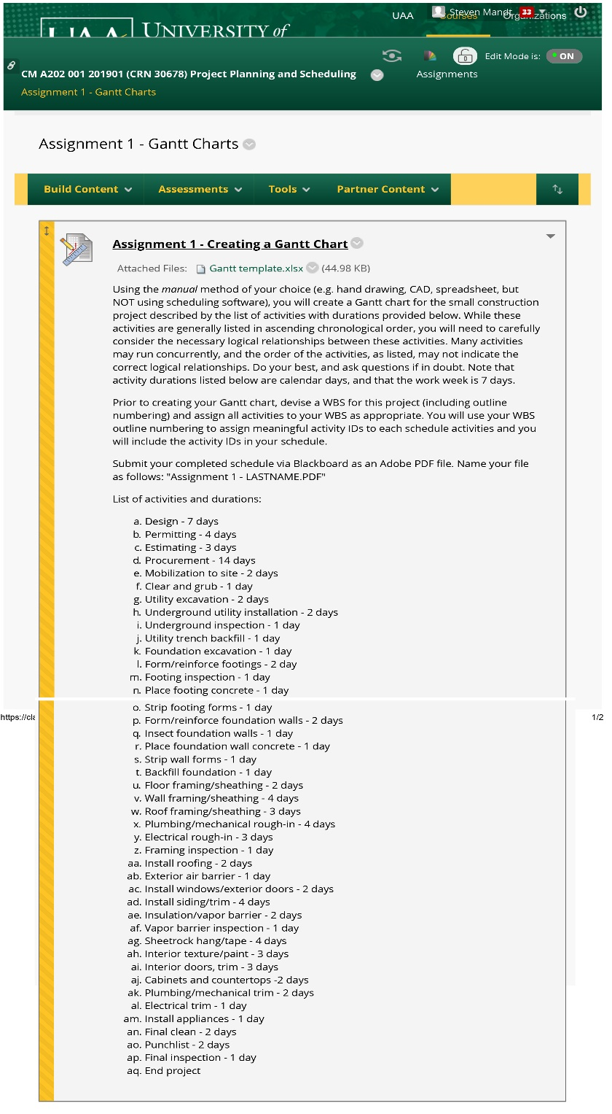

STUDENT LEARNING OUTCOME 5 (continued)

5.2 Source Course – CM A202 – Project Planning and Scheduling

Assessment Data 5.2 –

STUDENT LEARNING OUTCOME 6

6. Analyze professional decisions based on ethical principles.

6.1 Source Course – CM A422 – Sustainability in the Built Environment
Assessment Data 6.1 –
Assignment: Writing Assignment 3
Students are asked to read Holmes Rolston, III’s essay entitled “Environmental Ethics” (The Blackwell Companion to Philosophy, 2nd ed. Nicholas Bunnin and E.P. Tsui-James, Oxford: Blackwell Publishing, 2003). The essay considers the ethical responsibility that humans have vis-à-vis the natural environment. Questions arise as to environmental health and quality and the social responsibility to protect the environment as a shared resources. Rolston proposes that flora, fauna, animal species, ecosystems, and the earth have basic rights that should be protected by the same kinds of ethical considerations that humans extend to each other. As participants in the transformation of the natural environment through construction activities, students are asked to analyze the implications of Rolston’s philosophy in relation to the established ethical framework of utilitarianism (ethical decisions based on consideration of the what is the greatest good for the greatest number of people) and Kantian moral theory (ethical decisions based on the fulfillment of one’s duty).
Student work is evaluated on the basis of the following rubric:
- Depth of insight, clarity of thought (20%)
- Independent, innovative, critical thinking (20%)
- Essay structure (20%)
- Transition between parts, clarity and logic (20%)
- Spelling, grammar, adherence to instructions (20%)

The assignment is worth 25 points.

STUDENT LEARNING OUTCOME 6 (continued)

6.2 Source Course – CM A422 – Sustainability in the Built Environment

Assessment Data 6.2 –

Assignment: Writing Assignment 1

Through assigned reading materials, students are introduced to concepts associated with sustainable construction. These include resource efficiency, population densities, consumption patterns, transportation energy consumption, climate related impacts, depletion of natural resources, cost differentials associated with sustainable “green” materials, construction industry trends, life-cycle assessment, and the role that corporate and personal responsibility play in constructing the built environment. These factors impact industry participants in ways that challenge the traditional quantitative analysis based primarily on time and cost. These factors call for a more nuanced analysis of qualitative issues based on ethical considerations of what constitutes a “good” decision for a construction project. This assignment asks students to explore how natural factors (including human nature) impose limitations on the construction industry and what this implies for the decision making process of industry professionals.

Evaluation of student work is based on the following rubric:

- Is the paper accurate and thoughtful? (20%)
- Does the paper exhibit information literacy and independent research? (20%)
- Is the paper structured properly? (20%)
- Are presentation guidelines followed? (20%)
- Are assignment instructions followed (word count, font size, etc.)? (20%)

STUDENT LEARNING OUTCOME 7

7. Analyze construction documents for planning and management of construction processes.

7.1 Source Course – CM A301 – Construction Project Management II

Assessment Data 7.1 –

Assignment: Final Project / Analyze Construction Documents

For the Final Project in the Construction Project Management II course, the students were assigned one of six construction management-related topics: Analyze Construction Documents; Project Delivery; Legal Aspects, Project Controls, Multi-disciplinary Teams, and Communication.

In a fictitious scenario, the students receive a request from their boss to prepare an oral presentation, which is to be delivered at the construction management company’s training retreat for new employees. The presentation must include a Powerpoint slide show to enhance the oral presentation.

Oral presentations should be approximately 10 to 15 minutes in duration. Elements of POLC and either the demonstration or valuation of at least one of the following: the Pareto Principle and/or Sensitivity Analysis; Communication; Time Management, and Decision Analysis must be included in the presentation. This assignment is worth 250 points.

In the Fall 2017 class, three (3) students were assigned the Analyze Construction Documents topic. All three students received a score of 240 points or higher.

STUDENT LEARNING OUTCOME 7 (continued)

7.2 Source Course – CM A301 – Construction Project Management II

Assessment Data 7.2 –

Assignment: Risk Register

Construction Project Management II focuses on all aspects of construction project management. This assignment focuses on the potential impact of risk considerations in the planning phase and continued management of a construction project. Students were asked to create a Risk Management Plan based upon the Mallard Lane Parking Garage project. They were instructed to utilize a Risk Register (Excel spreadsheet) and identify / list ten (10) risks associated with this construction project. The final deliverable needs to include the following areas: Risk Identifier, Risk Description, Risk Trigger, Probability, Impact, Score, Ownership, Mitigation and Residual Risk

This assignment is worth 100 points.

STUDENT LEARNING OUTCOME 8

8. Analyze methods, materials, and equipment used to construct projects.

8.1 Source Course – AET A102 – Methods of Building Construction

Assessment Data 8.1 –

Assignment:

8.2 Source Course – CM A460 – Construction Equipment Management and Methods

Assessment Data 8.2 –

STUDENT LEARNING OUTCOME 9

9. Apply construction management skills as a member of a multi-disciplinary team.

9.1 Source Course - CM A301 – Construction Project Management II

Assessment Data 9.1 –

Assignment: Final Project / Multi-disciplinary Teams

For the Final Project in the Construction Project Management II course, the students were assigned one of six construction management-related topics: Analyze Construction Documents; Project Delivery; Legal Aspects, Project Controls, Multi-disciplinary Teams, and Communication.

In a fictitious scenario, the students receive a request from their boss to prepare an oral presentation, which is to be delivered at the construction management company’s training retreat for new employees. The presentation must include a Powerpoint slide show to enhance the oral presentation.

Oral presentations should be approximately 10 to 15 minutes in duration. Elements of POLC and either the demonstration or valuation of at least one of the following: the Pareto Principle and/or Sensitivity Analysis; Communication; Time Management, and Decision Analysis must be included in the presentation. This assignment is worth 250 points.

STUDENT LEARNING OUTCOME 9 (continued)

9.2 Source Course - AET A102 – Methods of Building Construction

Assessment Data 9.2 –

Assignment:

STUDENT LEARNING OUTCOME 10

10. Apply electronic-based technology to manage the construction process.

10.1 Source Course – AET A101 – Fundamentals of CADD for Building Construction

Assessment Data 10.1 -

Assignment 5-3

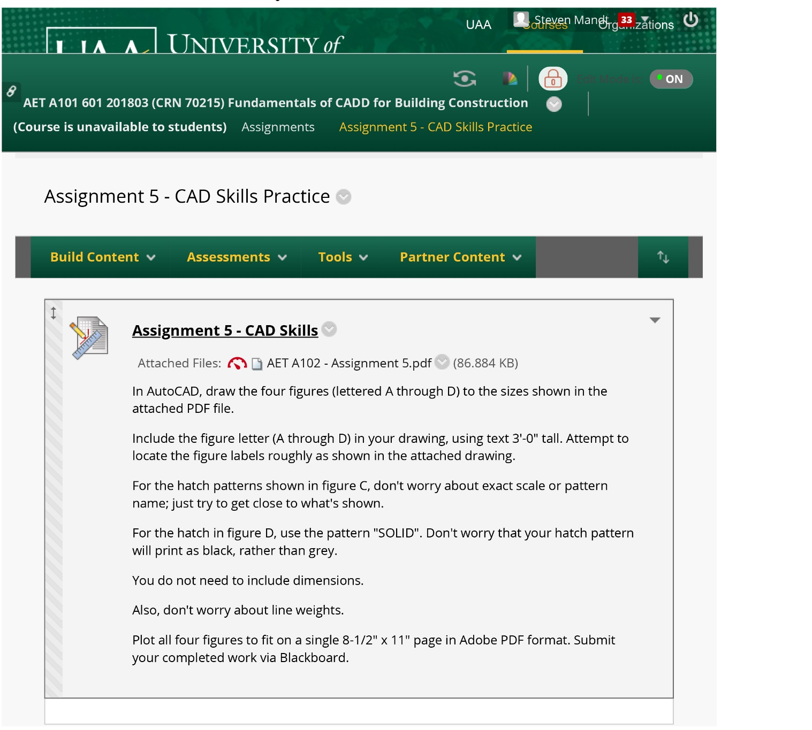

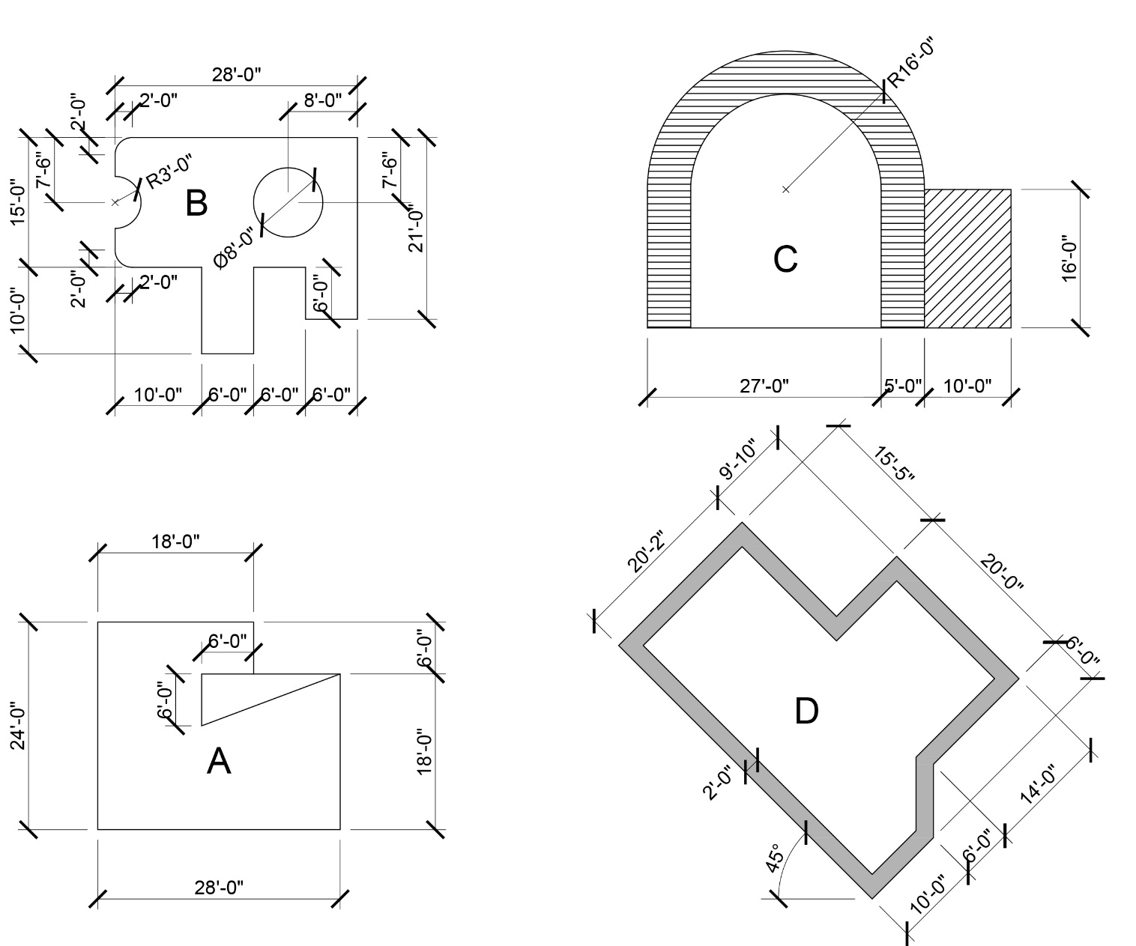
S

TUDENT LEARNING OUTCOME 10 (continued)

10.2 Source Course – AET A101 – Fundamentals of CADD for Building Construction

Assessment Data 10.2 –

Assignment: Chapter 18 - Exercises

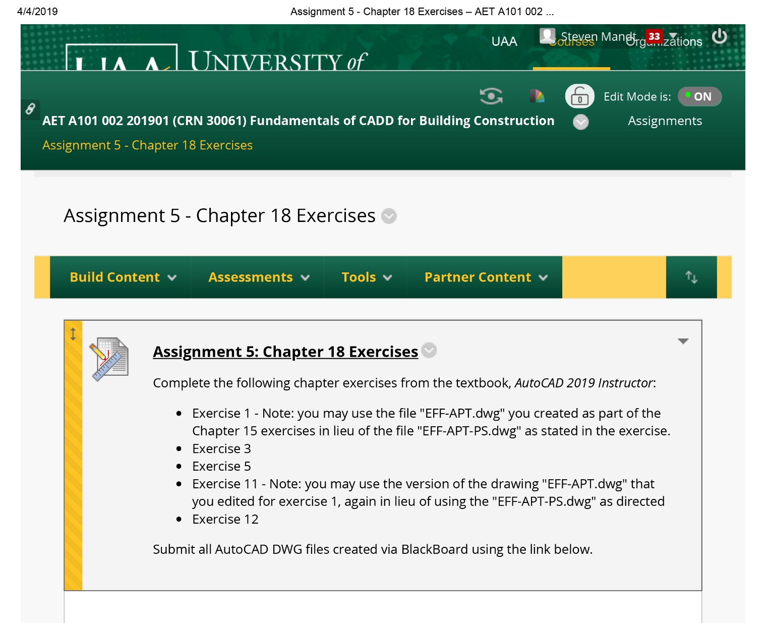

STUDENT LEARNING OUTCOME 10 (Continued)

10.3 Source Course – AET A213 – Construction Civil Technology

Assessment Data 10.3 –

Assignment: Project 3A

Construction Civil Technology outlines elements of civil design and construction, including soils and soil properties, roads, earthwork and utilities using local, state, and federal regulations. Project 3A asks students to layout a subdivision using the electronic digital technology, AutoCAD Civil 3D.

This assignment is worth 100 points.

STUDENT LEARNING OUTCOME 11

11. Apply basic surveying techniques for construction layout and control.

11.1 Source Course – AET A101 – Fundamentals of CADD for Building Construction

Assessment Data 11.1 –

Assignment:

STUDENT LEARNING OUTCOME 11 (Continued)

11.2 Source Course – CM A213 – Construction Civil Technology

Assessment Data 11.2 –

Assignment: Final Project

Construction Civil Technology outlines the elements of civil design. Students become familiar with all the major design tasks in a civil project: design, material quantities, costs estimation. Students are introduced to construction surveying.

The Final Project is worth 10% of the student’s overall grade.

11.1 Source Course – AET A101 – Fundamentals of CADD for Building Construction

STUDENT LEARNING OUTCOME 11 (Continued)

Assessment Data 11.3 –

Assignment: Project 7 / Topographical Layout

In Fundamentals of CADD for Building Construction, students are introduced to AutoCAD in the creation of a topographical layout utilizing surveying data. They are taught that written specifications and surveying data must be used in conjunction with the creation of drawings. This assignment demonstrates the range of material that students are expected to know in order to effectively interpret and develop construction drawings.

This assignment is worth 100 points.

STUDENT LEARNING OUTCOME 12

12. Understand different methods of project delivery and the roles and responsibilities of all constituencies involved in the design and construction process.

12.1 Source Course – CM A301 – Construction Project Management II

Assessment Data 12.1 –

Assignment: Final Project / Project Delivery

For the Final Project in the Construction Project Management II course, the students were assigned one of six construction management-related topics: Analyze Construction Documents; Project Delivery; Legal Aspects, Project Controls, Multi-disciplinary Teams, and Communication.

In a fictitious scenario, the students receive a request from their boss to prepare an oral presentation, which is to be delivered at the construction management company’s training retreat for new employees. The presentation must include a Powerpoint slide show to enhance the oral presentation.

Oral presentations should be approximately 10 to 15 minutes in duration. Elements of POLC and either the demonstration or valuation of at least one of the following: the Pareto Principle and/or Sensitivity Analysis; Communication; Time Management, and Decision Analysis must be included in the presentation. This assignment is worth 250 points.

STUDENT LEARNING OUTCOME 12 (continued)

12.2 Source Course – CM A201 – Construction Project Management I

Assessment Data 12.2 –

Assignment: Project Delivery Systems

Construction Project Management I introduces students to the management facets of a construction project. The Project Delivery Systems assignment tests the student’s understanding of how to interpret construction documents, such as contracts, specifications, and drawings, and apply this knowledge in the formulation of project management strategies.

The test is worth 15 points.

STUDENT LEARNING OUTCOME 13

13. Understand construction risk management.

13.1 OSH A405 - Construction Industry Safety Management

Assessment Data 13.1 –

Assignment: OSHA 30-hour Construction Safety and Health Training Course

In Fall of 2018, students were presented with basic risk management considerations and requirements in accordance with ANSI Z10 Occupational Health & Safety Management Systems as part of the Construction Safety course.

Students enrolled in the OSH A405 class are presented with the curriculum of the OSHA 30-Hour Construction Industry Outreach Program. This training program provides training for workers and employers on the recognition, avoidance, abatement, and prevention of safety and health hazards in workplaces. The program specifically addresses the OSHA Focus Four Hazards (Falls, Struck-by, Electrocution and Caught-in or Between).
Successful completion of all thirty (30) contact hours of the OSHA 30-Hour Construction Industry Outreach Training program is considered to have met the student learning outcome and is used to assess this student learning outcome for both semesters. Students receive a course certification card to document successful completion of this course.

STUDENT LEARNING OUTCOME 13 (continued)

13.2 Source Course – CM A301 – Construction Project Management II

Assessment Data 13.2 –

Assignment: Risk Register

This assignment was given after an in-class lecture that focused extensively on construction risk management. Students were asked to create a Risk Management Plan based upon the Mallard Lane Parking Garage project. They were instructed to utilize a Risk Register (Excel spreadsheet) and identify / list ten (10) risks associated with this construction project. The final deliverable needs to include the following areas: Risk Identifier, Risk Description, Risk Trigger, Probability, Impact, Score, Ownership, Mitigation and Residual Risk

This assignment is worth 100 points.

STUDENT LEARNING OUTCOME 14

14. Understand construction accounting and cost control.

14.1 Source Course – CM A301 – Construction Project Management II

Assessment Data 14.1 –

Assignment: Construction Accounting

This course focuses on construction accounting, cost control, project controls, and job cost accounting. The students understanding on construction accounting is assessed in the Construction Accounting quiz, which includes five (5) short answer questions.

This assignment is worth 25 points.

STUDENT LEARNING OUTCOME 14 (continued)

14.2 Source Course – CM A201 – Construction Project Management I

Assessment Data 14.2 –

Assignment: Project 5 / Construction Financials

In this assignment, students are asked to read several source documents and view video resources to research construction budget and financial reporting methods. The students must use ProCore to access this information and respond. In addition to the budget and financial exercises, students must also respond to five (5) essay questions regarding construction budgets. These responses to these five questions must use complete sentences, proper grammar, spelling, and punctuation. Each answer should be at least a minimum of one paragraph composed of 5 to 6 sentences.
This assignment is worth 150 points based on the following rubric:

Grading Rubric
CRITERIA | POINTS
PROCORE Exercises:  Budget Powerpoint 16.6 points  Deep Dive Training Videos 16.6 points  Budget Exrecises #1-4 16.6 points | 50
RESEARCH Questions:  5 essay questions 20 points each | 100
TOTAL POINTS | 150

STUDENT LEARNING OUTCOME 14 (continued)

14.3 Source Course – CM A301 – Construction Project Management II

Assessment Data 14.3 -

Assignment: Final Project / Project Controls

For the Final Project in the Construction Project Management II course, the students were assigned one of six construction management-related topics: Analyze Construction Documents; Project Delivery; Legal Aspects, Project Controls, Multi-disciplinary Teams, and Communication.

In a fictitious scenario, the students receive a request from their boss to prepare an oral presentation, which is to be delivered at the construction management company’s training retreat for new employees. The presentation must include a Powerpoint slide show to enhance the oral presentation.

Oral presentations should be approximately 10 to 15 minutes in duration. Elements of POLC and either the demonstration or valuation of at least one of the following: the Pareto Principle and/or Sensitivity Analysis; Communication; Time Management, and Decision Analysis must be included in the presentation. This assignment is worth 250 points.

STUDENT LEARNING OUTCOME 15

15. Understand construction quality assurance and control.

15.1 Source Course – CM A301 – Construction Project Management II

Assessment Data 15.1 –

Assignment: Final Project / Project Controls

For the Final Project in the Construction Project Management II course, the students were assigned one of six construction management-related topics: Analyze Construction Documents; Project Delivery; Legal Aspects, Project Controls, Multi-disciplinary Teams, and Communication.

In a fictitious scenario, the students receive a request from their boss to prepare an oral presentation, which is to be delivered at the construction management company’s training retreat for new employees. The presentation must include a Powerpoint slide show to enhance the oral presentation.

Oral presentations should be approximately 10 to 15 minutes in duration. Elements of POLC and either the demonstration or valuation of at least one of the following: the Pareto Principle and/or Sensitivity Analysis; Communication; Time Management, and Decision Analysis must be included in the presentation. This assignment is worth 250 points.

STUDENT LEARNING OUTCOME 15 (continued)

15.2 Source Course – CM A450 – Construction Management Professional Practice

Assessment Data 15.2 –

Assignment:

STUDENT LEARNING OUTCOME 16

16. Understand construction project control processes.

16.1 Source Course – CM A301 – Construction Project Management II

Assessment Data 16.1 -

Assignment: Final Project / Project Controls

For the Final Project in the Construction Project Management II course, the students were assigned one of six construction management-related topics: Analyze Construction Documents; Project Delivery; Legal Aspects, Project Controls, Multi-disciplinary Teams, and Communication.

In a fictitious scenario, the students receive a request from their boss to prepare an oral presentation, which is to be delivered at the construction management company’s training retreat for new employees. The presentation must include a Powerpoint slide show to enhance the oral presentation.

ral presentations should be approximately 10 to 15 minutes in duration. Elements of POLC and either the demonstration or valuation of at least one of the following: the Pareto Principle and/or Sensitivity Analysis; Communication; Time Management, and Decision Analysis must be included in the presentation. This assignment is worth 250 points.

STUDENT LEARNING OUTCOME 16 (continued)

16.2 Source Course – CM A202 – Project Planning and Scheduling

Assessment Data 16.2 –

Assignment:

STUDENT LEARNING OUTCOME 17

17. Understand the legal implications of contract, common, and regulatory law to manage a construction project.

17.1 Source Course – CM A301 – Construction Project Management II

Assessment Data 17.1–

Assignment: Final Project / Legal Aspects

For the Final Project in the Construction Project Management II course, the students were assigned one of six construction management-related topics: Analyze Construction Documents; Project Delivery; Legal Aspects, Project Controls, Multi-disciplinary Teams, and Communication.

In a fictitious scenario, the students receive a request from their boss to prepare an oral presentation, which is to be delivered at the construction management company’s training retreat for new employees. The presentation must include a Powerpoint slide show to enhance the oral presentation.

Oral presentations should be approximately 10 to 15 minutes in duration. Elements of POLC and either the demonstration or valuation of at least one of the following: the Pareto Principle and/or Sensitivity Analysis; Communication; Time Management, and Decision Analysis must be included in the presentation. This assignment is worth 250 points.

STUDENT LEARNING OUTCOME 17 (continued)

17.2 Source Course – AET A123 – Codes and Standards

Assessment Data 17.2 –

Assignment: Test 1

This entire course is based on the Municipality of Anchorage Title 21 (Land Use), the 2012 International Building Code, and associated codes which is regulatory law. The final exam has includes 25 regulatory law questions and problems based on the 2012 IBC. The final exam has a point value of 300 points which is approximately 13 percent of the student’s grade for the course. The scores for the final exam are direct measure of each student’s understanding of fundamentals of contracts, codes, and regulations that govern a construction project.

Grading Rubric (Test 1 Only)

Test 1 has 32 questions and is worth 100 points.

Alternative Assessment 9.1 There is no final exam. A final project of a code analysis for a proposed structure, as presented in a construction document set, is prepared by the student. The code analysis incorporates elements of the Title 21 and the IBC that include: Zoning districts; Setbacks; Parking; Accessibility for parking, access, and operations; Landscaping requirements; Construction types classification; Height and area limitations and modifications; Occupancy use; Means of egress; Fire resistance ratings for components and assemblies; and Special inspection requirements.

The code analysis is prepared by listing: Existing conditions for each category, cite code required conditions with references, and recommendations for compliance where deficiencies in the design are recognized. Students also edit the construction documents to show the ‘worst case scenario’ for path of egress, location of alarms, exit signs, a fire control center, and emergency lighting. The project comes from their own design results in the AET A121 Architectural Drawing class or a student designed building for the theoretical UAA School of Architecture.

There is a scoring sheet and the value of the project is 100 out of a total of 2000 points possible for the class.

STUDENT LEARNING OUTCOME 17 (continued)

17.3 Source Course – CM A401 – Construction Law

Assessment Data 17.3 –

Assignment: Problem No. 1

Construction Law focuses specifically on the legal implications of contract, common, and regulatory law in the construction industry. The students’ understanding of the legal implications of contract, common, and regulatory law to manage a construction project is assessed in the Problem No. 1 assignment.

The assignment is worth 20 points.

STUDENT LEARNING OUTCOME 18

18. Understand the basic principles of sustainable construction.

18.1 Source Course – CM A422 – Sustainability in the Built Environment

Assessment Data 18.1 –

Assignment: Final Exam

The Final Exam is a comprehensive evaluation of student understanding of all material covered throughout the entire class, which includes the rationale for high-performance buildings; the Brundtland Commission report; the Hannover Principles; indigenous and vernacular design; life cycle analysis; ISO 14040 and 14044; ethical concerns regarding the natural environment; LEAN management principles; LEED certification process and requirements; implications of over population and over consumption; biophilia; biomimicry; passive solar design; Integrated Design Process; sustainable building materials; layout of energy efficient buildings; indoor environmental quality, and the hydrologic cycle of buildings.

The exam is worth 75 points.

STUDENT LEARNING OUTCOME 18 (continued)

18.2 Source Course –CM A422 – Sustainability in the Built Environment

Assessment Data 18.2 –

Assignment: Mid-term Examination

The Midterm Examination asks students to summarize key concepts found in the following sections of the course reading:

- Carbon Accounting
- Ethical Challenges
- Respect for Nature and the Land Ethic
- Ecological Footprint
- Depletion of Metal Stocks
- LEED v4 Structure and Process
- High-Performance Building Delivery Systems

Grades are based upon the following rubric:

Key Concepts 50%
Sentence Structure 25%
Spelling/Grammar 25%

The examination is worth 75 points.

STUDENT LEARNING OUTCOME 19

19. Understand the basic principles of structural behavior.

19.1 Source Course – CM A231 – Structural Technology

Assessment Data 19.1 -

Assignment: Test 2

Structural Technology examines structural theory and the physical principles that underlie structural behavior. The course is divided into analysis and design. The projects that demonstrate the basic principles of structural design are the design of beams in three different materials – steel, wood, and reinforced concrete. This data point is the design of simply supported beams that are a part of a structural framework. Test 2 evaluates students’ ability to recognize the principles of structural design of beams.

Test 2 is worth 200 points. The problems in CM A231 are graded on the correctness of the solution, however points are deducted for unprofessional presentation.

STUDENT LEARNING OUTCOME 19 (continued)

19.2 Source Course – CM A331 – Statics and Strengths of Materials

Assessment Data 19.2 -

Assignment:

STUDENT LEARNING OUTCOME 20

20. Understand the basic principles of mechanical, electrical and piping systems.

20.1 Source Course – AET A142 – Mechanical and Electrical Technology

Assessment Data 20.1 -

Assignment: Project 5

Mechanical and Electrical Technology introduces students to the basic concepts, processes, and fundamentals of mechanical and electrical systems common to all buildings. Project 5 focuses on the fluid mechanics associated with water supply systems and the principles used in determining drain, waste, and vent (DWV) requirements. It requires students to calculate water supply pipe requirements based on municipal water supply pressure. Students must reference the Uniform Plumbing Code (UPC) to determine the number of Water Supply Fixture Units associated with supply lines to calculate pipe sizes. Students must also use the UPC to determine the Drainage Fixture Units used to calculate DWV requirements. Calculations are presented in AutoCAD as a Mechanical Plan layout.

Project 5 is worth 80 points. A score of 75% and above is considered sufficient to have met the student learning outcomes.

STUDENT LEARNING OUTCOME 20 (continued)

20.2 Source Course – AET A142 – Mechanical and Electrical Technology

Assessment Data 20.2 -

Assignment: Final Exam

Mechanical and Electrical Technology introduces students to the basic concepts, processes, and fundamentals of mechanical and electrical systems common to all buildings. The Final Exam covers material primarily associated with electrical systems. Students must be able to differentiate between series and parallel circuits; AC and DC power; calculate amps, volts, watts, and power within electrical circuits; explain how electrical components (such as GFCI receptacles, single pole, double pole, 3-way & 4 way switches, and transformers) work; explain the types and relative efficiencies of various lamps; demonstrate the use of National Electrical Code tables to determine safe wire sizes, and calculate demand and power usage, applying local electrical utility billing rates.

The Final Exam is worth 180 points. A score of 75% and above is considered sufficient to have met the student learning outcomes.

