Kodiak College

Alutiiq Language
Occupational Endorsement Certificate

Educational Effectiveness
Assessment Plan

Version 1.0

Submitted to
The Kodiak College Assessment Committee March 2014
The Kodiak Instructional Council on March 2014
The Director of Kodiak College April 2014
The UAA Office of Academic Affairs on April 2014

Reviewed by the Academic Assessment Committee 4/18/14
Reviewed as an information item by the Faculty Senate 5/2/14

Table of Contents
1.0 Mission Statement 2
2.0 Program Introduction 2
Program Course Listing & Graduation Requirements 3
3.0 Program Student Learning Outcomes 3
Table 1: Program Student Learning Outcomes: Alutiiq Language OEC 4
4.0 Student Learning Outcome Measures 4
Table 2: Measures for Program Student Learning Outcomes 5
5.0 Data Collection Process 6
Table 3: Summary of Data Collection Administration 6
6.0 Method of Data Analysis and Formulation of Recommendations for Program Improvement 6
7.0 Modification of the Assessment Plan 7
8.0 Summary 8
Appendix A: Oral Proficiency Interview or Oral Exam 9
Measure Description 9
Factors that May Affect (or Skew) the Collected Data 9
How to Interpret the Data 9
Sample: Oral Exam rubric 10
Sample: ACTFL Oral Proficiency Interview Rating Grid 11
Appendix B: Exams 12
Measure Description 12
Factors that May Affect (or Skew) the Collected Data 12
How to Interpret the Data 12
Appendix C: Student Products 13
Measure Description 13
Factors that May Affect (or Skew) the Collected Data 13
How to Interpret the Data 13
Sample Rubric for Student Products 13
Appendix D: Student Discussion & Focus Groups 14
Measure Description 14
Factors that May Affect (or Skew) the Collected Data 14
How to Interpret the Data 14
Sample Rubric for Student Discussion 14

Mission Statement

The mission of the Alutiiq Language OEC is to recognize acquisition of Alutiiq language skills and knowledge through certification for Alutiiq language professionals and paraprofessionals.

Program Introduction

This Assessment Plan document defines the educational objectives and expected outcomes for the Alutiiq Language Occupational Endorsement Certificate (OEC) within the Alutiiq Studies Program at Kodiak College, University of Alaska Anchorage. It outlines the plan that will be followed for ongoing assessment of the program, and how that plan will be used to formulate improvements to the program.

Kodiak College’s mission is “To provide quality education and training tools and opportunities for Island learners.” Alutiiq Studies at Kodiak College is an Alaska Native Studies program providing career preparation & professional development rooted in Alutiiq culture and values.

The Occupational Endorsement Certificate (OEC) in Alutiiq Language was initially conceived in planning for a five-year (2011-2016) U.S. Department of Education Title III grant funded project at Kodiak College. This grant project focuses on academic program development in Alutiiq language and culture as well as Native student support. The project was developed by Kodiak College faculty and staff in collaboration with Alutiiq community leaders and the Qik’rtarmiut Alutiit (Alutiiq People of the Island) Regional Language Advisory Committee (“Qik Committee”). The Qik Committee is made up of representatives from Kodiak region tribes, organizations, Native corporations, and fluent Alutiiq speakers and learners. Stakeholders on the Qik Committee identified a need within the region for face-to-face and eLearning of Alutiiq language and culture, both for individual lifelong learning, and as a credential for language professionals in schools, tribes, and non-profit organizations.

The Alutiiq Studies project develops Alutiiq Language and culture-related OECs and other programs to address demand for courses, program offerings and areas of specialized study. In addition to the Assessment plan outlined in this document, ongoing community planning such as the 2014 Alutiiq Language Strategic Plan and the Qik Committee, along with oversight by the Kodiak College Assessment Committee and Instructional Council, will ensure that programs remain responsive to community need and adhere to high academic standards.

This OEC will be awarded to any student who receives grades of C or higher in the 16-credit series of courses outlined in the section below. Attainment of the OEC in Alutiiq Language will provide knowledge, resources, and skills appropriate for a variety of entry-level jobs that use the Alutiiq language. Taken together, the courses introduce students to conversational speech and basic Alutiiq writing, reading, and grammar, as well as contextual information about Alaskan language relationships, language endangerment, and language revitalization. Students who earn this OEC will be able to certify a level of Intermediate speech ability according to the American Council on the Teaching of Foreign Languages (ACTFL) scale through completion of an oral proficiency assessment. The style of Alutiiq taught in this program is Kodiak Island Alutiiq.

Program Course Listing & Graduation Requirements

Students wishing to enroll in the Alutiiq Language OEC must complete the following list of courses with a C or higher:

AKNS A101E Elementary Alutiiq Language I 4
AKNS A102E Elementary Alutiiq Language II 4
AKNS A109D Alutiiq Orthography 4
AKNS A292B Alaska Native Conversational Fluency Intensive 1
And (choose ONE of the following): 3
AKNS A240 Alaska Native Cultural Orientation - Alutiiq/Sugpiaq (3)
or
AKNS A292A Alaska Native Language Apprenticeship (3) ____
Total 16

A total of 16 credits are required for the OEC. Completion of the Alutiiq Conversational Fluency Intensive course (AKNS A292B) with a C or higher requires a minimum of Intermediate level conversational proficiency, based on the American Council on Teaching of a Foreign Languages (ACTFL) Oral Proficiency Interview assessment conducted at the conclusion of the course. The ACTFL Proficiency Guidelines describe the functional ability of language learners for any language by measuring speaking skills in real conversation. Students who do not attain Intermediate speaking ability may retake the course until successful.

3.0 Program Student Learning Outcomes

Students who complete the OEC in Alutiiq Language are certified to have attained Intermediate speaking proficiency according to the American Council on Teaching of a Foreign Languages (ACTFL) rating system, and comparable skills in reading and writing in Kodiak Alutiiq at the conclusion of their program. Additionally, they will be able to discuss concepts of language learning, endangerment, and revitalization, and evaluate and assess language reference and learning materials to leverage their knowledge. These skills will prepare students for employment in regional and state jobs requiring proficiency in Alutiiq language. This will be measured through four Program Student Learning Outcomes tied to key proficiencies of Alutiiq language professionals and paraprofessionals.

Table 1: Program Student Learning Outcomes: Alutiiq Language OEC
Outcome | Description
1  Speaking proficiency | Students will demonstrate Intermediate speaking proficiency, with conversational speaking skills as described in the ACTFL 2012 proficiency standards.
2  Reading & writing | Students will read and comprehend basic Alutiiq, including words and sentences pertaining to everyday topics, at a level comparable to their speaking proficiency.
3  Language concepts | Students will define and identify measures of language endangerment, describe Alaska Native language relationships, and compare theories of second language acquisition for threatened languages.
4  Resource utilization | Students will locate and assess Alutiiq language resources and reference materials for diverse situations and proficiency levels.

Student Learning Outcome Measures

The Program Student Learning Outcomes (PSLOs) described above are assessed in two or more courses each. Four assessment methods providing a mixture of qualitative and quantitative data will be used to help ensure data validity. These methods include a written or multimedia exam, student products or assignments, student discussion or focus groups, and an Oral Proficiency Interview (OPI) or oral exam.

Exams in a written or multimedia format (online, including audio or video samples) will consist of student percentage scores on an exam tied to the student learning outcomes for that course. Exams will be used during the last two weeks of a semester-long course. This measure has been chosen for PSLO #1 (speaking proficiency) in AKNS A102E: Elementary Alutiiq II, and PSLO #2 (reading & writing) in AKNS A109D: Alutiiq Orthography. (see Table 2)

Student products or assignment scores are intended to measure PSLOs in weekly or semester-length assignments, which are tied to the PSLOs for both that course and the program. Faculty will select assignments that meet the PSLOs and fall within the second half of a semester-long course. This measure has been chosen for PSLO #2 (reading & writing) in AKNS A102E: Elementary Alutiiq II, PSLO #3 (language concepts) in AKNS A240A: Alutiiq Cultural Orientation, and PSLO #4 (resource utilization) in AKNS A109D: Alutiiq Orthography. (see Table 2)

Discussion from student discussion boards, audio/video discussion platforms (e.g. VoiceThread), or focus groups will be scored according to a rubric (see Appendix I) to convert qualitative information to numerical data for ease of evaluation. This measure has been chosen for PSLO #4 (resource utilization) in AKNS A101E: Elementary Alutiiq I, and AKNS A292A: Alaska Native Language Apprenticeship. (see Table 2 and Appendix I, Discussion Rubric)

Oral Proficiency Interviews (OPIs) and similarly-structured oral exams will provide data on the functional speaking ability of students. OPIs follow an already-established scoring system by the American Council on the Teaching of Foreign Languages (ACTFL). Use of the OPI tool requires training by ACTFL, which current program faculty have completed. Future new program faculty needing to conduct OPIs will be required to undergo training from ACTFL before administering the assessment tool. This measure has been chosen for PSLO #1 (speaking proficiency) in AKNS A101E: Elementary Alutiiq I, and AKNS A292B: Alaska Native Conversational Fluency Intensive. (see Table 2 and Appendix II, description of the ACTFL OPI and rating scale)

Table 2: Measures for Program Student Learning Outcomes
Course  PSLO | AKNS A101E | AKNS A102E | AKNS A109D | AKNS A240A | AKNS A292A | AKNS  A292B
1  Speaking proficiency | OPI | Exam |  |  |  | OPI
2  Reading & writing |  | SP | Exam
3  Language concepts |  |  |  | SP |  | SP
4  Resource utilization | Disc. |  | SP |  | Disc.
Table 2 Key to Abbreviations: Exam = Written/multimedia exam; SP= Student products/class assignments; Disc. = Student Discussion/Focus Groups; OPI = Oral Proficiency Interview/Oral Exam. Empty fields indicate PSLO is not assessed in that course.

The assessment measures chosen for each course reflect course-level PSLOs as well as PSLOs for the complete OEC program. Speaking proficiency is assessed in three courses that require progression of fluency within the course-level learning objectives. Reading and writing in Alutiiq is assessed in two courses, most notably the Alutiiq Orthography: AKNS A109D, which is specifically about the Alutiiq writing system. While concepts of language acquisition, revitalization, and endangerment are covered in all courses in the OEC, PSLO #3 is assessed in AKNS A240A and AKNS A292B. The final PSLO regarding resource evaluation, assessment, and utilization, is assessed in three courses: AKNS A101E: Elementary Alutiiq I, AKNS A109D: Alutiiq Orthography, and AKNS A292B: Alaska Native Conversational Fluency Intensive.

5.0 Data Collection Process

The Alutiiq Language OEC data collection timeline follows the Kodiak College institutional timeline, consisting of 15-week semesters. The Program Chair will consult with other program faculty at the beginning of each semester regarding the PSLOs and Measures to be conducted in each offered course. Student Products and Discussion data will be collected during the second half of each semester, on a date agreed upon by the Program chair and affected faculty. Exam data will be collected during the final two weeks of each semester. Oral Proficiency Interviews will occur in the final two weeks of each semester, or at the conclusion of the workshop-format AKNS A292B course. Final collection, evaluation, and scoring of PSLO measures are to occur during week 15.

Table 3: Summary of Data Collection Administration
Measure | Description | Frequency | Collection & Administration
OPI  Oral Proficiency Interview/Oral Exam | Individual oral exam or fluency assessment conducted by course instructor addressing course outcomes, program outcomes, or both. | Each Semester | Conducted & collected by course Instructor, delivered to Program Chair for tabulation, analysis, & reporting
Exam  Written/multimedia exam | Individual exam on cumulative course content scored by an instructor according to a predesigned scoring template, that address course outcomes, program outcomes, or both. | Each Semester | Conducted & collected by course Instructor, delivered to Program Chair for tabulation, analysis, & reporting
SP  Student products/class assignments | Assignments or products created by individuals or teams of students, evaluated and scored by an instructor according to a predesigned scoring template, that address course outcomes, program outcomes, or both. | Each Semester | Conducted & collected by course Instructor, delivered to Program Chair for tabulation, analysis, & reporting
Disc.  Student Discussion/Focus Groups | Individual participation and performance in student discussion boards, audio/video discussion platforms, or focus groups, scored according to a rubric tied to course outcomes, program outcomes, or both. | Each Semester | Conducted & collected by course Instructor, delivered to Program Chair for tabulation, analysis, & reporting

6.0 Method of Data Analysis and Formulation of Recommendations for Program Improvement

All data collected is forwarded to the Program Chair by the end of each semester. From there it is tabulated, correlated, summarized, and a preliminary assessment is made. It is then reviewed by the Program Chair and forwarded to the Kodiak College Assessment Committee.

The Program Chair also brings the results to the program faculty. The program faculty (consisting of program full-time-faculty, adjuncts, aides, and tutors, as applicable) will meet at least once a year to review the data collected using the assessment measures, including any suggestions made by the Assessment Committee. The meeting may result in recommendations for program changes that are designed to increase student learning and enhance student performance relative to the program outcomes. The results of the data collection, the interpretation of the results, and the recommended programmatic and process changes will be provided to the Office of Academic Affairs (in the required format) by June 15th each year. A plan for implementing the recommended changes, including publication of the changes and how they will be made available to the program’s stakeholders, will also be determined at this meeting.

Proposed programmatic changes may be in the form of any action or policy change that the faculty deems necessary to increase student learning relative to program outcomes. Recommendations may also be made for program improvement through consultation with community stakeholders such as the Qik’rtarmiut Alutiit (Alutiiq People of the Island) Regional Language Advisory Committee. Recommended changes should also consider workload (faculty, staff, and students), budgetary and facilities issues, and other relevant constraints. Some examples of changes made by programs at Kodiak College can include:
- changes in course content, scheduling, and sequencing
- changes in prerequisites, delivery methods, and instructional materials
- changes in faculty and/or staff assignments
- changes in advising methods and requirements
- addition, removal, and/or replacement of equipment
- changes to facilities

7.0 Modification of the Assessment Plan

The Assessment Committee (consisting of the Chair of Instruction, Department Chairs and Coordinators, the Campus Assessment Coordinator, College Director, and the liaison to the UAA Assessment Committee) reviews the collected data and the processes used to collect it at the end of each academic year. Upon analysis the members may determine it necessary to alter the Assessment Plan.

Changes may be made to any component of the plan, including the outcomes, assessment measures, methods for collecting data, or any other aspect of the plan. The changes will be approved by the Assessment Committee followed by the Instructional Council (all full-time teaching faculty, the Librarian, the Academic Counselor, Program Coordinators who are not full-time faculty, and the Registrar), the Chair of Instruction, and the College Director.

Small changes (or modifications) will result in a new document titled, “Version #.x” (where # is the number of the preceding version and x is the next tenth); more significant changes (or revisions) will result in a document titled, “Version #+1” (where #+1 is the next whole number). The modified Assessment Plan will be provided to the UAA Vice Provost for Undergraduate Academic Affairs for implementation.

8.0 Summary
The Alutiiq Language OEC provides students who have successfully completed the requirements of the OEC with certification of proficiency in Alutiiq language.
This Assessment Plan was developed by program faculty under the guidance of the Kodiak College Assessment Committee. The Assessment Committee consists of the Program Chairs and Program Coordinators of each of the Kodiak College Degree and Certificate programs, the Campus Assessment Coordinator, and the liaison to the UAA Assessment Committee. The particulars of the Assessment Plan for the Alutiiq Language OEC were informed by UAA requirements, UAA assessment initiatives, and direction from the UAA Office of Academic Affairs.
This document, which represents Version 1.0, defines the expected student learning outcomes for the Alutiiq Language OEC, and outlines a plan for assessing the achievement of the stated learning outcomes. The outcomes and assessment process were reviewed and accepted by the Assessment Committee, the Kodiak College Instructional Council, the Chair of Instruction, and the Director of Kodiak College, and forwarded to the Vice Provost for Academic Affairs in April 2014.

Appendix A: Oral Proficiency Interview or Oral Exam

Measure Description
An individual oral exam or fluency assessment will be conducted by course instructor.

Oral exams are intended to supplement written and multimedia assessments conducted in the same course, and are graded according to a rubric addressing course outcomes, program outcomes, or both.

Oral Proficiency Interviews (OPIs) are conducted according to the American Council on the Teaching of Foreign Languages (ACTFL) training and protocol, using the ACTFL OPI rating grid. Faculty in the program have been trained by an ACTFL-certified trainer on use of the ACTFL OPI tool. Any faculty conducting OPIs must undergo ACTFL training, as the process of assessing oral fluency is complex. For detailed information on the ACTFL rating scale, visit: http://www.actfl.org/sites/default/files/pdfs/public/ACTFLProficiencyGuidelines2012_FINAL.pdf

Factors that May Affect (or Skew) the Collected Data
- Students may enter the program with existing Alutiiq language proficiency due to existing community and K-12 programs, or rare cases of at-home Alutiiq language learning
- Some students may have undisclosed or undiagnosed learning disabilities or other conditions
- Some students may experience anxiety in testing or assessment situations
- Students taking individual courses and not the program may be less motivated to achieve Alutiiq language proficiency than their peers

How to Interpret the Data
The PSLO for oral proficiency is Intermediate speaking ability, which a student must demonstrate to pass the Alaska Native Conversational Fluency Intensive (AKNS A292B). The Intermediate fluency level, which is the target level for the Alutiiq Language OEC, is marked by the following features in developing learners. Intermediate speakers of Alutiiq:
- create with the language in full sentences
- ask and answer simple questions
- conduct simple short conversations
- talk about daily routines and communicate basic needs
- talk about self, family, school and workplace, weather, and other topics of daily personal interest
- may be able to use past, present, future tense with some regularity

Students in oral exams and Oral Proficiency Interviews should demonstrate the features listed above, and fit the following description from the ACTFL Guidelines:

Speakers at the Intermediate level are distinguished primarily by their ability to create with the language when talking about familiar topics related to their daily life. They are able to recombine learned material in order to express personal meaning. Intermediate-level speakers can ask simple questions and can handle a straightforward survival situation. They produce sentence-level language, ranging from discrete sentences to strings of sentences, typically in present time. Intermediate-level speakers are understood by interlocutors who are accustomed to dealing with non-native learners of the language (ACTFL 2012).

Students in the Elementary Alutiiq I (AKNS A101E) course, of which an oral exam is a measure of the PSLO for oral fluency should demonstrate progress toward, rather than attainment of, Intermediate fluency. For the oral exam, their percentage scores on the Oral Exam will demonstrate progress towards that goal. OPI and Oral Exam data (Proficiency level, or overall score converted to percentage) will be collected and reported by the instructor to the Program Chair.

Sample: Oral Exam rubric
The Rubric below is used in AKNS A 101E: Elementary Alutiiq I.
Oral Exam  AKNS A 101E | Personal Introduction | Picture  Noun Usage | Weather Response | Naama (locate item) Response
16 Possible Points | 25% | 25% | 25% | 25%
4 | 8 statements | 4 responses | 2 correct uses  (full sentence) | 2 correct uses  (full sentence)
3 | 6 statements | 3 responses | 1 correct use | 1 correct use
2 | 4 statements | 2 responses | Correct use achieved with assistance | Correct use achieved with assistance
1 | 2 statements | 1 response | Understood the question | Response limited to nouns
0 | Unable to introduce self | No response | No answer | No answer

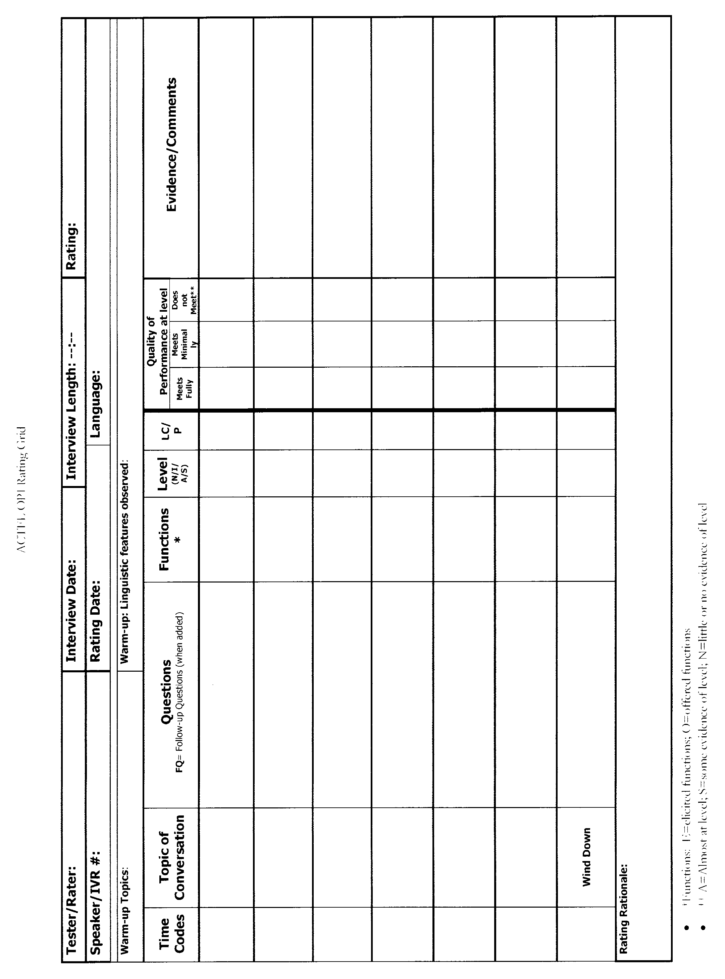
Sample: ACTFL Oral Proficiency Interview Rating Grid
The ACTFL rating grid below is used in AKNS A292B: Alaska Native Conversational Fluency Intensive.

Appendix B: Exams

Measure Description
Two courses (AKNS A 102E, AKNS A109D) use individual exam data on cumulative course content scored by an instructor according to a predesigned scoring template, that address course outcomes, program outcomes, or both.

The exam used for each course will be the final exam for the semester. Final exams are conducted using an online course platform (Blackboard) and are capable of multimedia content (i.e., images, audio/video delivery and recording). Question types used on exams are varied, including true/false, multiple choice, short answer, long answer, image “hot spot” identification, translation, and audio submission. The AKNS A109D: Alutiiq Orthography exam covers all aspects of the Orthography (writing system) and is used to measure PSLO #2 (Reading & Writing). The AKNS A102E: Elementary Alutiiq II exam covers holistic language understanding and speaking proficiency, and is used to measure PSLO #1 (speaking proficiency).

Factors that May Affect (or Skew) the Collected Data
- Students may enter the program with existing Alutiiq language proficiency due to existing community and K-12 programs, or rare cases of at-home Alutiiq language learning
- Some students may have undisclosed or undiagnosed learning disabilities or other conditions
- Some students may experience anxiety in testing or assessment situations
- Students may experience technological difficulties, such as Blackboard or internet outages or malfunctions

How to Interpret the Data
Exam data (overall score converted to percentage) will be collected and reported by the instructor to the Program Chair.

Appendix C: Student Products

Measure Description
Four courses use assignments or products created by individuals or teams of students, evaluated and scored by an instructor according to a predesigned scoring template, that address course outcomes, program outcomes, or both. Faculty will select assignments that meet the PSLOs and fall within the second half of a semester-long course. This measure has been chosen for PSLO #2 (reading & writing) in AKNS A102E: Elementary Alutiiq II, PSLO #3 (language concepts) in AKNS A240A: Alutiiq Cultural Orientation, and PSLO #4 (resource utilization) in AKNS A109D: Alutiiq Orthography.

Factors that May Affect (or Skew) the Collected Data
- Some students may not contribute equally in student product assignments when working in teams
- Some students may have undisclosed or undiagnosed learning disabilities or other conditions

How to Interpret the Data
Student product or assignment data (overall score converted to percentage) will be graded according to a rubric, collected and reported by the instructor to the Program Chair.

Sample Rubric for Student Products
This sample rubric below is used for scoring the AKNS A102E: Elementary Alutiiq II final project.
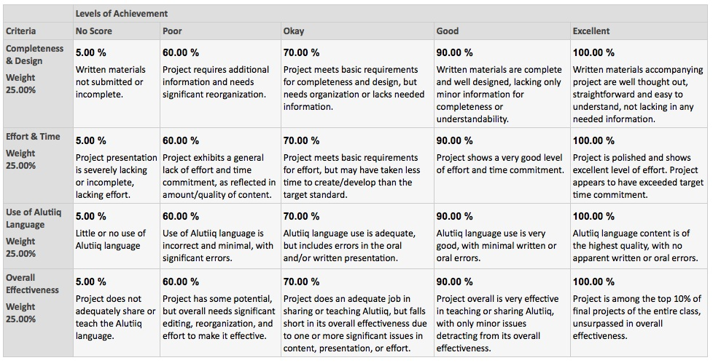

Appendix D: Student Discussion & Focus Groups

Measure Description
Two courses (AKNS A101E, AKNS A292A) use individual participation and performance in student discussion boards, audio/video discussion platforms, or focus groups to assess performance on PSLO #4 (resource utilization). This measure is scored according to a rubric.

Factors that May Affect (or Skew) the Collected Data
- Some students may have undisclosed or undiagnosed learning disabilities or other conditions
- Students may experience technological difficulties, such as Blackboard or internet outages or malfunctions
- Some students, such as introverted students, may experience discomfort in speaking or participating in class discussion

How to Interpret the Data
Student discussion data (overall score converted to percentage) will be graded according to a rubric, collected and reported by the instructor to the Program Chair.

Sample Rubric for Student Discussion
The sample rubric below is used to evaluate student discussion related to PSLO #4 (resource utilization) in AKNS A101E: Elementary Alutiiq I.

Student Discussion/Focus Group: Grading Rubric
Criteria | No Score: 0 | Okay: 2 | Good: 3 | Excellent: 4
Participation | Student does not participate | Student meets basic requirements of discussion with one relevant comment | Student offers two or more relevant comments | Student offers 3 or more relevant comments
Awareness of available sources | Student does not demonstrate awareness of any sources | Student demonstrates awareness of at least 1 relevant source | Student demonstrates awareness of at least 2 relevant sources | Student demonstrates awareness of 3 or more relevant sources
Evaluation of resource quality | Student unable to evaluate quality of resources | Student is able to evaluate two resources against each other | Student can discuss the qualities of a trustworthy Alutiiq language resource, and provide examples | Student can evaluate multiple resources against reach other, evaluating based on age, orthography, authorship, and level of editing
Location of resources | Student cannot locate resources. | Students can identify one location (physical or online) to find Alutiiq language reference materials | Students can identify 2 or more locations (physical or online) to find Alutiiq language reference materials | Student can locate physical and digital versions of key resources, and teach others how to locate needed resources

American Council on the Teaching of Foreign Languages (ACTFL) proficiency guidelines. Accessed on March 12th, 2014 at: http://www.actfl.org/sites/default/files/pdfs/public/ACTFLProficiencyGuidelines2012_FINAL.pdf
Faculty in the Alutiiq Studies program have received training by ACTFL on language proficiency and the Oral Proficiency Interview technique by an ACTFL-certified trainer.

