Aviation Maintenance Technology Program

Associate of Applied Science

Educational Effectiveness

Assessment Plan

Version 3.0

Adopted by

The Aviation Maintenance Faculty: 11/30/07

Submitted to

The Dean of the Community and Technical College: 11/30/07
The Office of Academic Affairs: 12/3/07

Reviewed with curriculum changes by the Academic Assessment Committee as an information item: 5/3/19
Reviewed by the Faculty Senate as an information item: 5/3/19

Table of Contents

Mission Statement 3
Program Introduction 3
Assessment Process Introduction 3
Program Outcomes 5
Table 1: Association of Assessment Measures to Program Outcomes 6
Assessment Measures 6
Table 2: Program Outcomes Assessment Measures and Administration 6
Assessment Implementation & Analysis for Program Improvement 7
General Implementation Strategy 7
Method of Data Analysis and Formulation of Recommendations for Program Improvement 7
Modification of the Assessment Plan 7
Appendix A: FAA Standardized Knowledge Exams “National Norms” 8
Measure Description: 8
Factors that affect the collected data: 8
How to interpret the data: 8
Appendix B: FAA Oral and Practical Exam Results 11
Measure Description: 11
Factors that affect the collected data: 11
How to interpret the data: 11
Appendix C: Exam Data for Airframe Program Knowledge 11
Measure Description: 11
Factors that affect the collected data: 11
How to interpret the data: 11
Appendix D: Exam Data for Industry Knowledge 11
Measure Description: 11
Factors that affect the collected data: 11
How to interpret the data: 11
Appendix E: Project/Paper Data for Critical Thinking, Problem Solving and Communication 11
Measure Description: 11
Factors that affect the collected data: 11
How to interpret the data: 11

Mission Statement

The Aviation Technology Division strives to achieve the following:

“The mission of University of Alaska Anchorage Aviation Technology Division is to enhance, promote, and provide quality aviation education, research, and service worldwide.”

Within that mission the Aviation Maintenance Technology program strives to achieve the following:

“The mission of the Aviation Maintenance Technology program is to meet the educational needs of individuals and the aviation maintenance needs of the State of Alaska, the nation and the world by preparing graduates to be highly qualified aviation maintenance professionals and employees.”

Program Introduction

The Aviation Maintenance Technology (AMT) program is a Federal Aviation Administration (FAA) approved and nationally recognized course of study that is designed to prepare graduates for entry into positions as maintenance technicians in general aviation, corporate aviation, airlines, or aerospace manufacturers. In addition to traditional aircraft maintenance courses, the curriculum emphasizes modern aircraft systems including electronics, composite structures, automatic controls and turbine engines. The Aviation Technology Division (ATD) offers two Aviation Maintenance Undergraduate Certificates, one with an Airframe and the other with a Powerplant emphasis.

The FAA approved AMT undergraduate certificate programs provide all of the required content to prepare students to achieve FAA certification as Aircraft Mechanics with Airframe and/or Powerplant ratings. Upon completion of the UAA undergraduate certificate programs, students may take written, oral and practical tests that are administered by FAA designees. Those who achieve passing scores on these tests are awarded the Aircraft Mechanic Certificate with appropriate rating(s) by the FAA.

After earning either undergraduate certificate, additional study allows a student to earn an Associate of Applied Science (AAS) degree in Aviation Maintenance Technology.

Assessment Process Introduction
This document defines the expected student learning outcomes for the Aviation Maintenance Technology program and outlines a plan for assessing the achievement of the stated outcomes.
The development of the original outcomes in 2003 consisted of utilizing the outcomes from the Federal Aviation Administration approved curriculum and UAA AAS GER requirements that have been utilized, with periodic revision, since the program was established in approximately 1980. These outcomes were deemed to be too numerous for UAA’s assessment process and therefore the outcomes were condensed and restated as shown in this current plan. Additionally, the assessment tools used were considered to be too dependent on indirect measures and therefore the faculty adopted new tools with this current plan. This represents a major revision of this plan.
The faculty met to review and discuss the outcomes and assessment processes throughout November 2007 and accepted this plan on November 30, 2007.

Program Outcomes

At the completion of this program, graduates will be able to:

- Demonstrate proficient, entry-level aviation maintenance skills.
- Demonstrate proficiency in emphasis area skills: airframe or powerplant.
- Demonstrate knowledge of aircraft engines, structures, and systems, as well as appropriate FAA regulations.
- Demonstrate knowledge of industry information: current status, segments and opportunities.
- Demonstrate critical thinking, problem solving, and communication skills.

Table 1: Association of Assessment Measures to Program Outcomes

Outcomes | FAA National Norms | Oral & Practical Exams | Exams, Program knowledge | Exams, Industry Knowledge | Project/  Paper Data
Proficient, entry-level aviation maintenance skills. | 0 | 1 | 1 | 0 | 0
Proficiency in emphasis area skills: Airframe or Powerplant | 0 | 1 | 1 | 0 | 0
Knowledge, as appropriate, of aircraft engines, structures and systems, as well as appropriate FAA regulations. | 1 | 1 | 1 | 0 | 0
Knowledge of industry information: current status, segments and opportunities. | 0 | 0 | 0 | 1 | 0
Critical thinking, problem solving, and communication skills. | 0 | 0 | 0 | 0 | 1
0 = Measure is not used to measure the associated outcome.
1 = Measure is used to measure the associated outcome.

Assessment Measures

A description of the measures used in the assessment of the program outcomes and their implementation are summarized in Table 2 below. The measures and their relationships to the program outcomes are listed in Table 1, above.

There is a separate appendix for each measure that shows the measure itself and describes its use and the factors that affect the results.

Table 2: Program Outcomes Assessment Measures and Administration

Measure | Description | Frequency/ Start Date | Collection Method | Administered by
FAA Standardized Knowledge Exams “National Norms” | National certification exam results comparing all certificated aviation maintenance schools | Annually/ Summer semester | Web based reports | FAA, reports available on the web. Collected by faculty.
FAA Oral and Practical Exam Results | National certification exam results comparing performance of aviation maintenance program graduates | Annually/ Summer semester | Received from designated examiners | Collected by faculty.
Exam Data for Airframe Program Knowledge | Averaged final exam results of courses within the program appropriate to the emphasis area; Airframe or Powerplant | Annually/ Summer semester | From AMT program files | Collected by faculty.
Exam Data for Industry Knowledge | Averaged exam results of courses within the program appropriate to the emphasis area; Airframe or Powerplant | Annually/ Summer semester | From AMT program files | Collected by faculty.
Project/Paper Data for Critical thinking, Problem solving and Communication | Averaged project/paper results of courses within the program.  1. For the Airframe emphasis:  - AMT 364 Avionics Systems  - Individual Research Paper  - AMT 369L Airframe Inspections and Assembly Lab  - Inspection checklist lab  - Conformity check lab  - Airworthiness directive lab  2. For the Powerplant emphasis:  - AMT 187L Reciprocating Engine Overhaul Lab  - Engine overhaul lab report  - AMT 279L Turbine Engine Repair and Overhaul Lab  - Combined average of complete engine lab projects/reports | Annually/ Summer semester | From AMT program files | Collected by faculty.

Assessment Implementation & Analysis for Program Improvement

General Implementation Strategy

The general strategy for implementation of this and all successive plans is as follows:

- Late spring and summer semester- collect data from the identified sources.
- Early fall semester- compile collected data and provide copies to faculty.
- Late fall semester- faculty meets to review and interpret data.
- Early spring semester- faculty meets to revise/modify/expand plan and program based on data review.
- Late spring semester- implement changes and begin cycle again.

Method of Data Analysis and Formulation of Recommendations for Program Improvement

The faculty of the program is to meet at least twice a year to review the data collected and revise/modify/expand the plan and assessment tools. These meetings should result in recommendations for program changes that are designed to enhance performance relative to the program’s objectives and outcomes. The results of the data collection, an interpretation of the results, and the recommended plan and programmatic changes are to be forwarded to the office of Academic Affairs (in the required format) by the end of May each year. A plan for implementing the recommended changes, including advertising the changes to all the program’s stakeholders, is also to be completed at the meetings.

The proposed programmatic changes may be any action or change in policy that the faculty deems as being necessary to improve performance relative to program outcomes. Recommended changes should also consider workload (faculty, staff, and students), budgetary, facilities, and other relevant constraints. A few examples of changes made by programs at UAA include:
- changes in course content, scheduling, sequencing, prerequisites, delivery methods, etc.
- changes in faculty/staff assignments
- changes in advising methods and requirements
- addition and/or replacement of equipment
- changes to facilities

Modification of the Assessment Plan

As this plan version incorporates major changes it is anticipated that the faculty, after reviewing the collected data and the processes used to collect it, may decide to alter the assessment plan. Changes may be made to any component of the plan, including the outcomes, assessment measures, or any other aspect of the plan. The changes will be approved by the faculty of the program. The modified assessment plan will be forwarded to the dean/director’s office and the Office of Academic Affairs.

Appendix A: FAA Standardized Knowledge Exams “National Norms”

Measure Description:

Aviation maintenance technicians are required to pass a series of exams to receive a certificate to perform maintenance on U.S. civil aircraft. This series includes written, oral and practical exams in the areas of General with Airframe or Powerplant. The written portions of the exams are conducted at FAA testing centers with the results tabulated and reported with a comparison to the national averages, or “norms”.

This test data can be retrieved from the FAA web site and used as an indicator of student performance on a standardized, national certification exam. As the results are reported based on the school from which the student graduated, the comparison to other aviation maintenance schools and their graduates is a direct one.
Factors that affect the collected data:

As with all statistics, the results require an understanding of what is being presented. The FAA data is published quarterly and in a standard format. The data presents results for the current quarter and an average for the previous 12 months. If no students from the school take a test during a calendar quarter the data can appear skewed.

All of the factors affecting the data are known to the faculty and an accurate analysis can be made with some effort. A spreadsheet to analyze the data has been created and used successfully thereby reducing any potential individual interpretation.

As the FAA and UAA operate on different calendars, the exam results will only be collected and analyzed annually. This will give a complete picture of the number of students completing the program and provide for less statistical variation.
How to interpret the data:

As the results are reported for each of the FAA subject areas, which are covered in their entirety by the outcomes listed above, the correlation should be very good. Once the statistical variations are accounted for the test results can be directly compared to the outcomes for an indicator of effectiveness.

An example copy of the FAA Standardized Knowledge Exams “National Norms” report is attached below.

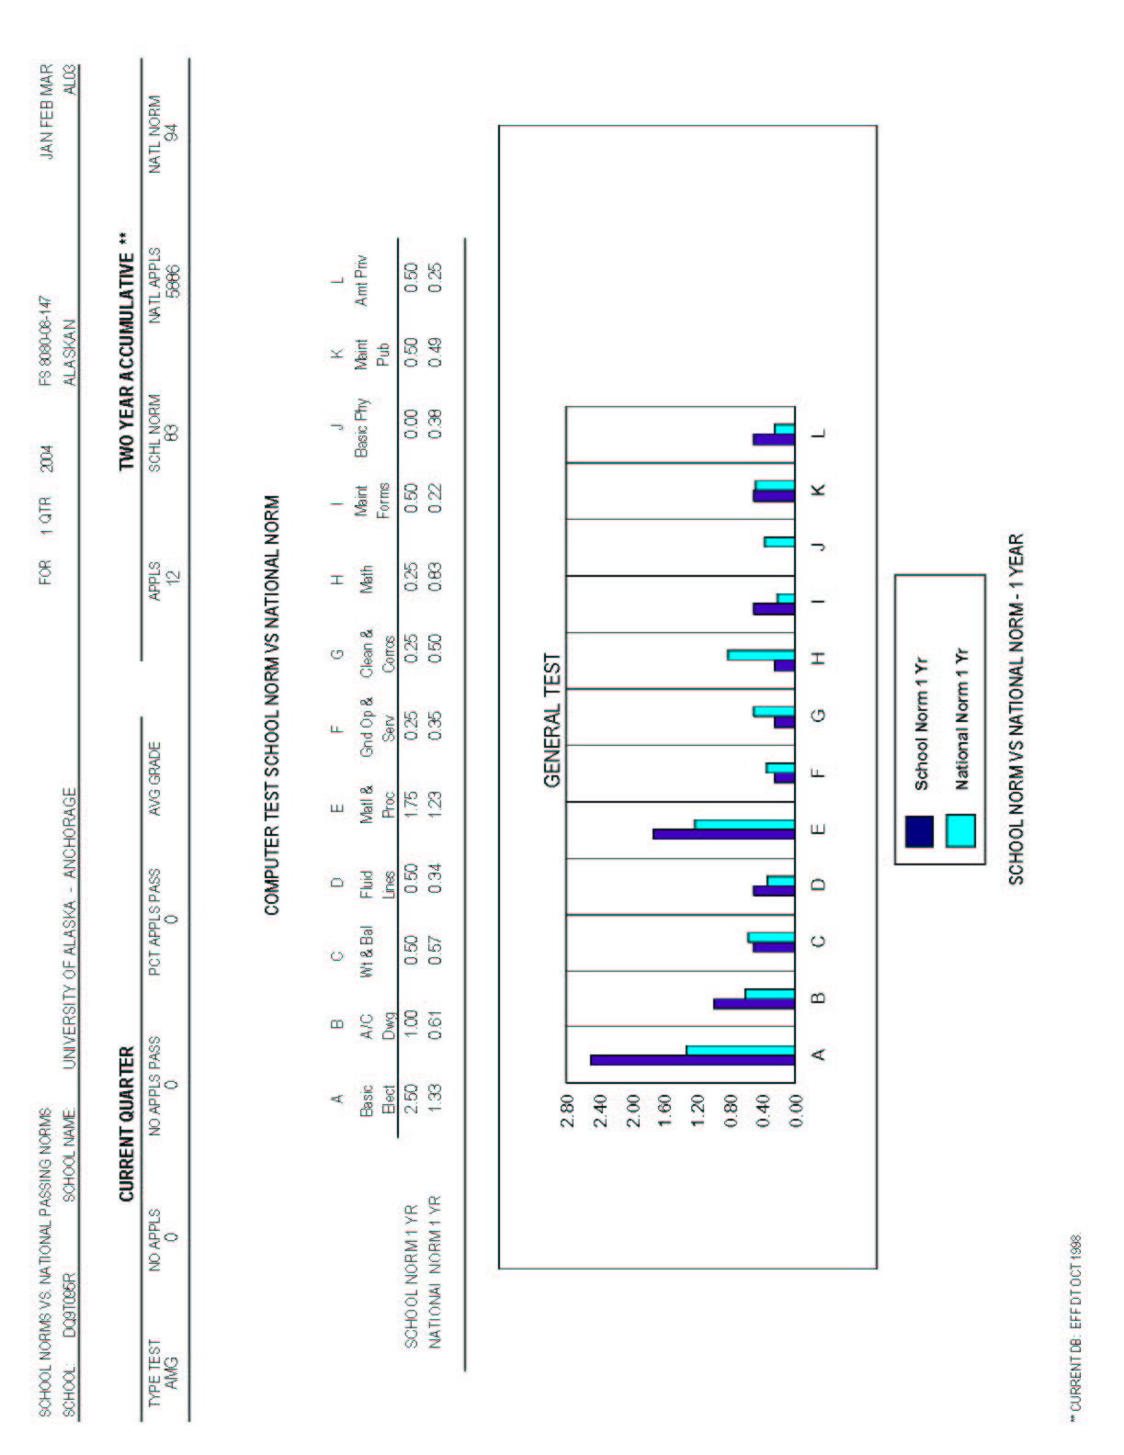

Appendix B: FAA Oral and Practical Exam Results

Measure Description:

Aviation maintenance technicians are required to pass a series of exams to receive a certificate to perform maintenance on U.S. civil aircraft. This series includes written, oral and practical exams in the areas of General with Airframe or Powerplant. The oral and practical portion of the exams are conducted by FAA designated examiners at the Aviation Technology Division.

These examiners have agreed to provide the results of the examinations for UAA graduates. The exam results will be used as an indicator of student performance on a standardized, national certification exam.
Factors that affect the collected data:

The exam results will be collected from the examiners for graduates of UAA with personal information redacted. Currently the two examiners who work at the Division examine practically all UAA graduates for their certification. If in the future other examiners begin testing a significant number of graduates a method of collecting this data will need to be devised.

As the oral and practical exams cover all areas of knowledge and skills related to the aviation maintenance outcomes, good correlation is anticipated. The majority of graduates take the exam at the end of the Spring semester, but as currently all students take their exams with the resident examiners a 100% capture is possible.
How to interpret the data:

Each examiner develops an oral and practical exam based on a national standard of knowledge and projects that test the applicants understanding and ability.

The oral portion of the exam is given a numerical percentage which is based on passing with 70% of the knowledge areas. This percentage directly measures the applicant’s knowledge and will be used directly and unmodified.

The practical portion of the exam requires the applicant to perform a project to demonstrate skill in the particular area. This portion is given a pass/fail by the examiner and, again, the applicant must pass 70% of the projects to receive certification. The percentage of projects successfully passed is a direct measure of the applicant’s ability and will be used directly and unmodified.

As the results are reported for each of the FAA subject areas, which are covered in their entirety by the outcomes listed above, the correlation should be very good. The test results can be directly compared to the outcomes for an indicator of effectiveness.

An example copy of the examiners Oral and Practical Test Planning Sheet which is used to record the results of the exam is attached below.

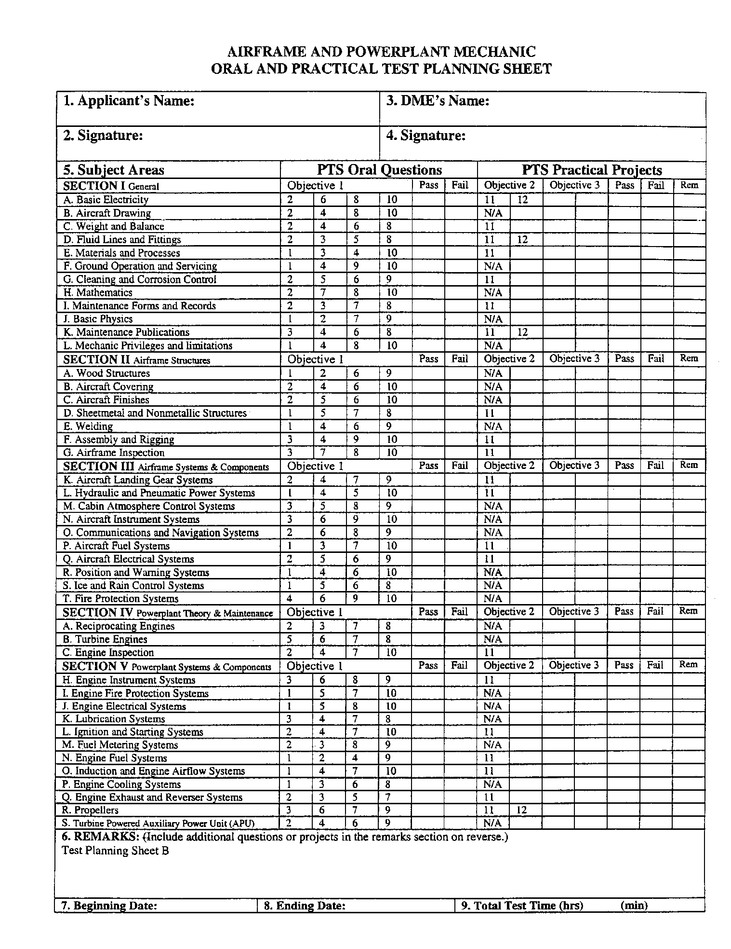
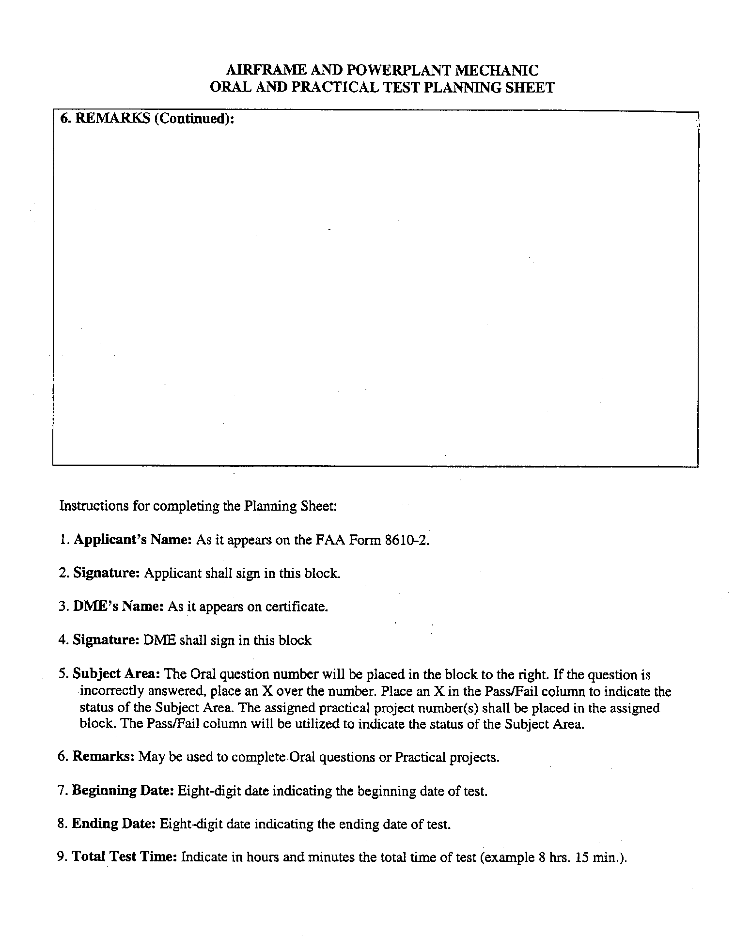
Appendix C: Exam Data for Emphasis Area Knowledge
Measure Description:

The stated outcomes:

- Proficient, entry-level aviation maintenance skills.
- Proficiency in emphasis area skills: Airframe or Powerplant
- Knowledge of aircraft engines, structures and systems, as well as appropriate FAA regulations.

can be assessed with the averaged final exam results from the following representative courses within the program according to the emphasis area sought.

1. For the Airframe emphasis:

- AMT 172 Aircraft Publications, Regulations and Records
- AMT 185 Sheet Metal Structures
- AMT 273 Aircraft Fluid Power Systems
- AMT 274 Aircraft Electronic Systems
- AMT 283 Aircraft Auxiliary Systems
- AMT 285 Aircraft Bonded Structures
- AMT 369 Airframe Assembly and Inspections

2. For the Powerplant emphasis:

- AMT 172 Aircraft Publications, Regulations and Records
- AMT 181 Aircraft Fuel Systems
- AMT 187 Reciprocating Engine Overhaul
- AMT 282 Aircraft Propeller Systems
- AMT 284 Aircraft Electrical Machinery
- AMT 287 Reciprocating Engine Installation and Operation
- AMT 289 Turbine Engine Installation and Operation

The courses provide an overall coverage of topics a proficient maintenance technician would be expected to know. As the courses cover material from the introductory level to the final course wherein the student is expected to apply their cumulative knowledge to a broad range of scenarios a comprehensive assessment is provided.
Factors that affect the collected data:

The AMT program is required by the FAA to retain the exams of all students for 2 years beyond their graduation. These exams are on file at the Aviation Technology Division and accessible by the AMT faculty and the ATD office staff only.

As all instructors are required by the FAA to give at least 2 exams for the above mentioned records, the availability of these exams is assured.
How to interpret the data:

The final exam scores of the courses will be collected and averaged. Each course provides a building-block for subsequent courses.

The data will be collected and averaged as follows:

- Average of each course final exam scores independently
- Combined average of all courses final exam scores

The assessment will initially be based on the combined average with the individual course averages used to determine if adjustments are needed in the early or late stages of the program.

Variations in student enrollment will affect the data and the faculty has discussed several weighted average possibilities. It was decided to use the raw average for at least one assessment cycle to establish a base line.

Appendix D: Exam Data for Industry Knowledge

Measure Description:

The stated outcome “knowledge of industry information: current status, segments and opportunities” is best assessed with the averaged exam results of the following courses within the emphasis areas:

1. For the Airframe emphasis:

- AMT 172 Aircraft Publications, Regulations and Records
  - Final exam
- AMT 369 Airframe Assembly and Inspections
  - Final exam

These courses provide the broadest coverage of employers and segments and the regulatory environment affecting those employed in the industry. AMT 172 is the introductory course where the student is first exposed to this industry environment and AMT 369 is the final course wherein the student is expected to apply their cumulative knowledge to a broad range of scenarios.

2. For the Powerplant emphasis:

- AMT 172 Aircraft Publications, Regulations and Records
  - Final exam
- AMT 187 Reciprocating Engine Overhaul
  - Exam #1
- AMT 279 Turbine Engine Repair and Overhaul
  - Exam #1

These courses provide the broadest coverage of employers and segments and the regulatory environment affecting those employed in the industry. AMT 172 is the introductory course where the student is first exposed to this industry environment and AMT 187 and 279 are the courses wherein the student is expected to apply their cumulative knowledge to a broad range of scenarios.

The exam data from these courses should provide an initial and final comparison of the students understanding of the industry and career they are entering.
Factors that affect the collected data:

The AMT program is required by the FAA to retain the exams of all students for 2 years beyond their graduation. These exams are on file at the Aviation Technology Division and accessible by the AMT faculty and the ATD office staff only.

As all instructors are required by the FAA to give at least 2 exams for the above mentioned file, the availability of these exams is assured.

How to interpret the data:

The exam scores of these courses will be collected and averaged. Each course provides a building-block for subsequent courses.

The data will be collected and averaged as follows:

- Average of each course exam scores independently
- Combined average of all courses exam scores

The assessment will initially be based on the combined average with the individual course averages used to determine if adjustments are needed in the early or late stages of the program.

Variations in student enrollment will affect the data and the faculty has discussed several weighted average possibilities. It was decided to use the raw average for at least one assessment cycle to establish a base line.

Appendix E: Project/Paper Data for Critical Thinking, Problem Solving and Communication

Measure Description:

The stated outcome “critical thinking, problem solving, and communication skills” requires considerable data to fully assess. This outcome will be assessed with the averaged project and research paper results of the following courses within the AAS program:

1. For the Airframe emphasis:

- AMT 364 Avionics Systems
  - Individual Research Paper
- AMT 369L Airframe Inspections and Assembly Lab
  - Inspection checklist lab
  - Conformity check lab
  - Airworthiness directive lab

Within the Airframe emphasis area of the AAS the projects/papers listed are cumulative applications of the knowledge the student receives in this emphasis area. These projects and associated reports require the student to research and critically analyze data, regulations, and physical factors and make a determination of solutions and required actions. All results are presented in comprehensive written reports. All labs are performed in a group/team environment requiring oral communications and group interaction.

2. For the Powerplant emphasis:

- AMT 187L Reciprocating Engine Overhaul Lab
  - Engine overhaul lab report
- AMT 279L Turbine Engine Repair and Overhaul Lab
  - Combined average of complete engine lab projects/reports

Within the Powerplant emphasis area of the AAS the projects listed are cumulative applications of the knowledge the student receives in this emphasis area. These projects and associated reports require the student to research and critically analyze data, regulations, and physical factors and make a determination of solutions and required actions. All results are presented in comprehensive written reports. All labs are performed in a group/team environment requiring oral communications and group interaction.

These scores and associated averages represent the student’s ability to research and critically analyze data, regulations, and physical factors and make a determination of solutions and required actions. These projects and papers also demonstrate the student’s abilities within written communications while the group/team environment demonstrates the student’s ability to communicate within that setting.

Factors that affect the collected data:

The AMT program is required by the FAA to retain records of lab project/class scores of all students for 2 years beyond their graduation. These records are on file at the Aviation Technology Division and accessible by the AMT faculty and the ATD office staff only.

As all instructors are required by the FAA to utilize a standard set of projects for the above mentioned file, the availability of these records is assured.
How to interpret the data:

The project/paper scores of the identified courses will be collected and averaged as follows:

- Average of each individual class projects/papers
- Combined average of courses within the emphasis area

The assessment will initially be based on the combined average with the individual course project/paper averages used to determine if adjustments are needed within individual areas of the program.

Variations in student enrollment will affect the data and the faculty has discussed several weighted average possibilities. It was decided to use the raw average for at least one assessment cycle to establish a base line.

