Bachelor of Business Administration (BBA) Educational Effectiveness Assessment Plan

Version 2022

Approved by the CBPP faculty in
September 2021

Submitted to the Dean of the College of Business and Public Policy in
November 2021

Submitted to the UAA Office of Academic Affairs in
November 2021

Reviewed with curriculum changes by the Academic Assessment Committee: 12/3/21
Reviewed by the Faculty Senate as an information item: 12/3/21

BBA Educational Effectiveness Assessment Plan
Table of Contents
Introduction 3
College Mission Statement 4
Program Mission Statement 4
BBA Competency Goals 5
BBA Learning Objectives 6
Table 1 - Learning Objectives Supporting BBA Goal 1 (Discipline Content Knowledge) 7
Table 2 – BBA Competency Goals and Learning Objectives 2 through 4 (All Disciplines) 8
Student Success Rate Goal 9
Assessment Tools 9
Table 3 – Direct Assessment Tools and Administration 10
Assessment Implementation & Analysis for Program Improvement 11
Assessment Timetable 12
Appendix A: BBA Core Curriculum Mapping 14
Appendix B: Examples of Assessment Data Collection Documents 15

Introduction
Purpose. The purpose of this document is to provide a guide for assessing the overall academic effectiveness of the Bachelor of Business Administration degree program (BBA) offered by the College of Business and Public Policy (CBPP). This document addresses the needs of accreditors, administrators, external stakeholders, students, and faculty. Accreditors set general standards including the requirement that actual results agree with the mission statements of the BBA program and the College. Administrators are accountable for program effectiveness and ensuring the program is delivering expected program student learning outcomes (PSLOs). The assessment of PSLOs is critical to certify the BBA program is meeting the expectations of external stakeholders (i.e., employers and the business community) in relation to graduates and their professional skill sets. Students should receive a knowledge base in respective majors from the BBA program, which can be applied to professions. The faculty is responsible pedagogically for the implementation, assessment, and analysis of the effectiveness and continued improvement of instruction.

Relationship to the Association to Advance Collegiate Schools of Business International (AACSB) standards. The BBA is one of four CBPP degree programs accredited by AACSB International (www.aacsb.edu). While this plan was designed to meet AACSB standards and program definitions, it is also consistent with Northwest Commission on Colleges and Universities (NWCCU) standards.

Readers of this plan should note that the terms “learning objective” used by AACSB and program student learning outcome (PSLO) used by NWCCU have the same meaning throughout this document.

Relationship to disciplinary majors. The BBA program encompasses six (6) disciplinary majors:

- Accounting
- Economics
- Finance
- Logistics
- Management
- Marketing

Each department, or disciplinary area, will supplement this assessment plan with additional content knowledge learning objectives (LOs) specific to their major. Supplemental materials will be included within this plan as appendices.

College Mission Statement
The College of Business and Public Policy at the University of Alaska Anchorage prepares students for leadership at the frontiers of a changing world. We help diverse and growing communities in Alaska and elsewhere meet their challenges by delivering the highest quality in business and public policy education, research, and professional assistance.

Program Mission Statement
The College of Business and Public Policy’s degree programs are designed to actively engage students, faculty, staff, and community members in developing and applying the knowledge and skills necessary for success in a complex, global environment.

Discipline specific mission statements:

- Accounting – The mission of the Accounting Program is to prepare professionals for careers in accounting by providing a well-rounded foundation in areas of accounting practice.

- Economics – The mission of the Economics Program is to discover and disseminate knowledge through teaching, research, and engagement. Economics professionals develop critical thinking, quantitative, problem solving, and communication skills allowing them to contribute to complex policy debates and excel in a rapidly changing global labor market.

- Finance – The mission of the Finance Program is to develop professionals grounded in the financial principles of diversification, asset pricing, valuation, and capital budgeting.

- Management – The mission of the Management Program is to present insights into best practices, both theoretical and applied, to help prepare professionals to understand, predict, and manage their work environment.

- Global Logistics and Supply Chain Management – The mission of the Global Logistics and Supply Chain Management Program is to prepare professionals to pursue meaningful and rewarding careers in management areas involving the movement of material into and within a business, and distribution of final products to customers.

- Marketing – The mission of the Marketing Program is to produce creative and analytical professionals who hold a comprehensive knowledge base of the key marketing concepts, processes, and tools essential for success in the marketplace.

BBA Competency Goals
Competency goals articulate what graduates should be able to do and/or what overall traits they should possess at the conclusion of the BBA program.

To align with the AACSB standards, competency goals will be supported by one to two direct measurable learning objectives and at least one indirect measurable learning objective. The 2020 AACSB accreditation standards state, “(Learning) objectives identify specific, observable behaviors and actions related to a goal that faculty will use to describe, monitor, and assess student achievement. Thus, objectives are used as indicators of (competency) goals.”

Upon graduation, BBA program graduates will possess the following skills as defined by these BBA Competency Goals:

- Students will have a baccalaureate content knowledge of his/her major discipline.
- Students will have knowledge of business environments.
- Students will have analytical skills.
- Students will have professional communication skills.

Competency Goal 1 is measured separately for each discipline in the BBA program. Goals 2 through 4 are common to all disciplines and are therefore measured using representative samples of all BBA students.

BBA Learning Objectives
The achievement of each competency goal is measured by student achievement of specific and measurable learning objectives. The BBA faculty has identified student learning objectives for each goal.

Competency Goal 1
Learning Objective 1.1
Competency Goal 2
Learning Objective 1.2

Goal 1 – Students will have a baccalaureate content knowledge of his/her major discipline.

The learning objectives for this goal (called the “content knowledge goal”) vary by discipline. Learning objectives for each discipline area are listed in Table 1.

Table 1 - Learning Objectives Supporting BBA Goal 1 (Discipline Content Knowledge)
Discipline | Objective
Accounting | ACCT 1.1 – Prepare financial statements.
 | ACCT 1.2 – Prepare a cost allocation.
 | ACCT 1.3 – Prepare a tax return.
Economics | ECON 1.1 - Achieve a score of 80% or higher on a comprehensive exam.
 | ECON 1.2 – Demonstrate content knowledge in a written senior paper.
 | ECON 1.3 – Demonstrate content knowledge by applying economic reasoning to solve empirical problems in business and public policy.
Finance | FIN 1.1 – Show a knowledge of asset pricing.
 | FIN 1.2 – Execute an understanding of valuation and capital budgeting.
 | FIN 1.3 – Demonstrate knowledge of the financial environment.
Logistics | LOG 1.1 – Demonstrate an understanding of the role logistics plays in creating or adding value to supply chain management.
 | LOG 1.2 – Identify key logistics components and explain how they affect the economy and the financial performance of organizations.
 | LOG 1.3 – Recognize the process of how data is transformed into information appropriate to logistics and supply chain management.
 | LOG 1.4 – Explain how information systems can increase efficiency along a supply chain.
Management | MGMT 1.1 – Understand individual and organizational behavior and human resource issues
 | MGMT 1.2 – Identify business strategies and best practices for managing resources and optimizing results
 | MGMT 1.3 – Forecast and plan operating systems
 | MGMT 1.4 – Understand economic, demographic, and geographic trends and their impacts on industries
 | PMRE 1.1 - Project the financial performance of an income-producing real estate asset.
 | PMRE 1.2 - Demonstrate property management knowledge by producing a comprehensive Property Profile report/analysis.
Marketing | MKTG 1.1 – Demonstrate the knowledge and skills to analyze markets and data to understand consumers, media, and competitors to make effective marketing decisions.
 | MKTG 1.2 – Explain marketing concepts and channels that drive, design, develop, and deliver integrated marketing communication.
 | MKTG 1.3 – Understand the strategic planning process by translating goals into a comprehensive marketing plan.
 | MKTG 1.4 – Identify and use the techniques and methods to define, segment, and target consumers and affect the consumer decision-making process.

Table 2 – BBA Competency Goals and Learning Objectives 2 through 4 (All Disciplines)
Goal 2 – Students will have knowledge of business environments.
Objective 2.1 – Convey knowledge of business perspectives.
Goal 3 – Students will have analytical skills.
Objective 3.1 – Apply analytical techniques to solve business problems.
Goal 4 – Students will have professional communication skills.
Objective 4.1 – Demonstrate effective written communication skills.
Objective 4.2 – Demonstrate effective oral communication skills.

Student Success Rate Goal
In AY 2021-2022 and years prior, our goal was that 70% of students would successfully demonstrate achievement of learning objectives.

Starting in AY 2022-2023, we have increased our goal to 75%.

From AY 2022-2028, we plan to incrementally increase the successful percentage from 75% to 80%, which is a 10-percentage point increase over 7 years.

Assessment Tools
Concept of the assessment tool. For the purposes of this plan, an assessment tool is a procedure, protocol, or exercise that is reasonably objective, repeatable over time, and can be used to carry out the following two-step process for each learning objective:

Step 1: Determine whether each student did or did not meet the objective (yes or no).
Step 2: Determine the percentage of sampled students who did meet the objective.

This concept follows AACSB guidelines. This method purposely deemphasizes exceptionally high and low scores and focuses program improvement on increasing the number of students who achieve a certain competency level.

Example. Objective 4.2 states that students will “demonstrate effective oral communication skills.” Any tools used to measure the achievement of this objective must be capable of returning a “successful” or “not successful” evaluation for each oral communication artifact delivered by the student. As a second step, the percentage of assessed students who did achieve the objective is computed. The result of using this tool might be that 75% of sampled students demonstrated successful achievement of this objective.

Table 3 summarizes the primary tools to be used in evaluating the BBA program’s learning objectives. Assessment of these goals and their objectives will be completed in the BBA curriculum’s core courses. These core courses are completed by all BBA degree seeking students.

Table 3 – Direct Assessment Tools and Administration
Tool | Description  (Students will…) | Data Collection Method | Administered by
Business Presentations | Prepare and deliver a managerial level presentation of a relevant business topic | Evaluation by faculty using standardized rubrics | Course Instructors
Written Papers | Compose papers as part of BBA core course assignments | Evaluation by faculty using standardized rubrics | Course Instructors
Case Analyses | Analyze aspects of a business case; develop conclusions and/or recommendations | Evaluation by faculty using standardized rubrics | Course Instructors
Embedded Course-Level Assessments | Complete or perform specific assignments and/or sections of course examinations | Evaluation by faculty using standardized rubrics | Course Instructors
Capstone Course  Artifacts | Integrate discipline knowledge relative to program outcomes as demonstrated by written work, project deliverables, and/or oral presentations | Evaluation by faculty using standardized rubrics | Course Instructors

NOTE: Standard rubrics have been developed to assist in assessing Learning Objectives 2-4. These rubrics were developed by the CBPP Assurance of Learning Committee.

Data is collected during both fall and spring semesters of an academic year for BBA Competency goals. Following an assessment schedule required by AACSB, not all Competency goals are assessed every year. The schedule is set so that the odd-numbered competency goals (1 and 3) are collected in odd academic years (2023, 2025, etc.). Even-numbered competency goals (2 and 4) are collected in even academic years (2022, 2024, etc.).

AACSB makes a distinction between direct measures of learning and indirect measures of learning. Direct measures are defined as having demonstrable evidence about specific student learning and the learning environment: exam questions or rubrics applied to projects, portfolios, observations, etc. Indirect measures are defined as having evidence about how students or (other stakeholders) feel (i.e., their perceptions) about learning and their learning environment: surveys, questionnaires, interviews, focus groups, reflective essays, etc. Indirect data measures will be collected annually from students and at least twice during a five-year cycle from other stakeholders.

Assessment Implementation & Analysis for Program Improvement
General Management of Assessment Activities
The assessment activities are managed through CBPP Assurance of Learning (AoL) committee that is comprised of a faculty member from each department plus the committee chair and the associate dean (ex-officio).

General Implementation Strategy
The CBPP AoL Committee is responsible for overseeing the assessment process.

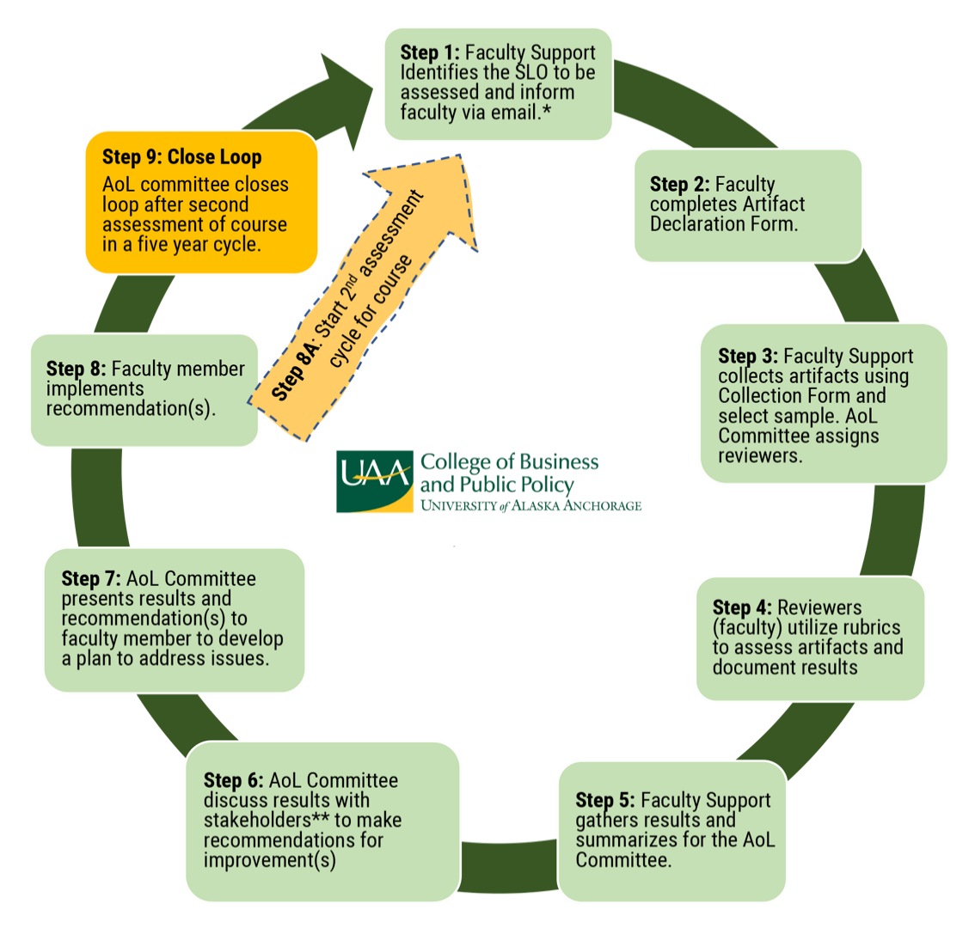

*Faculty are contacted at the beginning, middle and end of the semester to ensure that artifacts will be ready for collection and evaluation.

**Stakeholders may include Curriculum Committee, Chairs, and CBPP Director of Graduate Programs.

Assessment Timetable
- Faculty whose course is scheduled for assessment are contacted at the beginning of each semester and informed about the competency goals and learning objective(s) that will be assessed for the semester. They provide information about their assignment and assessment tool.

- Faculty Support collects artifacts. Faculty are responsible for mapping questions or other assignments that align with the learning objective(s). AACSB recommends that 20-25% of total students enrolled in the program are assessed each year.

- The CBPP AoL Committee, with the assistance of Faculty Support, compiles and analyzes collected data.

- The AoL Committee discusses assessment results with faculty and if applicable, the CBPP Curriculum Committee.

- The AoL Committee and faculty make recommendations for the instructor to implement. This information is shared with other stakeholders, e.g., Chairs, Director of Graduate Programs, Dean’s Office, and other faculty.

- The process will repeat for a second cycle and the loop will be closed after the second cycle. AACSB requires the assessment of competency goals twice and the loop to be closed once in a five-year period.

- The Chair of the AoL committee will submit an Annual Academic Assessment Report to the CBPP Dean’s Office for review and submission to the Office of Academic Affairs (OAA).

- The AoL Committee will present data analysis and recommendations at an all-College meeting.

Proposed program changes may be any action or change in policy the faculty deems as being necessary to improve performance relative to learning objectives. Recommended changes should also consider workload (faculty, staff, and students), budgetary, facilities, and other relevant constraints. A few examples of changes made by programs at UAA include:
- Changes in course content, scheduling, sequencing, prerequisites, delivery methods, etc.
- Changes in faculty/staff assignments
- Changes in advising methods and requirements
- Addition and/or replacement of equipment
- Changes to facilities

The CBPP Dean’s Office and college staff are responsible for:
- Providing sufficient financial support for the development and implementation of this plan.
- Ensuring that faculty assessment efforts are appropriately reflected in annual workload agreements.

The BBA Faculty is responsible for:
- Undertaking assessment efforts as an integral portion of teaching activity.
- Participating in meetings to discuss assessment data and offer recommendations for program improvement.

Modification of the Educational Effectiveness Assessment Plan
The BBA faculty, after reviewing the collected data and the processes used to collect it, may decide to alter this assessment plan. This plan will be reviewed and updated as needed every five to seven years as recommended by the UAA Faculty Senate Academic Assessment Committee. Changes may be made to any component of the plan, including the goals, objectives, assessment tools, collection methods, or any other aspect of the plan. Any changes are to be approved by the faculty of the program. A modified assessment plan will be forwarded to the CBPP Dean and the UAA Office of Academic Affairs.

Appendix A: BBA Core Curriculum Mapping
Learning objectives are aligned with the BBA Objectives.

BBA CORE COURSE MAPPI NG
 | Obj. 2.1 | Obj. 3.1 | Obj. 4.1 | Obj. 4.2
MANAGEMENT
BA A300 Organizational Behavior | x
CIS A280 Managerial Communications |  |  | x | x
MARKETING
BA A343 Principles of Marketing | x | x
FINANCE
BA A325 Corporate Finance |  | x
ACCOUNTING
ACCT A201 Financial Accounting |  | x
ACCT A202 Managerial Accounting |  | x
BA A241 Business Law | x
ECONOMICS
ECON A101 Macroeconomics | x | x
ECON A102 Microeconomics | x | x
BA A273 Statistics for Business |  | x
MANAGEMENT INFORMATION SYSTEMS (MIS)
CIS A376 MIS |  | x
Analytic Courses
BA A375 Statistics for Business and Economics OR |  | x
ECON A312 Econometrics for Business and Economics OR |  | x
ECON A329 Economic and Business Forecasting OR |  | x
CIS A470 Data Warehouses and Business Intelligence OR |  | x
FIN/ACCT Analytic (new course) |  | x

Appendix B: Examples of Assessment Data Collection Documents
COLLEGE OF BUSINESS AND PUBLIC POLICY
ASSURANCE OF LEARNING (AOL)
ANNUAL ASSESSMENT REPORTING TEMPLATE

Please indicate which of the BBA Competency Goals and Learning Objective(s) you are reporting on and submit assessment data for:
- [Insert BBA Competency Goal]
- [Insert BBA Learning Objective(s)]

Please indicate in which COURSE data was collected. (EXAMPLE BA A343 Principles of Marketing)
- [Insert Course]

In which SEMESTER was the data collected? (i.e., summer 2022, fall 2022, spring 2023)
- [Insert Semester]

How many student products were evaluated?
- [Insert Number of Student Products]

Of the student products evaluated, how many were rated as:
- Successful: [Insert Number]
- Unsuccessful: [Insert Number]
- Total Number: [Insert Total]

Describe your benchmark for determining a successful or unsuccessful product:
- [Insert Response]

Identify the assessment method and provide a copy of the assessment tool (i.e., exam [exam questions], activity, exercise, project, etc.).
- [Insert Response]

As course instructor, were you satisfied with student performance and learning as related to the Learning Goal and Objective(s) being assessed? Provide rationale for the selection.
- [Select Yes or No]
- [Insert Rationale for Selection]

What can you, your department, or the College do to improve student performance and/or learning in future offerings of this course?
- [Insert Response]

Please also attach the following with your submission of this template (attach in e-mail response).
- Rating/grading rubric for evaluating student performance and/or student products.

AACSB International 2021 Assurance of Learning Seminar I: Foundation & Fundamentals Participant Notebook. P. 41

