Academic Assessment Plan

College: Community and Technical College

Program(s): AAS Architectural and Engineering Technology

Reviewed: Spring 2019

Table of Contents

Mission Statement 4
Program Introduction 4
Assessment Process Introduction 4
AET Program Outcomes 6
Table 1: Association of Assessment Measures to AAS Program Outcomes 7
Table 2: Program Outcomes Assessment Measures and Administration 8
Assessment Implementation & Analysis for Program Improvement 9
General Implementation Strategy 9
Method of Data Analysis and Formulation of Recommendations for Program Improvement 9
Modification of the Assessment Plan 9
Appendix A: Student Exit Survey 10
Measure Description: 10
Factors that affect the collected data: 10
How to interpret the data: 10
Data Spreadsheet: 11
Sample instrument: 12
Appendix B: Architectural Drafting Project 15
Measure Description: 15
Factors that affect the collected data: 15
How to interpret the data: 15
Sample instrument: 16
Example student project: 18
Appendix C: Civil Drafting Project 19
Measure Description: 19
Factors that affect the collected data: 19
How to interpret the data: 19
Sample instrument: 20
Example student project: 24
Appendix D: Mechanical/Electrical Drafting Project 25
Measure Description: 25
Factors that affect the collected data: 25
How to interpret the data: 25
Sample instrument: 26
Example student project: 28
Appendix E: Structural Drafting Project 30
Measure Description: 30
Factors that affect the collected data: 30
How to interpret the data: 30
Sample instrument: 31
Example student project: 32
Appendix F: Code Project 33
Measure Description: 33
Factors that affect the collected data: 33
How to interpret the data: 33
Sample instrument: 34
Example student project: 35
Appendix G: Internship Assessment 38
Measure Description: 38
Factors that affect the collected data: 38
How to interpret the data: 38
Sample instrument: 39
Appendix H: AET Advisory Committee 40
Measure Description: 40
Factors that affect the collected data: 40
How to interpret the data: 40
Sample instrument: 41
Appendix I: Program and Drafting Certificate Outcome Comparison 42

Mission Statement

The mission of the Architectural and Engineering Technology program is to prepare students to become technicians or drafters who work in support of the design, construction, and land development industry.

Program Introduction

The Architectural and Engineering Technology (AET) program provides entry-level skills, continuing education, and advanced technical skills in several specialized fields, including computer-aided design and drafting (CADD), 3-D modeling, and rendering. The AET program offers an Occupation Endorsement Certificate in CAD for Building Construction (new in 2008), four Undergraduate Certificates in the specialized areas of Architectural Drafting, Civil Drafting, Mechanical/Electrical Drafting, and Structural Drafting, and an Associate of Applied Science (AAS) degree in Architectural and Engineering Technology which encompasses all of these fields. There are a total of 60 credits required for the AAS degree of which 42 (12 courses) are major requirements, 15 are university requirements and 3 are elective credits. The credits required for each of the 4 drafting certificates are a subset of these 60 credits. Additionally, in 2003, the department (Construction and Design Technology) added an AAS degree in Construction Management (CM) and later, in 2007, a bachelor of science in CM. The CM program shares a core of six cross-listed courses with AET - half of the AET major required courses.
 | AET/CM 101 | AET/CM 102 | AET 181 | AET 111 | AET/CM 213 | AET 121 | AET/CM 123 | AET 131 | AET/CM 231 | AET/CM 142 | AET 143 | AET 282 | AET 283 | AET 286 | ENGL 111 | MATH 105 | ENGL 212* | COMM 111* | GEOL 111* | ELECTIVE
AAS | X | X | X | X | X | X | X | X | X | X | X |  |  | X | X | X | X | X | X | X
Architectural Cert | X | X | X |  |  | X | X |  |  |  |  |  |  | X | X | X |  | X
Civil Certificate | X | X | X | X | X |  |  |  |  |  |  |  |  | X | X | X |  | X
Mech/Elect Cert | X | X | X |  |  |  |  |  |  | X | X |  |  | X | X | X |  | X
Structural Cert | X | X | X |  |  |  |  | X | X |  |  |  |  | X | X | X |  | X
CAD OEC | X |  | X |  |  |  |  |  |  |  |  | X | X

Because the Occupational Endorsement Certificate is not a subset of the AAS courses and has different outcomes, a separate plan and report will be submitted at a later time.

Assessment Process Introduction
This document defines the expected student learning outcomes for the AET program (AAS degree and drafting certificates) and outlines a plan for assessing the achievement of the stated outcomes.
The development of the outcomes and assessment strategies is an ongoing process that began during the revision of the AET curriculum in 2000 with the assistance of the AET Advisory Committee. The objectives, outcomes, and strategies defined during the revision project were subsequently refined and edited with input from Sarah Kirk and Gerry Busch during the 2003 academic year. At some point between 2000 and 2003 nine program outcomes were identified by the full time faculty. Subsequently they were divided into objectives and outcomes as was the custom of the day. With the recommendation from the Outcomes Assessment Peer Review Committee that outcomes should not be distinguished from objectives, Version 2 of the Assessment Plan returned to the original nine outcomes. In the past, the assessment of the AAS program and the four drafting certificates had been done separately in some years and combined in others. With the concurrence of the Office of Academic Affairs, they are combined again for this version (Version 3).

This version of the Plan contains outcomes for the AAS degree and the four drafting certificates. The outcomes for each are essentially the same varying only in focus and degree (see Appendix I). The courses required for each of the certificates are literally a subset of the courses required for the AAS degree. Whereas the AAS degree covers all of the specialized areas of architectural drafting, civil drafting, mechanical/electrical drafting, and structural drafting; the drafting certificates focus on a specific area. There are only two courses that vary between certificates. Because of scheduling, not every course is offered in every semester. Students in the program usually take AET/CM 101, AET/CM 102, and AET 181 in their first semester, and then take the remaining courses in a different sequence depending on course scheduling. The result is that the courses beyond 101, 102 and 181 have a variety of students with different levels of experience. That is, any given course, beyond the first three, has a combination of students who are in their second, third, or fourth semester in the program.
The faculty met and accepted the outcomes and assessment processes on July 7, 2008.

AET Program Outcomes
At the completion of this program, students are able to:

- Demonstrate skill and proficiency in CADD and 3D modeling.

- Demonstrate knowledge of drawing conventions including symbols, line types, line weights, and dimension styles as applicable to the design discipline.

- Visualize and translate drawing information to actual physical objects and completed construction components.

- Understand the role and purpose of building codes and standards as they pertain to the life, health, and safety of the public.
- Understand the role, duties, and responsibilities of the members of the design team, including the working relationship between technicians and professionals.
- Understand the elements of the construction document set and the role of construction documents as communication tools for the construction contract.
- Understand the construction process from the transformation of an idea or need into a completed project.
- Demonstrate communication skills to be successful in employment environment.
- Demonstrate critical thinking and problem solving skills in the employment environment.

Table 1: Association of Assessment Measures to AET Program Outcomes

Outcomes | Exit Survey | Architectural Project | Civil Project | M/E Project | Structural Project | Code Project | Internship Assessment | Advisory Committee
Demonstrate skill and proficiency in CADD and 3D modeling. | 1 | 1 | 1 | 1 | 1 | 0 | 1 | 1
Demonstrate knowledge of drawing conventions including symbols, line types, line weights, and dimension styles as applicable to the design discipline. | 1 | 1 | 1 | 1 | 1 | 0 | 1 | 1
Visualize and translate drawing information to actual physical objects and completed construction components. | 1 | 1 | 1 | 1 | 1 | 0 | 1 | 1
Understand the role and purpose of building codes and standards as they pertain to the life, health, and safety of the public. | 1 | 1 | 1 | 1 | 1 | 1 | 1 | 1
Understand the role, duties, and responsibilities of the members of the design team, including the working relationship between technicians and professionals. | 1 | 1 | 1 | 1 | 1 | 0 | 1 | 1
Understand the elements of the construction document set and the role of construction documents as communication tools for the construction contract. | 1 | 1 | 1 | 1 | 1 | 1 | 1 | 1
Understand the construction process from the transformation of an idea or need into a completed project. | 1 | 1 | 1 | 1 | 1 | 1 | 1 | 1
Demonstrate communication skills to be successful in employment environment. | 1 | 1 | 1 | 1 | 1 | 1 | 1 | 1
Demonstrate critical thinking and problem solving skills in the employment environment. | 1 | 1 | 1 | 1 | 1 | 1 | 1 | 1
0 = Measure is not used to measure the associated outcome.
1 = Measure is used to measure the associated outcome.

Assessment Measures

A description of the measures used in the assessment of the program outcomes and their implementation are summarized in Table 2 below. The measures and their relationships to the program outcomes are listed in Table 1, above.

There is a separate appendix for each measure that shows the measure itself and describes its use and the factors that affect the results.

Table 2a: Program Outcomes Assessment Measures and Administration

Measure | Description | Frequency/ Start Date | Collection Method | Administered by
Student Exit Survey | Three page exit survey of graduates. Information is solicited in a Likert style rating system. Open ended short answer questions are also posed. | Each semester/started in AY 03 | Both mail and email | AET Administrative Assistant
Architectural Project | Final drafting project – AET 121 | Varies/Fall 08 | Instructor | Instructor
Civil Project | Final drafting project – AET 111 | Varies/Fall 08 | Instructor | Instructor
M/E Project | Final drafting project – AET 143 | Varies/Fall 08 | Instructor | Instructor
Structural Project | Final drafting project – AET 131 | Varies/Fall 08 | Instructor | Instructor
Code Project | Final code project – AET/CM 123 | Varies/Fall 08 | Instructor | Instructor
Internship Assessment | One page survey completed by employers of student interns at the end of the internship period. Information is solicited in a Likert style rating system. Open ended short answer questions are also posed. | Each semester/started in AY 03 | Career Services delivers | Career Services
Advisory Committee | Discussions with AET Advisory Committee members | Quarterly/  1976 | Minutes | Faculty and staff

Assessment Implementation & Analysis for Program Improvement

General Implementation Strategy

The AY07 Plan submitted last year was judged by the Assessment Peer Review Committee to be lacking in direct measures. The full time faculty in the AET Program, Ellen McKay and Brian Bennett, taught a total of 21 overload credits in AY07 and as a result did not have the resources to revise the plan during the allotted time. This plan, Version 3, upon approval, will be implemented over the coming academic year, AY09.
Method of Data Analysis and Formulation of Recommendations for Program Improvement

The program faculty will meet at least once a year to review the data collected using the assessment measures. This meeting should result in recommendations for program changes that are designed to enhance performance relative to the program’s outcomes. The results of the data collection, an interpretation of the results, and the recommended programmatic changes will be forwarded to the Office of Academic Affairs (in the required format) by June 15th each year. A plan for implementing the recommended changes, including of advertising the changes to all the program’s stakeholders, will also be completed at this meeting.

The proposed programmatic changes may be any action or change in policy that the faculty deems as being necessary to improve performance relative to program outcomes. Recommended changes should also consider workload (faculty, staff, and students), budgetary, facilities, and other relevant constraints. A few examples of changes made by programs at UAA include:
- changes in course content, scheduling, sequencing, prerequisites, delivery methods, etc.
- changes in faculty/staff assignments
- changes in advising methods and requirements
- addition and/or replacement of equipment
- changes to facilities

Modification of the Assessment Plan

The faculty, after reviewing the collected data and the processes used to collect it, may decide to alter the assessment plan. Changes may be made to any component of the plan, including the outcomes, assessment measures, or any other aspect of the plan. The changes will be approved by the faculty of the program. The modified assessment plan will be forwarded to the dean/director’s office and the Office of Academic Affairs.

Appendix A: Exit Survey

Measure Description:

Three page exit survey of graduates. Information is solicited in a Likert style rating system. Open ended short answer questions are also posed.
Factors that affect the collected data:

The following factors could affect the collected data:
- Low return rates.
1. Many students relocate after graduation and do not leave valid forwarding addresses.
These alumni may never receive the survey.
2. Many others who receive the survey may not respond.
- Alumni who do respond may not represent a true average of the general population that graduated. A 35% return rate is the goal.
- There are different levels at which the training can be completed, ranging from the Associate of Applied Science degree to specialized certificates. The level of satisfaction may be affected by the amount of training received.
How to interpret the data:

Information is solicited in a Likert style rating system. The scores are entered into a spreadsheet that calculates mean, median, mode, standard deviation, and equates the question to the outcome.

The data gives a student self report on how well the outcome was attained.

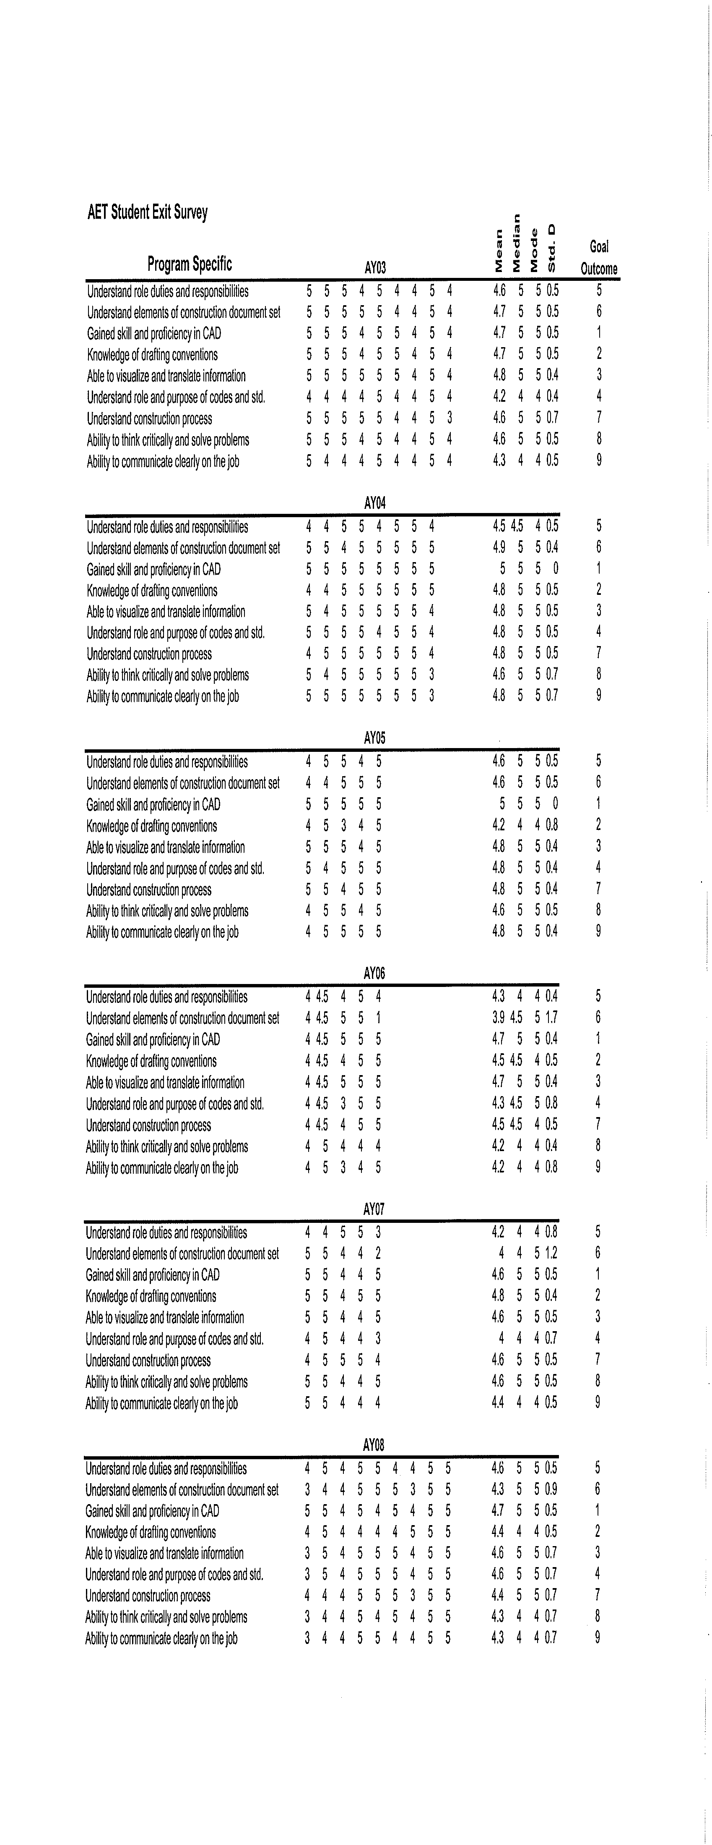

University of Alaska Anchorage

Construction & Design Technology Department

Architectural and Engineering Technology

Spring 2008

Student Exit Survey

Greetings. UAA is continually seeking to improve our programs to provide our graduates with the best possible knowledge and skills to be successful. Your candid and thoughtful feedback to the following questions is essential to our quest.

We are asking for your name and current address so we can thank you for responding and maintain our ability to remain in contact with you. However, your name and address will be separated from the survey BEFORE any tabulations are made. Your responses and comments will be collected by the CTC Dean’s office, who will separate your name and address from the survey, and then present only the findings as aggregate summaries to the Program and faculty so that no individual will be identified.

RESPONDENT INFORMATION

Name (Print):

Address:

Phone (Optional):

Email (Optional):

Date:

Please take a few moments to complete this survey. Then, send the completed survey in the pre-paid envelope.

THANK YOU.

Construction and Design Technology Department
University of Alaska Anchorage
Community and Technical College

ARCHITECTURAL and ENGINEERING TECHNOLOGY

Gender: Male Female

Age: ____20-24 ____25-29 ____30-39 ____40-49 ____50-59 ____60+

Degree: AAS Architectural Cert. Civil Cert.

Mechanical & Electrical Cert. Structural Cert.

______ CAD Occupational Endorsement

RATING THE PROGRAM
This program had a series of specific outcomes we expected to attain with you. Please rate the extent you believe each of the following was accomplished:

 | Excellent | Good | Fair | Poor | Not  Applicable

PROGRAM—SPECIFIC
You understand the role, duties and responsibilities of the members of the design team, including the working relationship between technicians and professionals.
You understand the elements of the construction document set and the role of construction documents as communication tools for the construction contract.
Your have gained skill and proficiency in computer-aided drafting and design.
You have knowledge of drafting conventions including symbols, linetypes, lineweights, and dimensions styles as applicable to the design discipline.
You are able to visualize and translate drawing information to actual physical objects and completed construction components.
You understand the role and purpose of building codes and standards as they pertain to the life, health and safety of the public.
You understand the construction process from the transformation of an idea or need into a completed project.

RATING THE UNIVERSITY
UAA had a series of general education outcomes we expected to attain with you. Please rate the extent you believe each of the following was accomplished:

 | Excellent | Good | Fair | Poor | Not Applicable
Ability to think critically and solve problems
Ability to communicate clearly on the job
Ability to express ideas in writing
Ability to use technology required for work
Ability to solve mathematical problems

What improvements would you recommend to make this UAA program better?

(If you would like to write more, please include a separate page.)

Would you recommend this program to others? Yes No

RATING THE UNIVERSITY SUPPORT SERVICES
We would also like to know if you received the help you needed from our academic services. Please rate the extent you believe we accomplished the following:

 | Excellent | Good | Fair | Poor | Not  Applicable
Quality of Architectural and Engineering Technology instruction
Quality of Architectural and Engineering Technology facilities
Architectural Engineering and Engineering Technology support staff helpfulness
Quality of UAA academic advising

How much did your program require you to access UAA’s library/information resources? Often Occasionally Rarely Never

Did the library/information resources adequately meet your needs? Yes No

Thank you again for your candid and thoughtful responses.
Appendix B: Architectural Project

Measure Description:

See attached sample final architectural project instructions.
Factors that affect the collected data:

Instructor subjectivity.
How to interpret the data:

Grading for the project is as follows:
A (>92%) Indicates creative and comprehensive mastery of required work
B (>85%) Indicates high level of performance in meeting requirements
C (>78%) Indicates satisfactory level of performance
D (>70%) Indicates minimal passing performance and results
F (<70%) Indicates unsatisfactory performance and result

The data gives the instructors subjective opinion on how well the outcome was attained.

AET-A121
Architectural Drafting
Bennett

Final Project

The Mountain View Drive area is one of the oldest residential areas in the Anchorage area. The historical mind set of the area has been one of a cultural and artistic bent. However, the district has been in decline for some time. The recent history is on of a fleeing economic base. The approximate 80% renter with removed stewardship, and 20% home ownership has contributed to a low income, high crime rate ethos and perception of the Mt. View district in surrounding communities.

As part of current Anchorage mayor Mark Begich’s last campaign, and the Anchorage Assembly, a determination has been make to invest in the Mountain View area as part of a community redevelopment-revitalization plan. The specific area around the Mt. View Drive and Commercial Road has been designated part of an incubator district in the revitalization. The intent is to return the district to its cultural and arts heritage as well as promote the development of new business opportunities.

Complimentary to the business revitalization is the social service support for the local residents. The intent is to bring the required non-profit and social services to the local. This is opposed to compelling local residents to travel outside of the district, via inconvenient or sporadic public transportation for a variety of needed social and personal services.

To facilitate this goal, currently, two groups have provided expertise and resources. The Anchorage Community Land Trust has been tasked with acquiring properties along Mt. View Drive. The intent of the Trust is to rehabilitate buildings where possible, rebuild structures where necessary, and develop open properties, using the goals and needs of the district as a guide. The Anchorage Young Lawyers Association is providing legal and procedural support as part of their pro bono efforts for the community.

The Anchorage Community Land Trust has taken possession of a circa 1960’s commercial building at 3142 Mt. View Drive and the building next door connected by a short walkway. The last owner used the building as an RV sales and repair facility. After modest renovations, the Anchorage Community Land Trust currently occupies offices on the second floor, fronting the street.

After an initial cleanup, restoration, and upgrade of the utilities and mechanical systems, the intent of the Trust is threefold: to convert the building to form an art cooperative, leasing/renting out space to local artists; provide affordable living space for low income residents; and provide space for community and cultural activities.

AET-A121, Architectural Drafting, “introduces technical skills needed by drafters to work with architects. Includes office practices, staff relationships, and architectural drawing production. Develops computer-aided drafting skills in architectural symbols. Conventions … code requirements, and research methods of detailing light commercial buildings.” This five week course will be offered in January of 2006 providing a direct fit between the goals of the course and the needs of the Anchorage Community Land Trust. The trust needs conceptualizations in the form of space division, walls, and windows; the documentation of many ideas to inform and choose from. Students in the AET-A121 class need an opportunity to apply the learning of technical skills and the exposure to the interactions and responsibilities between design professionals, community controlling authorities, and local clients.

It is anticipated that the results of student work in AET 121 will provide multiple solutions for the future evolution of the building from each student. Using a model developed from previous iterations, the mayor, as initiator, other community leaders, local architects, and the media would be invited to a culmination event for the class. The event is a public forum and presentation of those student results, allowing the public to experience many viewpoints dedicated to the solution. The forum also allows the student to experience a public evaluation of their work from members of a community of professionals outside of education.

Schedule
Week 2 – Introduction of Problem
Week 3 – Visualization (Sketch Review)
Week 4 – Preliminary Presentation
Week 5 – Final Presentation

Grading
A (>92%) Indicates creative and comprehensive mastery of required work
B (>85%) Indicates high level of performance in meeting requirements
C (>78%) Indicates satisfactory level of performance
D (>70%) Indicates minimal passing performance and results
F (<70%) Indicates unsatisfactory performance and result

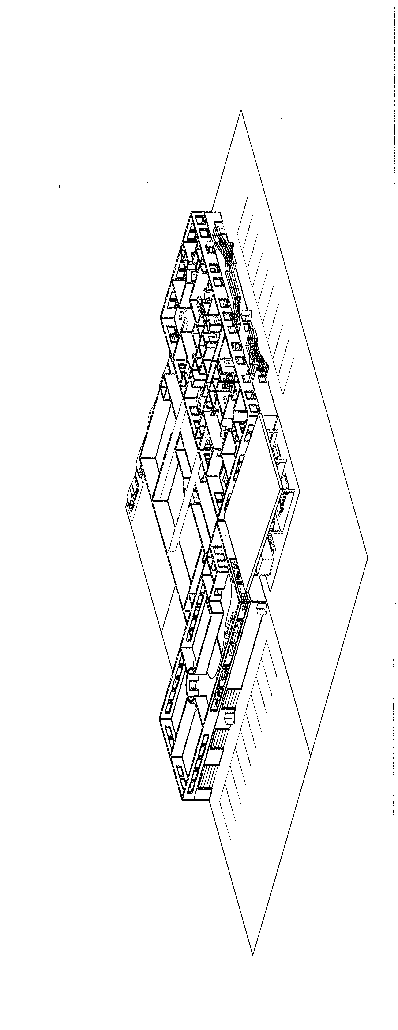
Appendix C: Civil Project

Measure Description:

See attached sample final civil project instructions

Factors that affect the collected data:

Instructor subjectivity.

How to interpret the data:

The project is graded on the following criteria:

File (10 points) Drawing file in the proper file on the server; file named according to
project instructions

Accuracy (10 points) Drawing accurately completed according to project instructions

Linework (20 points) Use of proper line type and line weight

Lettering (10 points) Consistent lettering in class standard font; sizes according to project
instructions

Dimensioning (10 points) Dimensions conform to standard practice and project instructions, are
well spaced and are located to facilitate readability.

Scale (10 points) Project is plotted to scale specified in project instructions; paper space
viewport edge does not print

Standards (10 points) Following class drafting standards for sheet organization including
titleblock and drawing reference

Composition (10 points) Overall layout and aesthetics of the drawing

Timesheet (10 points) Timesheet accompanies project and is an accurate reflection of the time
spent on the drawing

Deadline Unless prior arrangements are made with the teacher, all projects are due on the deadline. Projects will be assessed 5 points for each class period late.

The data gives the instructors subjective opinion on how well the outcome was attained.
AET 111
Civil Drafting
McKay

FINAL PROJECT - PLATTING

Situation:

There comes a time when every technician has to start working independent of a supervisor. The sooner you can think for yourself without relying on others to answer your questions the better employee you will be. This drawing will be a prized addition to your work portfolio.

Intent:

The intent of the final project is to put to use all of the skills that you have been instructed in during AET 111. It must be stressed that you must apply all you have learned in this course, and do it one step at a time. Remember, as you put your drawing together, it must be understood by others, be pleasing to view, and be in compliance with the law.

Objective:

Concentrate on applying your new skills to the main part of the plat, while keeping a keen eye out for using common sense and being consistent.

Some Final Instructions:

1. Use your own north arrow.

2. Curve Data Chart should include curve number, radius, arc length, chord length, chord bearing, delta angle and tangent. Bearings and angle measurements should show degrees, minutes, and seconds, lengths should be rounded to the nearest hundredth (two decimal places).

3. This subdivision lies to the north of West Northern Lights Blvd. and contains 8 lots. The name of the subdivision is Woronzof Terrace Subdivision. It is located within the SE 1/4, Section 22, T.13N, R.4W, Seward Meridian, Alaska, and contains 3.099 acres more or less. The Basis of Bearing is the centerline of West Northern Lights Blvd. between points 46 and 47. The subdivision is in Grid 1525 and the Zoning is R-2A.

4. The centerline of the street into the cul-de-sac begins at point 48 on the centerline of West Northern Lights Blvd. The name of the street is Amanda Court. It has a 50-foot right-of-way. The centerline between points 49 & 50 has a radius of 150.00 feet. The cul-de-sac and cul-de-sac returns have a radius of 50.00 feet. The curve returns from West Northern Lights Blvd. and Amanda Court have radii of 20.00 feet.

5. Easements: There is a 10-foot wide utility easement on the west, north, and east perimeters of the boundary (inside the subdivision). There is a 10-foot wide storm sewer easement each side of the lot line between lots 1 and 2, and also between lots 4 and 5.

6. Monuments: On the centerline of West Northern Lights Blvd. at the point where the extension of the west boundary of the subdivision intersects the centerline of West Northern Lights, and also where the extension of the east boundary intersects the centerline of West Northern Lights, the survey crew found Brass Capped Monuments set by a previous survey.

Aluminum Capped Monuments were set by this survey crew at the SE and NE corners of the subdivision boundary.

All other corners were set by this survey crew with 5/8” x 30” Rebar.

The Field Book for this project is 75-4.

7. The Vicinity Map can be traced from the scan of the USGS quadrangle map Anchorage A-8. The scale is 1” = 1 mile.

8. Surrounding Property: The municipality requirement is to show 300 feet on all sides
of the subdivision. This information should be taken from the Municipality grid maps.

Lay out the subdivision from the coordinate points for Woronzof Terrace Subdivision.

The final plat should include:

1. North arrow & scale bar
2. Complete titleblock
3. Layout of the subdivision
4. Easements
5. All subdivision information including lot numbers, areas, bearings and distances on all lot lines, curve numbers and arc lengths on all curves, easement identification, street name and monuments
6. Curve data chart with corresponding numbers on proper curves in the subdivision
7. Legend with corresponding monuments
8. Bearings rounded to the nearest second.
9. Boundary bearings take precedence over individual lot bearings.
10. All distance measurements should be rounded to the nearest hundredth (two decimal places).
11. Lot areas should be rounded to the nearest 10 square feet.
12. All lines non-radial to arcs should be labeled as such.
13. If a bearing or radius appears on the centerline of the street, they do not have to be repeated on the lot line; however all distances must be shown.
14. Label:
Bearings & Distances
Street widths & Easements
Curve Numbers
Lot Areas
Lot Numbers
Street Names
Owner’s Name & Address
John E. Doe
123 West 45th Ave.
Anchorage, Alaska 99503
Subdivision Name (titleblock)
Remaining titleblock info
15. Certificates should be taken from the Certificate.dwg file on the Group Drive.

Computer:

The AutoCAD drawing file named 111fin.dwg contains all the point coordinates to layout this subdivision. The student must compute bearings and distances between all points and curve data.

1. Print out the point layout.
2. Using AutoCAD draw all lot lines and curves as per the attached sketch.
3. Calculate all lot areas.
4. Calculate all curve data.

Submit:

1. Final Plat
2. Timesheet

Grading:

The grading of the Final Project will be based on accuracy, neatness, and consistency, all of which will show you to be a “thinking” drafter. The project is due at the end of class Thursday, October 30. Ten (10) bonus points may be earned if it is turned in by the end of class on Wednesday, October 29.

AET 111
Civil Drafting

Computer Instructions:

1. Copy the 111finpts.dwg file and the vicinity.bmp from the AET – 111 folder on the
shared drive (G:) on to your H: drive.
2. Using the LINE and ARC commands draw in all the lot lines and centerlines as per the attached sketch.
3. Using the LIST command find the bearing and distances for all lot lines.
Remember that the boundary bearing takes precedence over individual lot bearings along the boundary so do the boundary separately on a different
layer.
4. Using the LIST command find the arc length for each curve (including the centerline of Amanda Court).
5. On a separate layer draw straight lines between all PC and PT’s. Use LIST and find the chord length and chord bearing for each curve.
6. Draw a line from PC to RP to PT for each curve and use dimensioning commands to find the delta angle for each curve in degrees, minutes, and seconds.
7. Using the formula:
tangent = R tan Δ/2
find the tangent length for each curve.
8. Use the AREA command to find the area of each lot.

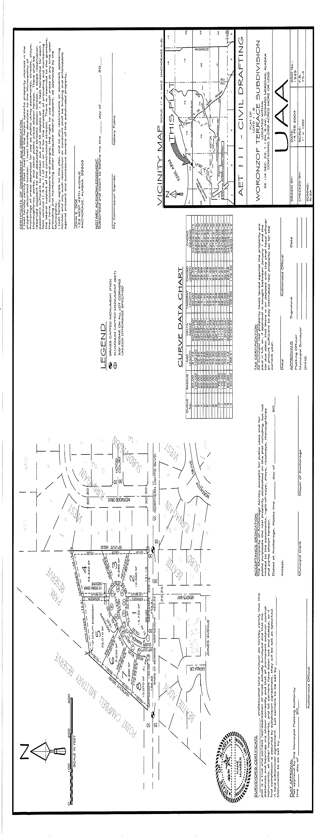
Appendix D: Mechanical/Electrical Project
Measure Description:

See attached sample mechanical/electrical project instructions.
Factors that affect the collected data:

Instructor subjectivity.

How to interpret the data:

Grading criteria for the project will be:

File (10 points) Drawing file in the proper file on the server; file
named according to project instructions

Accuracy (10 points) Drawing accurately completed according to project
instructions

Linework (20 points) Use of proper line type and line weight

Lettering (10 points) Consistent lettering in class standard font; sizes
according to project instructions.

Dimensioning (10 points) Dimensions conform to standard practice and project
instructions, are well spaced and are located to facilitate readability.

Scale (10 points) Project is plotted to scale specified in project instructions; paper
space viewport edge does not print

Standards (10 points) Following class drafting standards for sheet
organization including titleblock and drawing reference

Composition (10 points) Use of mock-up, overall layout and aesthetics of
the drawing

Timesheet (10 points) Timesheet accompanies project and is an accurate
reflection of the time spent on the drawing

Deadline Unless prior arrangements are made with the teacher, all projects are due on the deadline. Projects will be assessed 5 points for each class period late.

The data gives the instructors subjective opinion on how well the outcome was attained.

AET 143
Mechanical and Electrical Drafting
Callahan

Project 2 - Site Utilities Drawings

Purpose: To understand the use of project site drawings and drawing symbols for depicting building utility services, site utilities, and site improvements related to mechanical and electrical systems in buildings.

- The project will consist of two drawing sheets. Utilize the Site Base Plan for the first drawing sheet. The .pdf/.jpg drawing files in the Project 2 – Details folder are for the site plan details for the second drawing sheet.

- Sheet 1
  - Sheet title: “Site Utilities Plan”
  - Depict Site Utilities:
    - Electrical service (underground)
      - Transformer: Existing on pad near the SE corner of the Future Parking Garage.
      - Service lateral (underground): Continuous from pad to Electrical Room on the 1st floor.
      - Label on legend: “Electrical service, 3 phase, secondary”
    - Water supply (underground)
      - Depict the existing community water main on C Street.
      - Keybox valve shall be located just outside the east property line on C Street.
      - Water service pipe will enter the building on the east side.
      - Water service pipe will be 5” diameter, Ductile Iron Pipe (DIP). Label on legend: “Water, Class 52, 5” D.I.P.”
    - Sanitary sewer piping (underground)
      - A new sanitary sewer manhole will be placed on the east side of the building that will connect the existing sanitary sewer main to the building drain.
      - The building drain will exit the building approximately 20’ from the NE corner of the building on the east facing side. The building drain shall be 6” diameter, Ductile Iron Pipe. Label on legend: “Sanitary sewer, Class 52, 6” D.I.P.”
      - Place a sewer cleanout within 5’ of the building line.
    - Telephone: Telephone service will connect at the telephone pedestal (GCI) near the NW corner of the building.
    - Natural gas supply: The gas service pipe will connect to the high pressure
natural gas main on 31st Avenue.
    - Overhead light poles: Place (3) each along access alley on the north side of the building.
    - Storm drainage:
      - A new storm drain pipe (SD) will connect to existing SD manholes on the Benson Boulevard and 31st Avenue. Label on legend: “Storm drain, 12” C.M.P.”
      - Provide a new SD manhole in the location noted.
      - Depict roof drain lines from the building connecting to the new SD manhole. Label on legend: “Roof drain, Class 52, 6” D.I.P.”

  - Provide the following General Notes (3/32” text):

    - All site construction shall be in accordance with the 1994 Municipality of
Anchorage Standard Specifications (MASS) as currently amended.
    - The contractor shall verify the horizontal and vertical locations of all existing utilities encountered during construction. These shall be recorded and reported in accordance to the reporting requirements in Section 01320.
    - Restore all property disturbed by construction activity to original conditions.
    - All cut or fill slopes shall have a minimum slope of 2 horizontal to 1 vertical (2:1) unless noted otherwise.
    - The contractor shall follow all Municipality of Anchorage regulations pertaining to noise, dust control and hours of operations.

  - Detail indicators: Detail drawings from Sheet 2 shall be provided with reference indicators. Detail reference bubbles and section indicators shall be correctly numbered and coordinated in accordance with UDS standards.
  - Drawing Scale: 1” = 30’
  - Create a symbols legend and place it on your drawing. All symbols shall be represented, including line symbols. Symbol shall be enclosed in a border and be at the same scale as the symbols on the drawings.

- Sheet 2
  - Title: “Site Utilities Details”
  - Use UDS sheet organization standards for placement and reference numbering of detail drawings.
  - List of required detail drawings: (Text height: 3/32”)
    - Storm drain manhole
    - Sanitary manhole
    - Light pole base
    - Sewer cleanout
    - Water keybox
  - Drawings Scale: Not-to-scale (NTS). The 5 detail drawings shall be large enough to be easily readable but without crowding the drawing arrangement.
  - Insert the .jpg images into a drawing. Trace the line work. DO NOT trace the text or hatching. Scale each drawing to desired size. Annotate and hatch AFTER scaling. All the text should plot at a uniform 3/32” size (except titles). All hatching should be consistent.

- Plot and turn in completed project in accordance with the instructions in the Class Drawing Standards.

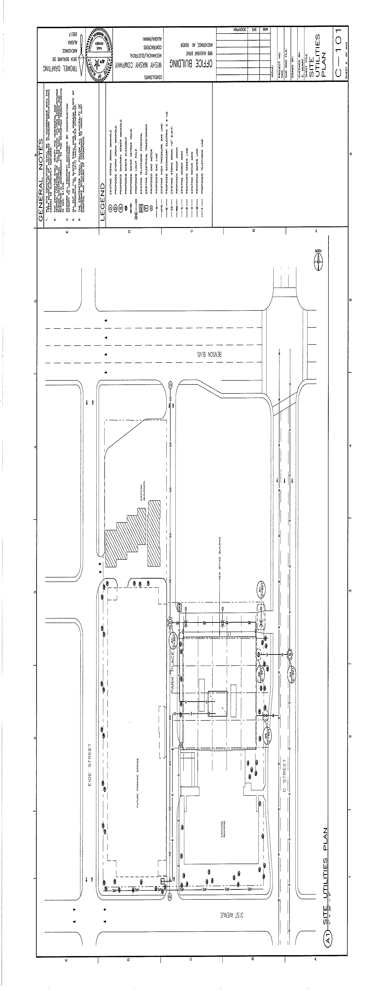

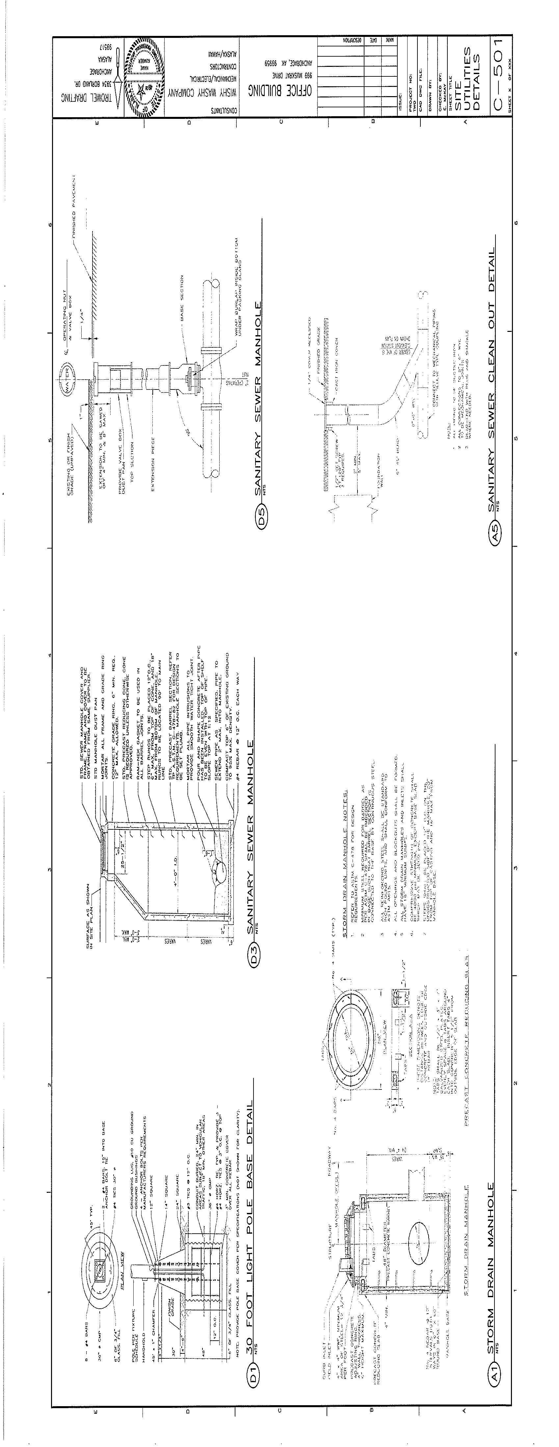
Appendix E: Structural Project
Measure Description:

See attached sample final structural project instructions.
Factors that affect the collected data:

Instructor subjectivity.
How to interpret the data:

The final project (worth 300 points) will be graded on the regular project criteria plus an expansion of the technician’s ability to understand and apply the already completed course projects. Drawing projects are regularly evaluated in the following categories:

File (10 points) Drawing file in the proper file on the server; file named according to project instructions.

Accuracy (10 points) Drawing accurately completed according to project instructions.

Linework (20 points) Use of proper line type and line weight.

Lettering (10 points) Consistent lettering in class standard font; sizes according to project
instructions.

Dimensions (10 points) Dimensions conform to standard practice and project instructions, are
well spaced and are located to facilitate readability.

Scale (10 points) Project is plotted to scale specified in project instructions; paper space
viewport edge does not print.

Standards (10 points) Following class drafting standards for sheet organization including
titleblock and drawing reference.

Composition (10 points) Use of mock-up, overall layout and aesthetics of the drawing.

Timesheet (10 points) Timesheet accompanies project and is an accurate reflection of the time
spent on the drawing.

A 280 – 300 (93%)
B 260 – 279 (86%)
C 240 – 259 (79%)
D 220 – 239 (72%)

The data gives the instructors subjective opinion on how well the outcome was attained.

AET 131
Structural Drafting
McKay

FINAL PROJECT – CONCRETE GIRDER BRIDGE

Situation:

Technicians frequently create working drawings of a project from sketches provided by the engineer. This project is the engineering drawing of a precast pre-stressed concrete girder bridge. The bridge is assembled from precast elements and jointed together with grouted connections. It will be fabricated at a plant and delivered to the job site, and is especially suitable for rapid construction at sites remote from sources transit-mixed concrete. It can be erected in climates where severe winter weather would prohibit placing fresh concrete. The girders and piles are pre-stressed concrete and the pile caps are precast-reinforced with deformed bars. The reinforcing steel embedded in the precast concrete is identified by mark number and detailed on the bar bending diagram. Other embedded metal items and welded assemblies are shown in details. Notes explaining the concrete mix and strength requirements are included.

Intent:

The intent of the final project is to put to use all of the skills that you have been instructed in during AET 131. It must be stressed that you must apply all you have learned in this course, and do it one step at a time.

Objective:

1. Create a 3-D solid model of the end on an interior girder. (This will help you visualize how the bridge goes together.)
2. Layout a mock-up so that all nine pages of engineer’s sketches will fit on one 24” x 36” sheet.
3. Have the mock-up approved by the instructor.
4. Complete the engineering drawing of the concrete girder bridge using the nine engineer’s sketches, the shop drawing provided, and the National CAD Standard.
5. Turn in the solid model on an 8 ½” x 11” sheet, the mock-up, and your final timesheet along with the final project by Monday following the last day of class.

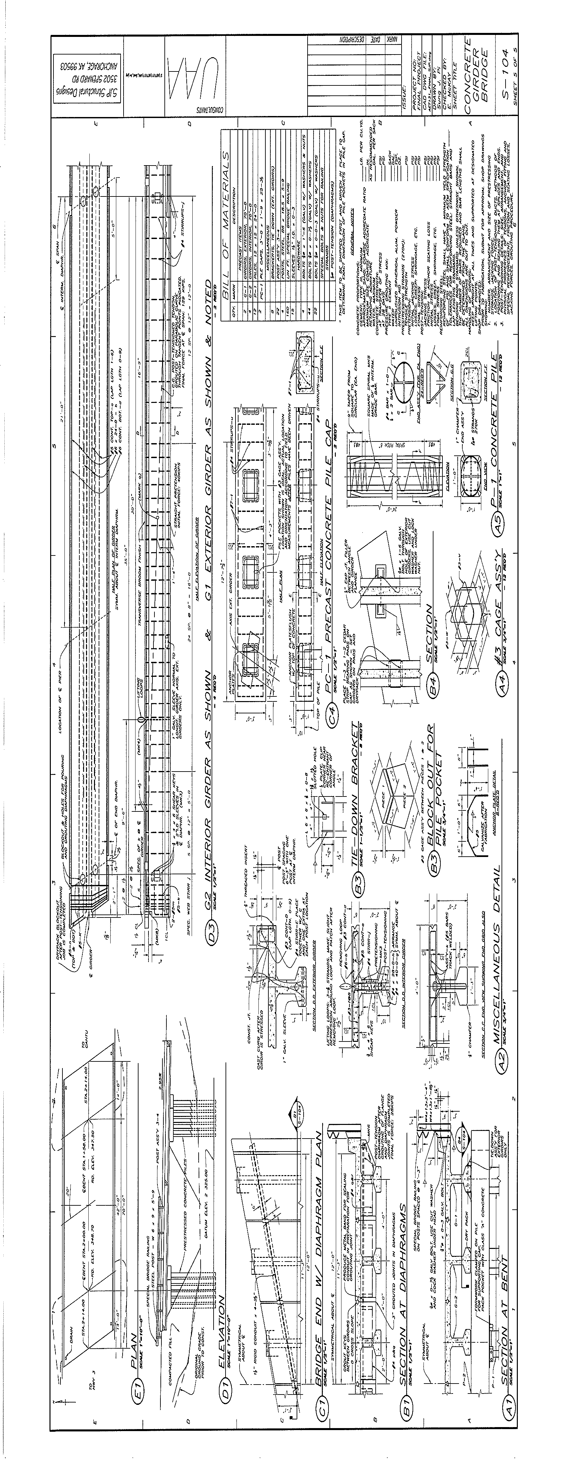
Appendix F: Code Project
Measure Description:

See attached final codes and standards project instructions.

Factors that affect the collected data:

Instructor subjectivity.

How to interpret the data:

This portion of the final project is worth 100 points. Points are awarded on completeness of analysis and correctness of the code citations. The total number of required answers are divided by 100 and then multiplied by the number of correct student responses.

A = 92 - 100
B = 84 - 91
C = 76 - 83
D = 68 - 75

The data gives the instructors subjective opinion on how well the outcome was attained.

AET/CM 123
Codes and Standards
McKay

FINAL PROJECT – Part A

SITUATION:

A code study is a Municipality of Anchorage requirement for issuance of a building permit. The Construction/Design firm for which you work has been retained to provide a code study for a new building at UAA. The gas line has become a reality and the construction industry is booming. There is a mandated 25% local hire and the need for technicians and construction managers has exploded. In a brief moment of clarity and cooperation the State Legislature, the Rasmuson Foundation, and the Alaska construction industry have decided to jointly fund a new building for the Construction and Design Technology Division at UAA. The University has further decided to make the CDT Division its own college – the Callahan College of Construction and Design (of C³D for short). Although developable land is scarce on the UAA campus (wetland issues) a building site has been identified. Because of the lot size and the remoteness from the existing parking, the building design will include a parking garage for C³D faculty, staff, and students. The building is being designed to accommodate a doubling of the existing programs with the possibility of adding a Master’s degree in Construction Management and a school of Architecture in the future.

INTENT:

The intent of the final project is the further your understanding of the codes that apply to projects within the Municipality and to better understand the interplay between Title 21 and the IBC.

OBJECTIVE:

Perform a code study for the C³D Building. Building requirements are as follows:
- The building to be located on Tract D, Goose Lake Land Exchange Subdivision.
- 150’ x 150’ fully sprinklered building on top of a two-story parking garage with the first floor of the parking garage below grade.
- The parking portion of the building to be concrete and the rest of heavy timber.

Use the attached format (RIM Architects’).
Be sure to check Title 21, plat notes, the IBC and local amendments. List all required information and give specific code reference. Note that some items may not be required.

Additional information (on a separate sheet).

What permits will be required for the project? List all.
Will Special Inspections be required?
Assuming a $15,600,000 valuation, what is the cost of the Building Permit?
EXAMPLE

CODE STUDY for C³D Building

Code Analysis

Applicable Code and Regulatory Requirements
2003 International Building Code
2003 International Mechanical Code
2003 International Fire Code
2003 Uniform Plumbing Code
2005 National Electrical Code
2003 International Fuel Gas Code
Title 23 – Local Amendments
2004 ANSI Elevators and Escalators
1991 Americans with Disabilities Act

Occupancy Classification
Mixed occupancy - Group B (IBC 304.1) and Group S-2 (IBC 311.3) fully sprinklered

Construction Type
Group B – Type IV (IBC 602.4)
Group S-2 – Type IA (IBC 508.2, 602.2)

Building Height (Group B)
Tabular height: 65’ (IBC Table 503)
Increase for sprinklers: 20’ (IBC 504.2)
Total allowable height: 85’
Actual height: (leave blank)
Tabular stories: 5 (IBC Table 503)
Increase for sprinklers: 1 (IBC 504.2)
Total allowable stories: 6
Actual stories: 3

Building Area (Group B)
Tabular area: 36,000 SF (IBC Table 503)
Increase for sprinklers: 300% (IBC 506.3)
Increase for frontage: 75% (IBC 506.2)
Total allowable area: 171,000 SF
Actual area: 22,500 SF

Fire Resistance Requirements for Building Elements (IBC Table 601)
Group B
Structural frame including columns, girders, trusses: HT
Exterior and interior bearing walls: 2 hr exterior and 1 hr/HT interior
Floor construction: HT
Roof construction: HT
Group S-2
Structural frame including columns, girders, trusses: 3 hr
Exterior and interior bearing walls: 3 hr
Floor construction: 2 hr
3 hr fire resistance construction between Group B and Group S-2 occupancies (IBC 508.2)

Fire Resistance Requirements for Exterior Walls (IBC Table 602)
Fire separation distance: >30 ft
No FR rating required for non-load bearing exterior walls.

Additional Fire Resistance Requirements
Shaft enclosures: 2 hr (IBC 508.2.1)
Vertical exit enclosures: 2 hr (IBC 508.2.1)
Elevator equipment room: 2 hr (IBC 3006.4, 508.2.1)
Roof covering and assembly classification: Class B (Table 1505.1)
Corridors (fire partition): no FR rating required (Table 1016.1)
Elevator lobbies: 1 hr (IBC 707.14.1, 708.3)
Storage rooms over 100 SF: no FR rating required (IBC Table 302.1.1)
Boiler room: no FR rating required (IBC Table 302.1.1)

Exits
Number of exits required: 2 (IBC Table 1005.1)
Separation distance: > 1/3 of the length of the overall diagonal (IBC 1014.2.1
Exception 2)
Travel distance: Group B – 300’; Group S-2 – 400’ (IBC Table 1015.1)

Stairs
Vertical exit enclosures: per IBC 1019.1
Stair pressurization: not required (IBC 1019.1.8)

Seismic Design
Category or Seismic use group: II (IBC Table 1604.5)

Elevator Venting
Not required (IBC 3004.1)

Title 21
Parking:
Total spaces required: 75 (21.45.080.R.3)
Handicapped spaces required: 3 (21.45.080.X.8)
Van accessible spaces required: 1 (21.45.080.X.8)

Zoning Classification: PLI (21.40.020)
Minimum yard requirements: (21.40.020.F)
Front: 25’
Side: 25’
Rear: 30’
Maximum lot coverage: 35% (21.40.020.G)
Maximum height of structures: UL (12.40.040.H)

UAA Drive Classification: IB – Neighborhood Collector (OS&HP)
Setback requirements: 35’ from centerline (21.45.140.1)

Landscaping Requirements: Visual enhancement landscaping on all areas not devoted to buildings, structures, drives, walks, off-street parking facilities, useable yard area or other authorized installations. (21.40.020.L)

Plat:
- This Tract for Educational and Recreational purposes only (Note #3).
- 30 foot wide buffer along UAA Drive, set back from the property line, for signage, driveways, walkways, bike paths, benches, removal of undergrowth, lighting and other landscape furnishings (Note #5).
- The final design of the building must blend in with the surroundings so that structures are unobtrusive to the Goose Lake Park (Note #7).

Additional information.

What permits will be required for the project?
Building Permit
Structural Permit
Electrical Permit
Mechanical Permit
Plumbing Permit
Grading/Excavation/Fill
Elevator Permit

Will Special Inspections be required? Yes

Assuming a $15,600,000 valuation, what is the cost of the Building Permit? $63,057 (Title 21.10.Table 3-A)

Appendix G: Internship Assessment
Measure Description:

See attached Career Services Internship Assessment Form

Factors that affect the collected data:

Even though it is strongly recommended not all students take AET 295, AET Internship because it is not a required course for either the AAS Degree or the certificates. In data collected would represent only those students who elect to take the course.

How to interpret the data:

The student qualifying for an intern position and the employer will have an opportunity to assess the student’s skills before graduation and entry into the job market or advancing on to a more specialized degree program. Throughout the internship, the student and prospective employer have the opportunity to assess a student’s skill level with various digital tools and their ability to contribute in a professional manner within the work environment. Flexible and adaptable skills along with the ability to develop design solutions within the restrictions of a job assignment will be required in most internship situations.
The data collected should be a fairly accurate indicator of the preparedness level of the student to perform in a job situation.

University of Alaska Anchorage
Career Services Center
Student Internship Services
3211 Providence Drive, BEB-122
Anchorage, AK 99508-8279
Phone: (907)-786-4513 Fax: (907)-786-4351
Student Internship Services Work Site Evaluation

Student Intern: _______________________________________ Date: _______________

Employer: _______________________________________________________________

Site Coordinator: ___________________________ Site Phone Number: _____________

Area Rated ( 5 = highest rating) | 1 | 2 | 3 | 4 | 5 | N/A
Independent planning & organizational skills
Demonstrates self-initiative & requests assistance when needed
Timeliness in task performance & problem solving
Ability to learn & implement new materials (i.e. software, etc.)
Ability to engage in multiple tasks, when necessary
Cooperatively works as a team member
Detail oriented & proofs for accuracy
Utilizes constructive criticism effectively
Interpersonal Communication Skills (Expressive)
Interpersonal
Communication Skills (Receptive)
Punctuality
Appearance / Grooming
Adherence to industry safety standards
Overall work ethic

Outstanding work qualities: _________________________________________________
_______________________________________________________________________.
Areas that need further development: _________________________________________
_______________________________________________________________________.
Any additional comments: __________________________________________________
_______________________________________________________________________.

Faculty Advisor: _______________________________ Attending: Yes_____ No _____

__________________________________ _________________________________
Site Supervisor Signature Student Signature

Mid-Way Evaluation _____ Final Evaluation _____

Appendix H: Advisory Committee

Tool Description:

This board of community professionals will be utilized to track how the AET Program is meeting its educational objectives. Their oversight will monitor how effectively the Program meets State & community needs and keeps abreast of technological changes. The Board meets quarterly and provides the AET Faculty with information concerning skills needed within the community and state as well as specific information regarding potential internship sites, community partners for Service Learning projects and potential employers.

Factors that affect collected data:

The number of graduating students will affect the collected data. Attendance level of Advisor Board members will also affect the quantity of input. The data will vary depending upon the availability of qualified people to serve on the Board. Optimally the Advisory Board will maintain a membership of a variety of professionals within the Construction and Design Technology industry.

How to interpret the data

Input from Advisory Board will affirm compliance with Program Objectives and provide guidance for improvement. The Program Director in collaboration with the faculty will make specific recommendations based on this input.

Sample Input

The following page is an example of the type of input solicited from the Advisory Committee. In AY 05 and again in AY 08 the Advisory Committee was asked to rate the course student outcomes for each AET course.

AET A101 - Fundamentals of CADD for Building Construction

Using the following scale, please rate the value of each Student Outcome towards a goal of producing students with the competency required for entry level technical positions.

1 = not important
2 = somewhat important
3 = important
4 = very important
5 = extremely important

Student Outcomes  After successful completion of the course, the student will be able to do the following: | 1 | 2 | 3 | 4 | 5
Discuss classroom, lab, and safety procedures.
Examine the working relationships and primary roles of the participants in the construction process.
Explain construction drawings and their accompanying written specifications.
Describe how construction drawings are coordinated for a single project.
Explain construction drawing set organization including drawing subsets (civil/site, architectural, structural, mechanical, electrical, and others as required by the needs of the project), the information conveyed by each subset, and how the subsets are related.
Define the basic commands and techniques used with computer-aided design and drafting (CADD) software including file, draw, edit, modify, insert, format, dimension, and text commands.
Select drawing sheet sizes, sheet-numbering, and drawing sheet layout.
Compute drawing scales for blocks and plotting in CADD.
Produce civil/site development drawings using CADD software.
Differentiate line types and drawing types including plats, plot plans, and as-builts.
Produce architectural drawings using CADD software.
Differentiate line types, schedules, and drawing views.
Apply drafting conventions, including dimensions, coordinate systems, scales, symbols, hatching, notation, basic terminology, and abbreviations used in architectural drawings.
Produce structural drawings using CADD software.
Differentiate line types and drawing views including design drawings and shop drawings
Produce mechanical drawings using CADD software.
Differentiate line type, symbols, schedules, and drawing views including plumbing, HVAC, and diagrams.
Produce electrical drawings using CADD software.
Differentiate line types, schedules, electrical component symbols, and drawing views, including plan layouts and schematics.

Appendix I: Program and Drafting Certificate Outcome Comparison

AAS Program Outcomes
At the completion of this program, students are able to:
- Demonstrate skill and proficiency in computer-aided drafting and design.
- Demonstrate knowledge of drafting conventions including symbols, linetypes, lineweights, and dimension styles as applicable to the design discipline.
- Visualize and translate drawing information to actual physical objects and completed construction components.
- Understand the role and purpose of building codes and standards as they pertain to the life, health, and safety of the public.
- Understand the role, duties, and responsibilities of the members of the design team, including the working relationship between technicians and professionals.
- Understand the elements of the construction document set and the role of construction documents as communication tools for the construction contract.
- Understand the construction process from the transformation of an idea or need into a completed project.
- Demonstrate communication skills to be successful in employment environment.
- Demonstrate critical thinking and problem solving skills in the employment environment.

Architectural Drafting Certificate Program Outcomes
At the completion of this program, students are able to:
- Demonstrate skill and proficiency in computer-aided drafting and design.
- Demonstrate knowledge of drafting conventions including symbols, linetypes, lineweights, and dimension styles as applicable to architectural drafting.
- Visualize and translate drawing information to actual physical objects and completed architectural projects.
- Understand the role and purpose of building codes and standards as they pertain to the life, health, and safety of the public.
- Understand the role, duties, and responsibilities of the members of the design team, including the working relationship between technicians and architects.
- Understand the architectural elements of the construction document set and the role of construction documents as communication tools for the construction contract.
- Understand the construction process from the transformation of an idea or need into a completed architectural project.
- Demonstrate communication skills to be successful in employment environment.
- Demonstrate critical thinking and problem solving skills in the employment environment.

Civil Drafting Certificate Program Outcomes
At the completion of this program, students are able to:
- Demonstrate skill and proficiency in computer-aided drafting and design.
- Demonstrate knowledge of drafting conventions including symbols, linetypes, lineweights, and dimension styles as applicable to civil drafting.
- Visualize and translate drawing information to actual physical objects and completed civil construction projects.
- Understand the role and purpose of building codes and standards as they pertain to the life, health, and safety of the public.
- Understand the role, duties, and responsibilities of the members of the design team, including the working relationship between technicians and civil engineers.
- Understand the civil elements of the construction document set and the role of construction documents as communication tools for the construction contract.
- Understand the construction process from the transformation of an idea or need into a completed civil project.
- Demonstrate communication skills to be successful in employment environment.
- Demonstrate critical thinking and problem solving skills in the employment environment.
Mechanical/Electrical Drafting Certificate Program Outcomes
At the completion of this program, students are able to:
- Demonstrate skill and proficiency in computer-aided drafting and design.
- Demonstrate knowledge of drafting conventions including symbols, linetypes, lineweights, and dimension styles as applicable to mechanical/electrical drafting.
- Visualize and translate drawing information to actual physical objects and completed mechanical/electrical construction projects.
- Understand the role and purpose of building codes and standards as they pertain to the life, health, and safety of the public.
- Understand the role, duties, and responsibilities of the members of the design team, including the working relationship between technicians and mechanical and electrical engineers.
- Understand the mechanical/electrical elements of the construction document set and the role of construction documents as communication tools for the construction contract.
- Understand the construction process from the transformation of an idea or need into a completed mechanical/electrical project.
- Demonstrate communication skills to be successful in employment environment.
- Demonstrate critical thinking and problem solving skills in the employment environment.

Structural Drafting Certificate Program Outcomes
At the completion of this program, students are able to:
- Demonstrate skill and proficiency in computer-aided drafting and design.
- Demonstrate knowledge of drafting conventions including symbols, linetypes, lineweights, and dimension styles as applicable to structural drafting.
- Visualize and translate drawing information to actual physical objects and completed structural construction projects.
- Understand the role and purpose of building codes and standards as they pertain to the life, health, and safety of the public.
- Understand the role, duties, and responsibilities of the members of the design team, including the working relationship between technicians and structural engineers.
- Understand the structural elements of the construction document set and the role of construction documents as communication tools for the construction contract.
- Understand the construction process from the transformation of an idea or need into a completed structural project.
- Demonstrate communication skills to be successful in employment environment.
- Demonstrate critical thinking and problem solving skills in the employment environment.

