Academic Assessment Plan

College: School of Education

Program(s): GC Indigenizing Education

Reviewed: Spring 2024

Mission Statement

The mission of the Indigenizing Education Graduate Certificate is to provide graduate students with the skills and knowledge to:
- Formulate a community approach to improve and shift schools and systems in grounded and ethical standards and practices towards Indigenizing schools, systems, and organizations.
- Interpret and apply current tribal and applicable federal, state, and local laws, regulations, and policies to the schools and/or organizational services to individuals, students, families, organizational staff, and communities.
- Implement collaborative practice, procedures and strategies to facilitate and communication among all stakeholders for systemic shift and change by including citizenship as a holistic approach.
- Utilize collaborative practice approaches for involving all stakeholders in educational/organizational planning, implementation, and evaluation.
- Demonstrate the skills necessary for ongoing communication, education, and community support to improve through tribal compacting and Indigenizing organizations for school and system changes and shifting.

The program is grounded in the School of Education Graduate Studies Department mission to prepare practitioners and supporters grounded in purpose and research to address complex problems of practice and structure in the context of community collaboration towards Indigenizing schools/organizations of Alaska’s Indigenous and culturally and linguistically diverse settings. The program strives to provide candidates with advanced knowledge and skills in providing learning environments/organizations that foster inclusivity, equity, innovation and collaboration that celebrates differences and promotes meaningful, lifelong learning and collaboration.

Program Introduction

The Indigenizing Education program in the School of Education Graduate Studies Department requires successful completion of 15 credits. The graduate certificate program provides specific learning for graduate students in supporting the Indigenizing schools/organizations.

Program Student Learning Outcomes
Student Learning Outcomes for the Indigenizing Education GCRT focuses on Indigenizing practice, leadership, teaching and learning, assessment, citizenship, and law and ethics. These outcomes are important for candidates to effectively support schools/organizations within communities and navigate the complex legal and ethical landscape of current structures and systems.
At the completion of this program, students will understand and demonstrate the capacity to promote the current and future success and well-being of students/staff/organizations within their community by applying the knowledge, skills, and commitments necessary for school/organizational change and advocate for the rights and needs of students/community members while adhering to tribal, state, and federal laws/policies and practices.

These outcomes result in the following Program Student Learning Outcomes
Upon completion of their Indigenizing Education GCRT program, graduates will be able to:
Outcome 1: Describe the value, history, and relationship of Indigenous ways of knowing, Indigenous peoples in Alaska, and education.
Outcome 2: Identify approaches and strategies to Indigenize education systems and teachings based on Indigenous cultures, languages, and views.
Outcome 3: Analyze and reframe the role of tribal governance in an educational system or problem.
Outcome 4: Design an age-appropriate, contextualized Indigenized curriculum/learning plan
Outcome 5: Compare principles and strategies found in Indigenized education systems and teaching practices.

Measures
A description of the assessment used to measure the program outcomes and their administration based on a 1 or 2 year plan are summarized in Table 1 and 2. Table 3 summarizes how the overall program aligns to the Program Student Learning Outcomes.

Table 1: Assessment Measures Description and Administration
2-year plan
Assessment Measure | Description | Frequency | Collection Method | Administered by
Reflective paper | Student will articulate what was learned, reflect in the shift in thinking, and address questions on Indigenous epistemologies to address the diverse needs of communities they serve. | EDIE A612 (Fall) | Course assignment submitted in Blackboard | Instructor(s) of record
Native Identity Website Project | Complete a website that addresses health and wellness as they learn more about themselves and selected Alaska Native Group | EDIE A630 (Spring) | Course assignment submitted in Blackboard | Instructor(s) of record
Case Study Analysis | Evaluate and Analyze case by writing a memo in response toward Indigenizing School/Organization | EDIE A664 (Summer) | Course assignment submitted in Blackboard | Instructor(s) of record
Learning Plan/Curriculum Design | Development and Analysis of a learning/curriculum plan for Indigenizing spaces that are appropriate for the population served. | EDIE A641 (Fall) | Course assignment submitted in Blackboard | Instructor(s) of record
Indigenizing Teaching and Practice Project | Reflection on models of collaboration and teaching in practice at their school/organization that supports Indigenizing spaces. | EDIE A658 (Spring) | Course assignment submitted in Blackboard | Instructor(s) of record

1-year plan
Assessment Measure | Description | Frequency | Collection Method | Administered by
Reflective paper | Students will articulate what was learned, reflect in the shift in thinking, and address questions on Indigenous epistemologies to address the diverse needs of communities they serve. | EDIE A612 (Fall) | Course assignment submitted in Blackboard | Instructor(s) of record
Native Identity Website Project | Complete a website that addresses health and wellness as they learn more about themselves and selected Alaska Native Group | EDIE A630 (Fall) | Course assignment submitted in Blackboard | Instructor(s) of record
Learning Plan/Curriculum Design | Development and analysis of a learning/curriculum plan for Indigenizing spaces that are appropriate for the population served. | EDIE A641 (Spring) | Course assignment submitted in Blackboard | Instructor(s) of record
Indigenizing Teaching and Practice Project | Reflection on models of collaboration and teaching in practice at their school/organization that supports Indigenizing spaces. | EDIE A658 (Spring) | Course assignment submitted in Blackboard | Instructor(s) of record
Case Study Analysis | Evaluate and Analyze case by writing a memo in response toward Indigenizing School/Organization | EDIE A664 (Summer) | Course assignment submitted in Blackboard | Instructor(s) of record

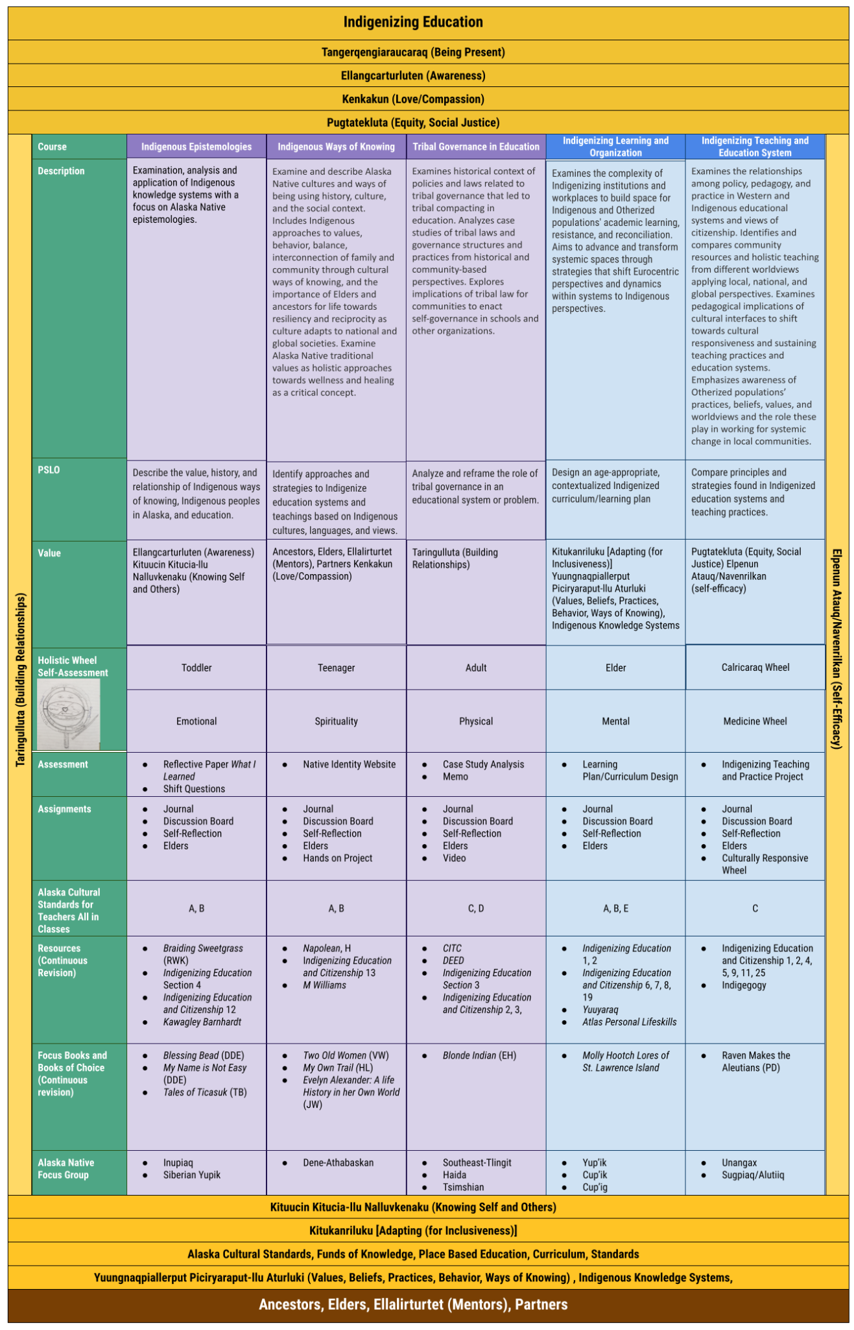
Table 3: Overall Indigenizing Education GCRT in Dr. Panigkaq John-Shields’ framework

Process
The Indigenizing Education GCRT program assessment process entails all data collected are forwarded to the Program Chair by the end of each semester. The program chair tabulates, correlates, summarizes, and prepares a preliminary assessment report which is shared with program faculty. It is then reviewed by the Program Chair.
The results of the data collection and analysis, including a discussion of the results, and a listing of the recommended program changes will be forwarded to the Office of Academic Affairs (in the required format) biannually by November 15th. The faculty will develop a plan for implementing the recommended changes, including publication of the changes and how they will be made available to the program’s stakeholders, will also be determined at this meeting.

Formulation of Recommendations for Program Improvement
The proposed program change may be any action or change in policy that the faculty deems necessary to improve performance relative to program outcomes. Recommended changes will consider workload (faculty, staff, and students), budgetary, facilities, and other relevant constraints. A few examples of changes made by program at UAA include:
- Changes in course content, scheduling, sequencing, prerequisites, and delivery methods.
- Changes in faculty/staff allocations and assignments.
- Changes in advising methods and requirements.
- Additions and/or replacements of equipment.
- Change in facilities.

