Academic Assessment Plan

College: Community and Technical College

Program(s): AAS Industrial Process Instrumentation

Reviewed: Spring 2019

Table of Contents

Introduction To Program Assessment Of Student Learning 3
Introduction to Industrial Process Instrumentation 4
Assessment Process Introduction 5
Memo to accompany “KPC Student Learning Outcome Assessment: Data Collection Sheet” (Sample) 6
KPC Student Learning Outcome Assessment: Data Collection Sheet (Sample) 7
Program Outcomes 10
Assessment Tools 11
Table 1: Program Outcomes Assessment Tools and Administration______________________________ 12
Table 2: Association of Assessment Tools to Program Outcomes________________________________ 14

Assessment Implementation & Analysis for Program Improvement 15
General Implementation Strategy 15
Method of Data Analysis and Formulation of Recommendations for Program Improvement 15
Modification of the Assessment Plan 15
Appendix A: PETR A155 P & ID Readings: ARCO-DSGN/CONST & ARCO (Construction) 16
Appendix B: PRT A140 Test 2, Problems 1 & 2 22
Appendix C: PRT A140, Test 7 23
Appendix D: ET A246 Test 3, Problems 1 & 2 24
Appendix E: ET A101 (DC Physics) Test 2 25
Appendix F: Course Groupings Associated With Each Outcome 26

Introduction To Program Assessment Of Student Learning

Student Learning (Outcomes) Assessment is an evaluation process where the program faculty review the published program outcomes and determine the success with which students have achieved (learned) those outcomes. Student learning (outcomes) assessments normally result in recommendations by the faculty for improvements related to program content or delivery. Plans for assessing student learning outcomes are prepared by program faculty and approved by their college. Active plans and outcomes assessment reports are filed yearly with the Office of Academic Affairs.

Assessment of educational effectiveness is increasingly recognized nationally as an essential component for all of higher education. In addition to its centrality to our goal of becoming a true learning organization, assessment of outcomes is also required by our accrediting commission, Northwest Association of Schools and Colleges, as well as the University of Alaska Board of Regents. The assessment of educational effectiveness and outcomes must be a part of every course [program] of study if we are to meet the expectations of our stakeholders, satisfy the requirements of our institutional and program accreditation, and be accountable to ourselves that we are providing the highest quality educational programs possible.

Each academic program at KPC is to engage in a continuous improvement process. This process is to be formalized and repeated on a regular cycle and must include the essential elements of:

- Setting program outcomes
- Selecting indicators that can be used to measure progress toward achieving those outcomes
- Gathering and analyzing data to determine achievement
- Recommending and implementing program changes that facilitate further progress in achieving the desired outcomes.

A framework that reflects well established and validated practices has been adopted for the continuous improvement of each academic and administrative unit of the University of Alaska Anchorage. It has been assigned the acronym PAAR; which stands for Plan, Act, Access, and Revise.

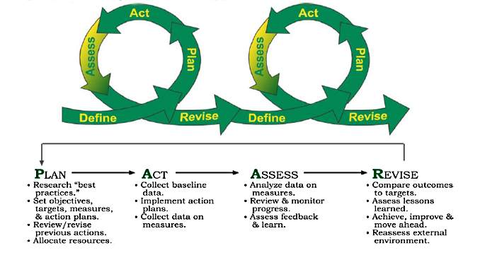This assessment plan document reflects the PAAR outline for the A.A.S. in Industrial Process Instrumentation degree program at the University of Alaska – Kenai Peninsula College.

Introduction to Industrial Process Instrumentation

The purpose of this document is to outline a series of steps for determining the academic effectiveness of the KPC A.A.S. Industrial Process Instrumentation program.

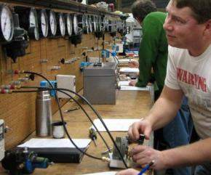
The Industrial Process Instrumentation (IPI) program is one of the premier vocational/technical learning programs in the UA system. The IPI program is designed to produce qualified instrumentation/industrial automation technicians for all industry applications in Alaska and elsewhere.

The A.A.S. Industrial Process Instrumentation Degree is designed to provide education/training that will enable individuals to obtain employment as instrument technicians who are responsible for the repair, maintenance, adjustment, and calibration of automatic controls used in refineries, chemical plants, pipelines, production facilities, and other industries where automatic control is used. In Alaska, this includes the process industries of oil and gas production, chemical manufacturing, petroleum refining, power generation and utilities, water and waste-water treatment, and seafood and other food processing.

The IPI lab facilities have state-of-the-art facilities, simulators, and equipment. All areas are kept up to industry standards as budgetary constraints allow. The IPI department strives to maintain a safe and realistic learning environment for students.

Hardware simulators use current industry technology in order to be as realistic as possible in a nonindustrial setting. Students wire, program, troubleshoot, and test just as they would on the job. The Instrumentation and Process Technology programs complement each other with students mirroring the teamwork between instrumentation and operations personnel in the industry.

New industry-standard software, “Wonderware” for Human Machine Interface (HMI) design has recently been added to the lab environment specifically to mirror what students will likely find when on the job.
Students who are currently enrolled in or graduate from the IPI program will typically find employment in the following industries in Alaska:

- The petrochemical plants up-stream oil & gas production
- Pipeline operations
- Refinery operations
- Mineral benefaction mills
- Wood products, fish processing
In other locations, the industries are more varied. Our students are currently employed at North Slope facilities, Cook Inlet offshore and onshore oil & gas facilities, Alyeska Pipeline Co., Alaska petro-chemical & refining plants, and many facilities in the continental U.S.

This program provides excellent employees to industry. (The following are quotes from Rick Main, Agrium)

KPC trained instrument technicians are top-notch.
They are very employable.
They exceed expectations for entry-level employees.
They are promotable within an organization and to other organizations.
Except in special circumstances, Agrium’s policy is to hire instrument technicians who have completed the Industrial Process Instrumentation program [at KPC].

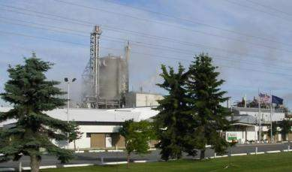

Assessment Process Introduction

KPC program Faculty, Assessment Coordinator, and Assistant Director for Academic Affairs work together to review assessment plans. The Assessment Coordinator collects data from the faculty and builds reports, reviewed by the KPC Assistant Director in the summer and Faculty in the Fall semester. This process has been transforming student learning assessment plans over the past six years.

Last year, using the latest assessment plans, KPC added a direct assessment data coversheet for faculty to use in collecting direct learning data, such as results on projects, quizzes, exams, or assignments. The original data sheet was provided by Kathleen Voge of the College of Business and Public Policy and has been reworked for KPC needs.

A sample of the direct assessment data collection coversheet and memo to faculty is included on the next page. This method has resulted in greater adjunct faculty participation.

Memo to accompany “KPC Student Learning Outcome Assessment: Data Collection Sheet” (Sample)

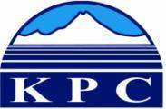

To: KPC Faculty Teaching Courses in the ______________________________Program
From : Paula J.S. Martin, Assistant Director for Academic Affairs
Date: ________________
Re: Assessment

You are teaching one or more courses that serve the ___________________________degree (or certificate) program. All KPC programs go through assessment of student learning outcomes, annually; therefore, we need faculty to collect assessment data for your class/classes that support the __________________________ degree (or certificate) program.

See the attached for directions, but the process is summarized below:

- Read the student learning outcome listed on the attached sheet.
- Decide which one class assignment (exam, paper, journal, homework, project, etc.) best addresses that learning outcome for your course. You can include more than one assignment, but you don’t need to.
- Provide the data:
  - Copy of the assignment
  - Scoring rubric or examples of good, marginal, and unsuccessful assignment
  - List of student scores on that assignment (and identifying what score=success)

KPC Student Learning Outcome Assessment: Data Collection Sheet (Sample)
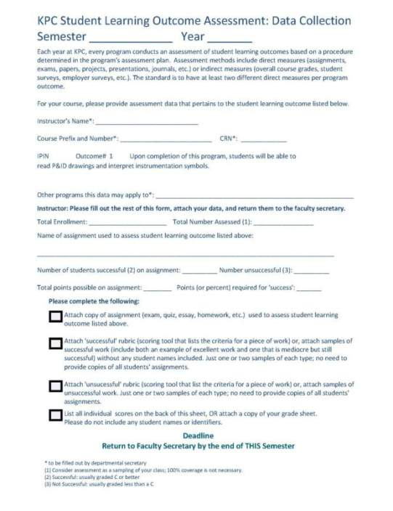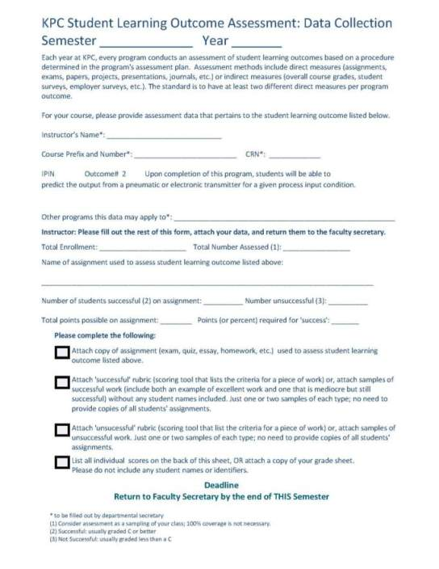

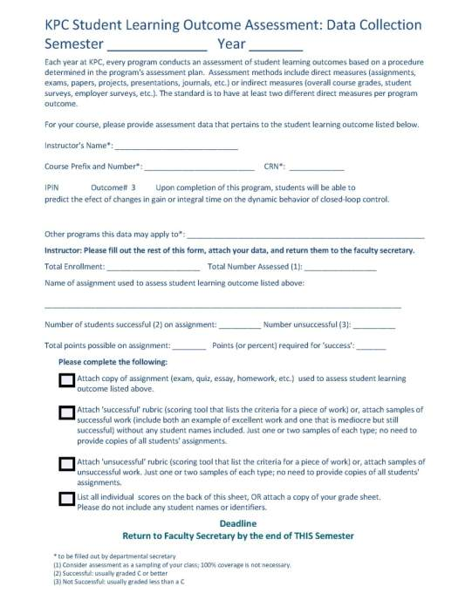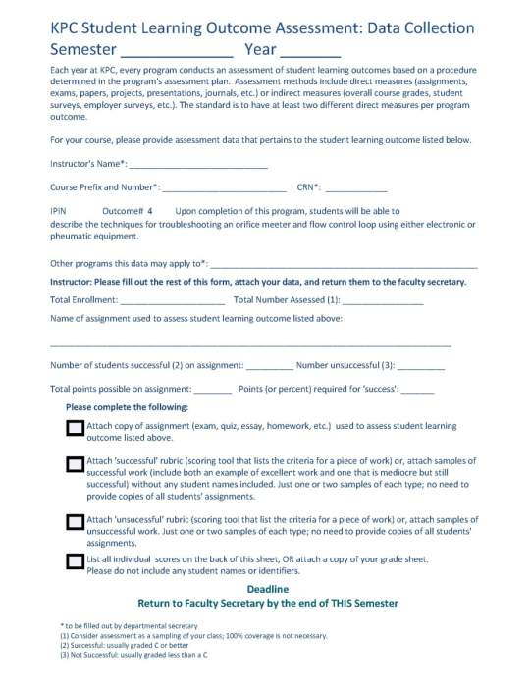
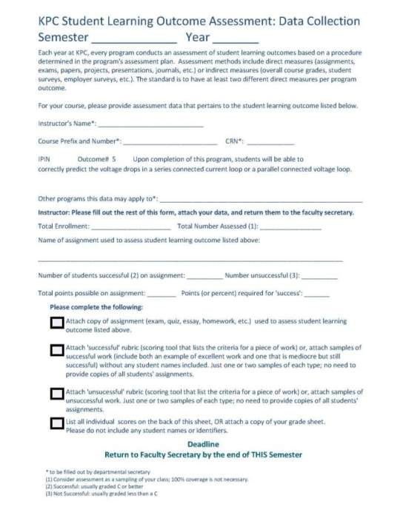

Program Outcomes

The KPC A.A.S. Industrial Process Instrumentation Program outcomes:

The graduates of the KPC Industrial Process Instrumentation program will have the ability to:

- read P & ID drawings and interpret instrumentation symbols
- describe the output from a pneumatic or electronic transmitter for a given process input condition
- predict the effect of changes in gain or integral time on the dynamic behavior of closed-loop control
- describe the techniques for troubleshooting an orifice meter and flow control loop using either electronic or pneumatic equipment
- identify the voltage drops in a series connected current loop or a parallel connected voltage loop
- distinguish between data transmitted by analog signals and data transmitted by digital signals

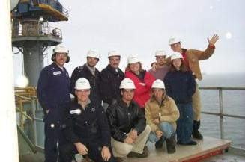

Assessment Tools

A description of the tools used in the assessment of the program outcomes and their implementation are summarized in Table 1. The tools and their relationships to the program outcomes are listed in Table 2.

There is a separate appendix for each tool that includes a more detailed description than is provided here and also describes the factors that affect the results and give examples of the tools and how they will be implemented.

The assessment tools may be used in total, or a sufficient number may be selected to accurately assess any given objective or outcome.

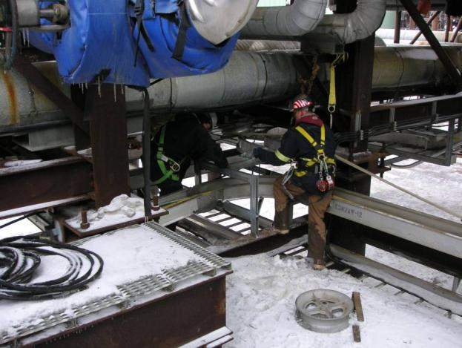

Table 1: Program Outcomes Assessment Tools and Administration
The IPIN outcomes were rewritten for AY10. IPIN now has five outcomes rather than the previous 12. Tools listed in the AY10 plan are those actually used in AY10. More tools will be added, including many tools used in the past (see AY09 Assessment Report), once they have been matched to the new six outcomes.

Tool | Description | Frequency/ Start Date | Collection Method | Administered by
PETR A155  P & ID reading  ARCO DSGN/  Construction  (Appendix A) | PETR A155 students read ARCO Design and Construction schematics and answer specific questions based on those readings. | Once per year or as offered | Direct assessment data collection sheets printed from MS Access database by assessment coordinator or director for academic affairs.  Class and faculty data entered by faculty secretaries, and given to program faculty.  Faculty provide assignment detail, rubrics, grading, and work samples and assessment coordinator or director for academic affairs for collation and initial report compilation. | Faculty, collected and delivered as described in the data collection memo and coversheet)
Exam: PRT A140 Test 2, Problems 1 & 2  (Appendix B) | Exam: PRT A140 Test 2, Problems 1 & 2(calculate volume of displacer sensor, calculate diameter of displacer sensor, calculate process variable percentage and transmitter output signal value) | Once per year or as offered | Same as above | Same as above
Exam: PRT A140 Test 7  (Appendix C) | Exam: PRT A140 Test 7  (calculate process variables given input values or diagrams) | Once per year or as offered | Same as above | Same as above
Exam: ET A246 Test 3, Problems 1 & 2  (Appendix D) | Exam: ET A246 Test 3, Problems 1 & 2  (given P & IDs, interpret data transmitted from various analog and digital signals) | Once per year or as offered | Same as above | Same as above
Exam: ET A101 Test 2  DC Physics  (Appendix E) | DC Physics calculations | Once per year or as offered | Same as above | Same as above
** On-going plan to look into adding testing or data from NSTO, HAZWOP etc. test results.

Table 2: Association of Assessment Tools to Program Outcomes

Samples of Measures:  (will vary by  semester, course,  instructor, etc.)  Outcomes: | PETR A155 students read ARCO Design and Construction schematics and answer specific questions based on those readings. | Exam: PRT A140 Test 2, Problems 1 & 2  (calculate volume of displacer sensor, calculate diameter of displacer sensor, calculate process variable percentage and transmitter output signal value) | Exam: PRT A140 Test 7  (calculate process variables given input values or diagrams) | Exam: ET A246 Test 3, Problems 1 & 2  (given P & IDs, interpret data transmitted from various analog and digital signals) | Exam: ET A101 Test 2  DC Physics
- read P & ID drawings and interpret instrumentation symbols | 1 | 1 | 1 | 1 | 1
- describe the output from a pneumatic or electronic transmitter for a given process input condition | 0 | 0 | 1 | 0 | 0
- describe the effect of changes in gain or integral time on the dynamic behavior of closed-loop control | Will add in AY11 | Will add in AY11
- describe the techniques for troubleshooting an orifice meter and flow control loop using either electronic or pneumatic equipment | Will add in AY 11 | Will add in AY 11
- identify the voltage drops in a series connected current loop or a parallel connected voltage loop | 0 | 0 | 0 | 1 | 1
- distinguish between data transmitted by analog signals and data transmitted by digital signals | 0 | 0 | 0 | 1 | 0

Assessment Implementation & Analysis for Program Improvement

General Implementation Strategy

Kenai Peninsula College has appointed an Assessment Coordinator who works with staff and faculty and the Assistant Director for Academic Affairs to collect the data indicated in Tables 1 and 2. Data is collected by the end of each Spring semester. The coordinator then spends approximately six weeks writing the annual assessment reports for each KPC program. Those reports are reviewed by the Assistant Director for Academic Affairs when she returns in early July. The reports and any updated plans are sent to the UAA Office of Academic Affairs by July 15. The program faculty review the reports and, as needed, update plans, in late August and September each year.

The assessment tools may be used in total, or a sufficient number may be selected to accurately assess any given objective or outcome.

Method of Data Analysis and Formulation of Recommendations for Program Improvement

The faculty of the Industrial Process Instrumentation program is to meet at least once a year with KPC Process Technology and Petroleum Technology faculty and the Assessment Coordinator to review the data collected using the assessment tools. This meeting should result in recommendations for program changes that are designed to enhance performance relative to the program’s student learning outcomes. The results of the data collection, an interpretation of the results, and the recommended programmatic changes are included in the report (and, if applicable, plan) for the following year. A plan for implementing the recommended changes, including of advertising the changes to all the program’s stakeholders, is also to be completed at this meeting.

The programmatic changes may be any action or change in policy that the faculty deems as being necessary to improve performance relative to programs’ outcomes. Recommended changes should also consider workload (faculty, staff, and students), budgetary, facilities, and other relevant constraints. A few examples of changes made by programs at UAA include:
- changes in course content, assignments, sequencing, prerequisites, delivery methods, etc.
- changes in faculty/staff assignments
- changes in advising methods and requirements
- addition and/or replacement of equipment
- changes to facilities

Modification of the Assessment Plan

The faculty, after reviewing the collected data, processes used to collect it, and final report, may decide to alter the assessment plan. Changes may be made to any component of the plan, including the objectives, outcomes, assessment tools, or any other aspect of the plan. The changes are to be approved by the faculty of the program. The modified assessment plan is to be forwarded to the KPC Assistant Director for Academic Affairs and ultimately to the UAA Office of Academic Affairs.

Appendix A: PETR A155 P & ID Readings: ARCO-DSGN/CONST & ARCO (Construction)

Tool Description:

PETR A155 students read ARCO Design and Construction schematics and answer specific questions based on those readings.

Factors that affect the collected data:

Numbers of students completing the assignment may vary.

Tabulating and Reporting Results:

The instructor will administer and collect the activity and provide the assessment coordinator the tabulated results with comments to be included in the program assessment report.

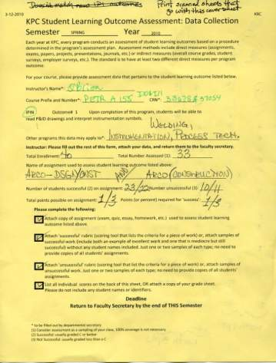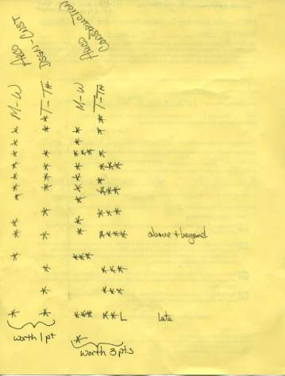

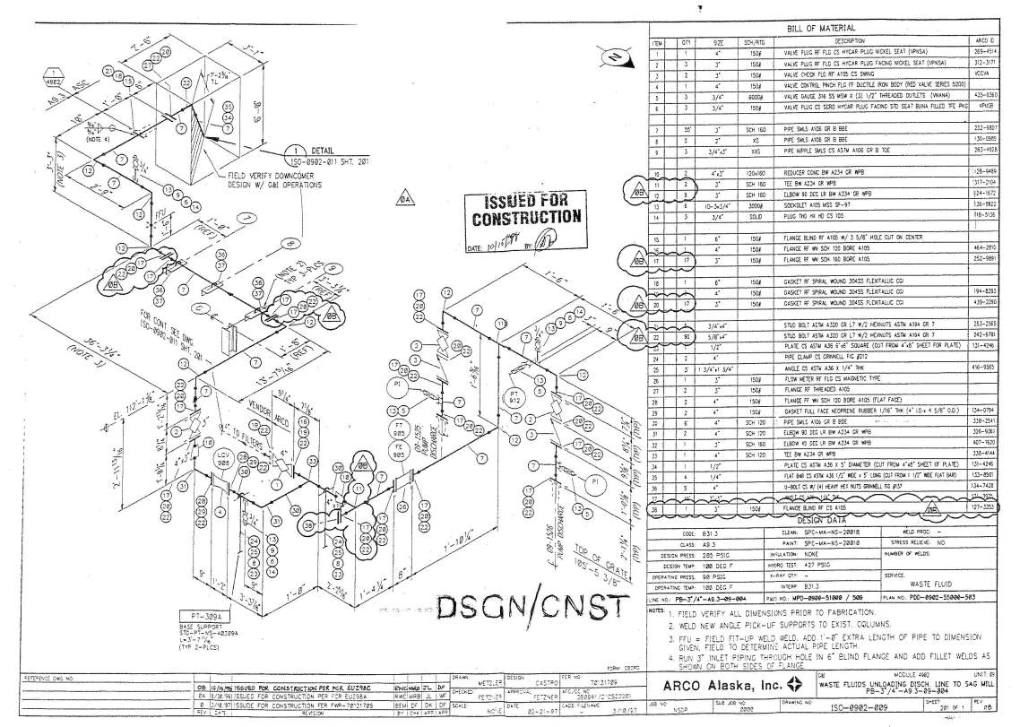
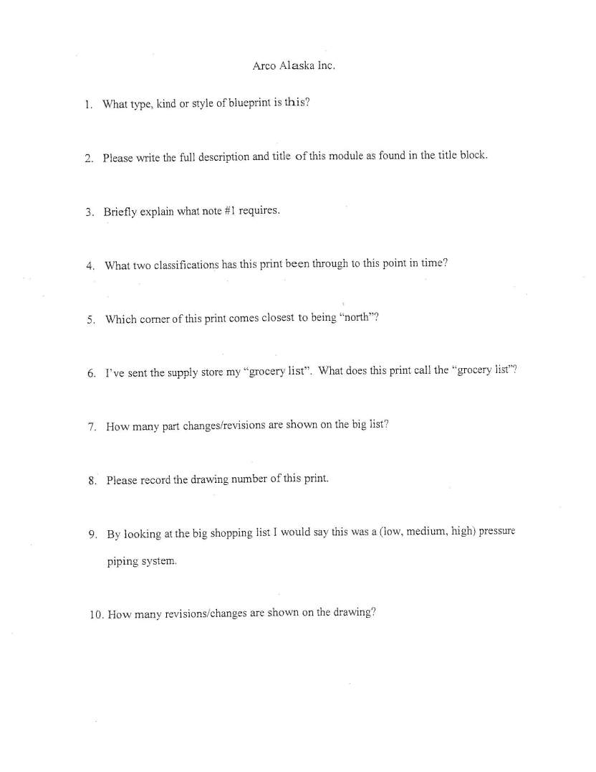
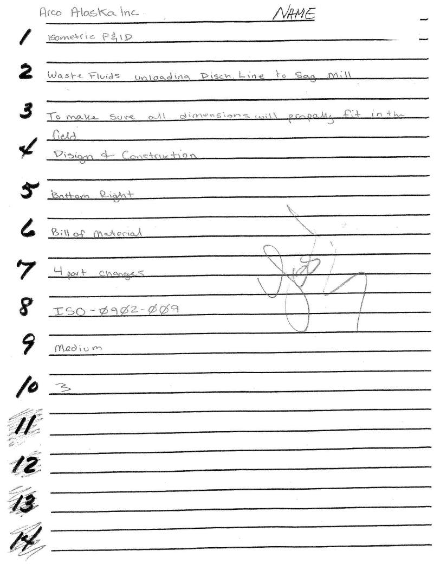

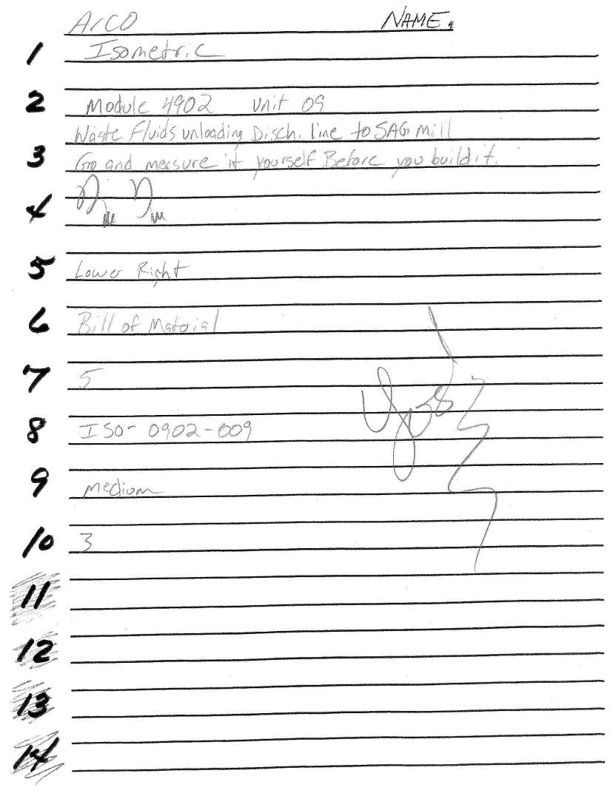

Appendix B: PRT A140 Test 2, Problems 1 & 2

Tool Description:

This assessment tool is an exam given in the PRT A140 class in which problems 1 & 2 specifically address Outcome #1 of the Industrial Process Instrumentation program. These two problems consist of simple P & ID diagrams and input data. The student is to calculate the correct volume of the displacer sensor, calculate the diameter of the displacer sensor, and calculate the process variable percentage and the transmitter output signal value.

Factors that affect the collected data:

Numbers of students completing the assignment may vary.

Tabulating and Reporting Results:

The instructor will administer and collect the exams and provide the assessment coordinator the tabulated results with comments to be included in the program assessment report.

Because of the security of exams, samples are not; however, samples can be requested by appropriate parties (deans, directors, OAA, etc.).

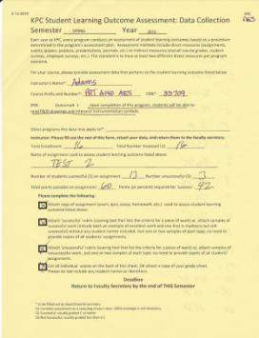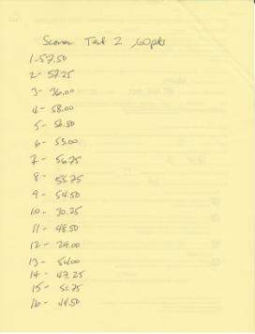

Appendix C: PRT A140, Test 7

Tool Description:

This assessment tool is an exam given in the PRT A140 class that specifically addresses Outcomes #1 & #2 of the Industrial Process Instrumentation program. The exam consists of various questions relating to these outcomes and various P & ID diagrams and inputs that require accurate readings of the P & IDs and accurate output calculations related to pneumatic or electronic transmitters for given processes.

Factors that affect the collected data:

Numbers of students completing the assignment may vary.

Tabulating and Reporting Results:

The instructor will administer and collect the exams and provide the assessment coordinator the tabulated results with comments to be included in the program assessment report.

Because of the security of exams, samples are not; however, samples can be requested by appropriate parties (deans, directors, OAA, etc.).

(See Appendix A & D for data collection samples)

Appendix D: ET A246 Test 3, Problems 1 & 2

Tool Description:

This assessment tool is an exam given in the ET A246 class that specifically addresses Outcome#5 and parts of Outcomes #1& #6 of the Industrial Process Instrumentation program. The exam consists of various P & IDs and input variables for students to interpret as well as problems for students to draw P & ID solutions to a given set of data. The exam emphasizes problems related to predicting thee voltage drops in a series connected current loop or a parallel connected voltage loop.

Factors that affect the collected data:

Numbers of students completing the assignment may vary.

Tabulating and Reporting Results:

The instructor will administer and collect the exams and provide the assessment coordinator the tabulated results with comments to be included in the program assessment report.

Because of the security of exams, samples are not; however, samples can be requested by appropriate parties (deans, directors, OAA, etc.).

(See Appendix A & D for data collection samples)

Appendix E: ET A101 (DC Physics) Test 2

Tool Description:

This assessment tool is an exam given in the electronics class, ET A101 DC Physics class that specifically addresses Outcome #5 of the Industrial Process Instrumentation. The exam consists of electronic schematics and inputs and the student calculates or identifies various elements of parallel circuits, series parallel circuits, or given a set of inputs, draws the appropriate schematic for the given data.

Factors that affect the collected data:

Numbers of students completing the assignment may vary.

Tabulating and Reporting Results:

The instructor will administer and collect the exams and provide the assessment coordinator the tabulated results with comments to be included in the program assessment report.

Because of the security of exams, samples are not; however, samples can be requested by appropriate parties (deans, directors, OAA, etc.).

Sample assessment data collection cover sheet and grades are shown in the images below.

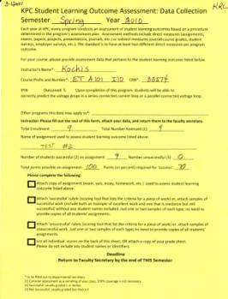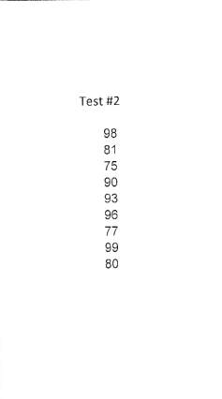

INDUSTRIAL PROCESS INSTRUMENTATION

Appendix F: Course Groupings Associated With Each Outcome

Outcome #1: read P & ID drawings and interpret instrumentation symbols
PRT A144 – Industrial Process Instrumentation I
PETR A240 – Industrial Process Instrumentation II
PETR A155 – Blue Print Reading
PRT A230 – Process Technology II
ET A246 – Electronic Industrial Instrumentation

Outcome #2: describe the output from a pneumatic or electronic transmitter for a given process input condition
PRT A144 – Industrial Process Instrumentation I
PETR A240 – Industrial Process Instrumentation II

Outcome #3: describe the effect of changes in gain or integral time on the dynamic behavior of closed-loop control
PETR A244 – Industrial Process Instrumentation IV

Outcome #4: describe the techniques for troubleshooting an orifice meter and flow control loop using either electronic or pneumatic equipment
PRT A230 – Process Technology II
PRT A250 – Process Troubleshooting
PETR A240 – Industrial Process Instrumentation II
PETR A244 – Industrial Process Instrumentation IV

Outcome #5: identify the voltage drops in a series connected current loop or a parallel connected voltage loop
ET A101 – Basic Electronics: DC Physics
ET A246 – Electronic Industrial Instrumentation

Outcome #6: distinguish between data transmitted by analog signals and data transmitted by digital signals
ET A241 – Microcomputer Interfacing
ET A246 – Electronic Industrial Instrumentation

