Academic Assessment Plan

College: Community and Technical College

Program(s): UC Welding Technology

Reviewed: Spring 2021
Table of Contents

Introduction To Assessment Of Student Learning 3
Points To Ponder… 4
Introduction to the Welding Technology Certificate 5
Program Outcomes 6
Assessment Tools 7
Assessment Implementation & Analysis for Program Improvement 10
General Implementation Strategy 10
Method of Data Analysis and Formulation of Recommendations for Program Improvement 10
Modification of the Assessment Plan 10
Appendix A: KPC’s PSLO Data Collection Cover Sheets 11
Appendix B: Grade Data (Suspended except for PSLO cover sheet data) 20
Appendix C: Welding Certification Test Results 21
Appendix D: Exit/Graduate (Alumni) Survey 22
Appendix E: Employer Survey 25
Appendix F: Instructor Impression Survey (Added as questions to KPC’s PSLO data collection cover sheets) 29
WELDING PLAN OUTCOMES “LAST PAGE” 30
Appendix G: Course Groupings Associated With Each Outcome 30

Table 1: Program Outcomes Assessment Tools and Administration 8
Table 2: Association of Assessment Tools to Program Outcomes 9

Introduction To Assessment Of Student Learning
The purpose of academic assessment is improvement of learning. The Academic Assessment Committee (AAC) of the Faculty Senate was created to provide peer leadership, support, and review of academic assessment to ensure that it can produce its intended benefit to students. Faculty are best suited to plan, implement, and act upon the academic assessment of student learning outcomes. Moreover, academic assessment is a mandate of Northwest Commission on Colleges & Universities (NWCCU) and the University of Alaska Board of Regents Policy (BOR). (AAC Handbook, page 1)
The assessment reporting process runs on a 3-year cycle. A graphical illustration of the repeating 3-year cycle of academic assessment cycle is shown on the following page. The process consists of a yearly assessment cycle embedded within a three-year review cycle. The academic assessment plan is a living document that describes the program’s student learning outcomes along with instruments that will be used to measure the outcomes.
The plan drives assessment activities to be conducted yearly that measure some or all of the program outcomes.
All outcomes must be measured within the three-year review cycle.
Data collected from the assessment instruments should be discussed and analyzed among department faculty and recommendations made to improve the program and/or the assessment plan for the following year. The AAC reviews the assessment activities and results of each program every three years; however, programs complete an academic assessment review cycle every year. Assessment coordinators for each program will answer an annual Assessment Survey based on the assessment activities completed each year.
Each academic program at UAA is to engage in a continuous improvement process. This process is to be formalized and repeated on a regular cycle and must include the essential elements of:

- Setting program outcomes
- Selecting indicators that can be used to measure progress toward achieving those outcomes
- Gathering and analyzing data to determine achievement
- Recommending and implementing program changes that facilitate further progress in achieving the desired outcomes.

Three-Year Academic Assessment Cycle (AAC Handbook)
Introduction to the Welding Technology Certificate
The mission of the Certificate in Welding Technology program is to provide students specific training for structural and pipe welding certification. Students gain a well-rounded education in the use of the latest welding technology, blueprint reading, layout, and fabrication. Graduates of this program will be prepared for employment as structural or pipe welders, and will have a solid welding background for many mechanical trades.
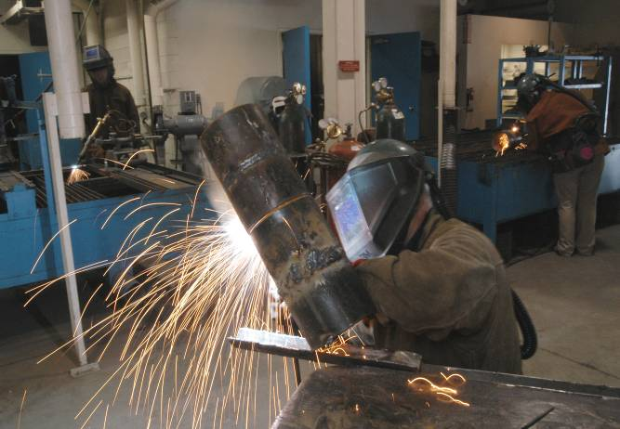
Students participating in this program are primarily interested in skill development sufficient to certify to specific standards. The card that goes with that accomplishment is more valuable in obtaining a job than is the certificate issued upon graduation. Experienced welders have the option of bypassing the first semester courses by completing written and practical examination on first-semester work. This will allow experienced welders to enter the program at an appropriate level.
Welding technology faculty frequently meets with industry employers to discuss industry needs and trends in the area of welding technology. Besides the KPC certificate program courses, KPC’s welding technology programs and faculty have provided training for specific industry needs. Welders from Morneftigas on Sakhalin Island (Russia) were trained and certified to ASME section IX. Advanced welding exclusively on new wire welding process was provided for the Unocal welding personnel. The Alpine fast-track program was designed to meet the immediate needs of the ARCO module fabrication project. Both the Russian project and the Alpine project were non-credit activities. Meetings to discuss current needs and KPC’s ability to meet those needs preceded each training session. Curriculum and equipment have been continually adjusted as needed to meet those needs.
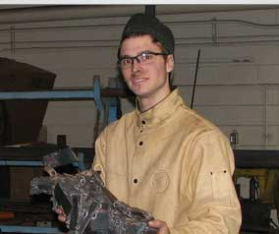
This document defines the educational outcomes for the Certificate in Welding Technology program and outlines a plan for assessing the achievement of the stated outcomes.
The development of the objectives and outcomes consisted of numerous both formal and informal meetings with industry people from the above companies and KPC vocational faculty.
The faculty met and accepted the objectives, outcomes, and assessment processes on September 20, 2003. The document has been under continual revision since that date, and an official revision was accepted on March 31, 2007.

Program Outcomes
The specific educational student learning outcomes that support the program are to produce graduates who demonstrate competence in:

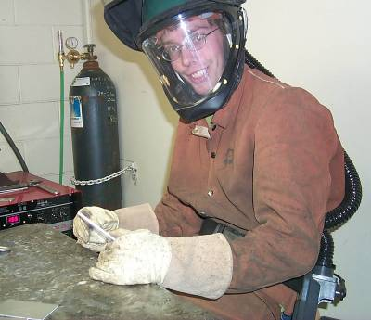

AWS D1.1 structural

- the oxy-acetylene cutting process
- the preparation of steel plate certified groove welds
- the welding of steel-plate all position groove welds


ASME section IX pipe welding

- the oxy-acetylene cutting process of steel pipe (both with freehand and machine cutting)
- the preparation of steel pipe to be welded with the stick-electrode process for common sizes of pipe used in industry
- the welding of steel pipe per Procedure KPC-I for testing and welds common schedules and sizes of pipe used in industry.

National Testing Standards

- Completes structural and pipe certification national testing standards.

Assessment Tools

A description of the tools used in the assessment of the program outcomes and their implementation are summarized in Table 1. The tools and their relationships to the program outcomes are listed in Table 2.

There is a separate appendix for each tool that includes a more detailed description than is provided here and also describes the factors that affect the results and give examples of the tools and how they will be implemented.

The assessment tools may be used in total, or a sufficient number may be selected to accurately assess any given objective or outcome.

The assessment tools may be used in total, or a sufficient number may be selected to accurately assess any given objective or outcome.

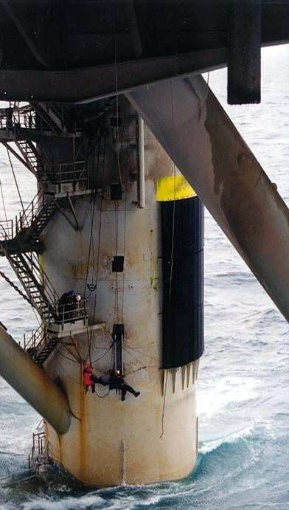
Table 1: Program Outcomes Assessment Tools and Administration

Tool | Description | Frequency/ Start Date | Collection Method | Administered by
Course-level Assessment through KPC’s PSLO data collection coversheets | Assessment of courses relative to their own outcomes. Course results are mapped to program outcomes. This usually includes digital (photographic) documentation | Each semester as taught | Cover sheets and Images submitted by instructors on course PSLO cover sheets | Assessment Coordinator in conjunction with Advisors, Faculty & staff
Welding Certification Tests | Welding Certification Tests | Annually, on-going | Faculty | Faculty Certified Tester
Exit/Graduate (Alumni) Survey | Perception survey of attainment of stated program outcomes, as seen by the graduating students. | Annually starting Spring 2003 for new graduates and in 2 and 5 years as a graduate follow up  (suspended activity) | Hand delivered at KPC to current graduates -- mailed for  follow up | Assessment Coordinator in conjunction with Advisors/Staff
Employer Survey | Perception survey of graduates attainment of stated program outcomes, and assessment of outcomes to current industry needs, as seen by employers | Every three years starting with 2002 – may survey some employers each year with the intent of not resurveying any given employer more frequently than every three years.  (suspended activity) | mailed survey or personal interview | Assessment Coordinator in conjunction with Advisors, Faculty & staff
Instructor Impression (questions added to KPC’s PSLO data collection cover sheets) | Instructors will evaluate outcomes for each course and interpret data from other course-level assessments | Each semester starting  Spring 2004  Survey replaced with questions on KPC PSLO data collection cover sheets | Assessment Coordinator prepares and gives to Faculty | Faculty returns to assessment coordinator for tabulation & reporting

Table 2: Association of Assessment Tools to Program Outcomes

Outcome | Course-Level Assessment  Digital Imaging documentation of Projects | Welding Certification Test | Employer Survey | Instructor Impression
- the oxy-acetylene cutting process | 1 | 1 | 1 | 1
- the preparation of steel plate certified groove welds | 1 | 1 | 1 | 1
- the welding of steel-plate all position groove welds | 1 | 1 | 1 | 1
- the oxy-acetylene cutting process of steel pipe (both with freehand and machine cutting) | 1 | 1 | 1 | 1
- the preparation of steel pipe to be welded with the stick-electrode process for common sizes of pipe used in industry | 1 | 1 | 1 | 1
- the welding of steel pipe per Procedure KPC-I for testing and welds common schedules and sizes of pipe used in industry. | 1 | 1 | 1 | 1
- Completes structural and pipe certification national testing standards.

0 = Tool is not used to measure the associated objective.
1 = Tool is used to measure the associated objective.

Assessment Implementation & Analysis for Program Improvement
General Implementation Strategy

The original Educational Effectiveness Assessment Plan was implemented in 2002 by the Business and Industry Division of Kenai Peninsula College. At that time, a graduate survey and an employer survey were conducted, collected, and reported.

In 2003, Kenai Peninsula College has appointed an Assessment Coordinator who will work with the staff and faculty to collect the data indicated in Tables 1 and 2. This coordinator will also provide support for course-level assessment and other assessment activities as needed. The assessment coordinator will work with staff and faculty to assemble the data and forward it to the director of KPC for final report preparation. The final report will be reviewed by the program faculty before submitting it to the UAA Academic Affairs assessment coordinator in June of 2004.
Method of Data Analysis and Formulation of Recommendations for Program Improvement

The faculty of the Welding Technology program is to meet at least once a year with the division chair and the assessment coordinator to review the data collected using the assessment tools. This meeting should result in recommendations for program changes that are designed to enhance performance relative to the program’s objectives and outcomes. The results of the data collection, an interpretation of the results, and the recommended programmatic changes are to be forwarded to the office of Academic Affairs (in the required format) by the end of May each year. A plan for implementing the recommended changes, including of advertising the changes to all the program’s stakeholders, is also to be completed at this meeting.

The proposed programmatic changes may be any action or change in policy that the faculty deems as being necessary to improve performance relative to programs objectives and outcomes. Recommended changes should also consider workload (faculty, staff, and students), budgetary, facilities, and other relevant constraints. A few examples of changes made by programs at UAA include:
- changes in course content, scheduling, sequencing, prerequisites, delivery methods, etc.
- changes in faculty/staff assignments
- changes in advising methods and requirements
- addition and/or replacement of equipment
- changes to facilities
Modification of the Assessment Plan

The faculty, after reviewing the collected data and the processes used to collect it, may decide to alter the assessment plan. Changes may be made to any component of the plan, including the objectives, outcomes, assessment tools, or any other aspect of the plan. The changes are to be approved by the faculty of the program. The modified assessment plan is to be forwarded to the dean/director’s office and the Office of Academic Affairs.

Appendix A: KPC’s PSLO Data Collection Cover Sheets

Tool Description:

KPC’s Assessment Coordinator provides instructors with PSLO data collection cover sheets. The instructors choose appropriate course-level activities to provide to the assessment coordinator for use in program assessment. The cover sheets are generic enough for each instructor to choose from assignments, quizzes, projects, exams, etc., that they already assign in their classes.

The instructor includes a sample of the assignment, a successfully completed student sample (with names removed), and if appropriate, a mediocre student sample, and/or an unsuccessful student sample (all with no student names). The instructor also includes a score sheet or grading rubric and a list of grades for the class on the particular assessment.

The instructor also has the opportunity to answer a series of questions that helps interpret the results or makes recommendations for course or program improvement.

Factors that affect the collected data:

The course-level assessment is strongly influenced by the instructor’s perceptions since this is the individual supplying the data. This is tempered somewhat if one of the course-level assessment tools is a student perception survey. The factors that affect the results depend, in large measure, on the assessment tools used by the instructor. Some factors that influence the collected data include:

- The standard set by the instructor. A low standard tends to result in fairly high values in course-level assessments. Students will not know if the standard was appropriately set until they leave the course and have to apply the knowledge and skills learned, so both the student perceptions and the instructor-introduced measures may tend to be higher than is reasonable if the standards are set too low. The opposite effect is seen when the standards are set too high. The level of the standard should be determined by the program faculty so that comparison between instructors is valid. Variability of standards makes data combination and comparison questionable.
- The number and detail of assessments used in the course. For example, a single exam is often not a good indicator of performance for a variety of reasons (must be comprehensive, does not account for students that “have a bad test”, etc.). The fewer the assessments and the less detailed the assessments, the less reliable the results.

How to interpret the data:

Care should be taken to investigate and discuss the factors influencing the results before interpreting the outcome. The results of course-level assessments should also be compared against other measures to get good picture of program performance.

See attached cover sheets for samples course-level data collection process.


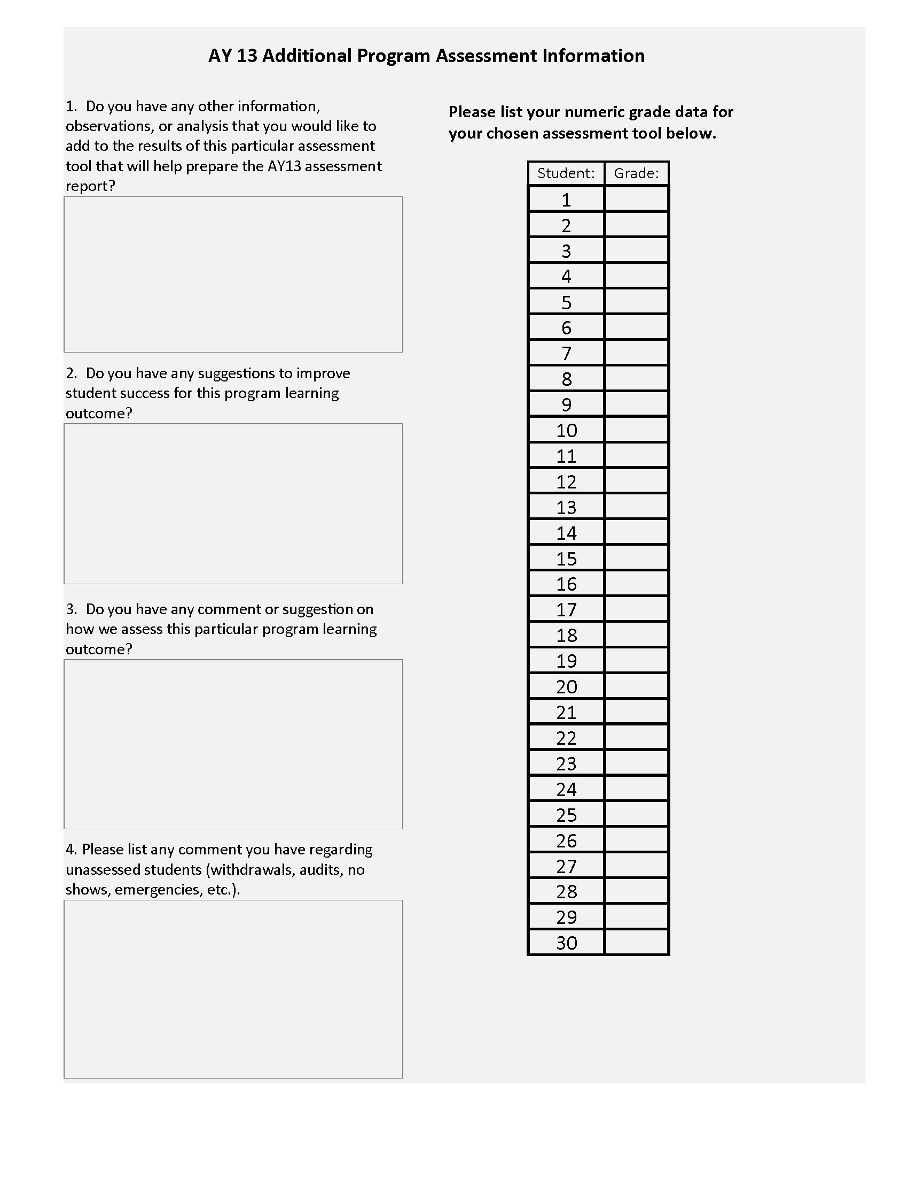

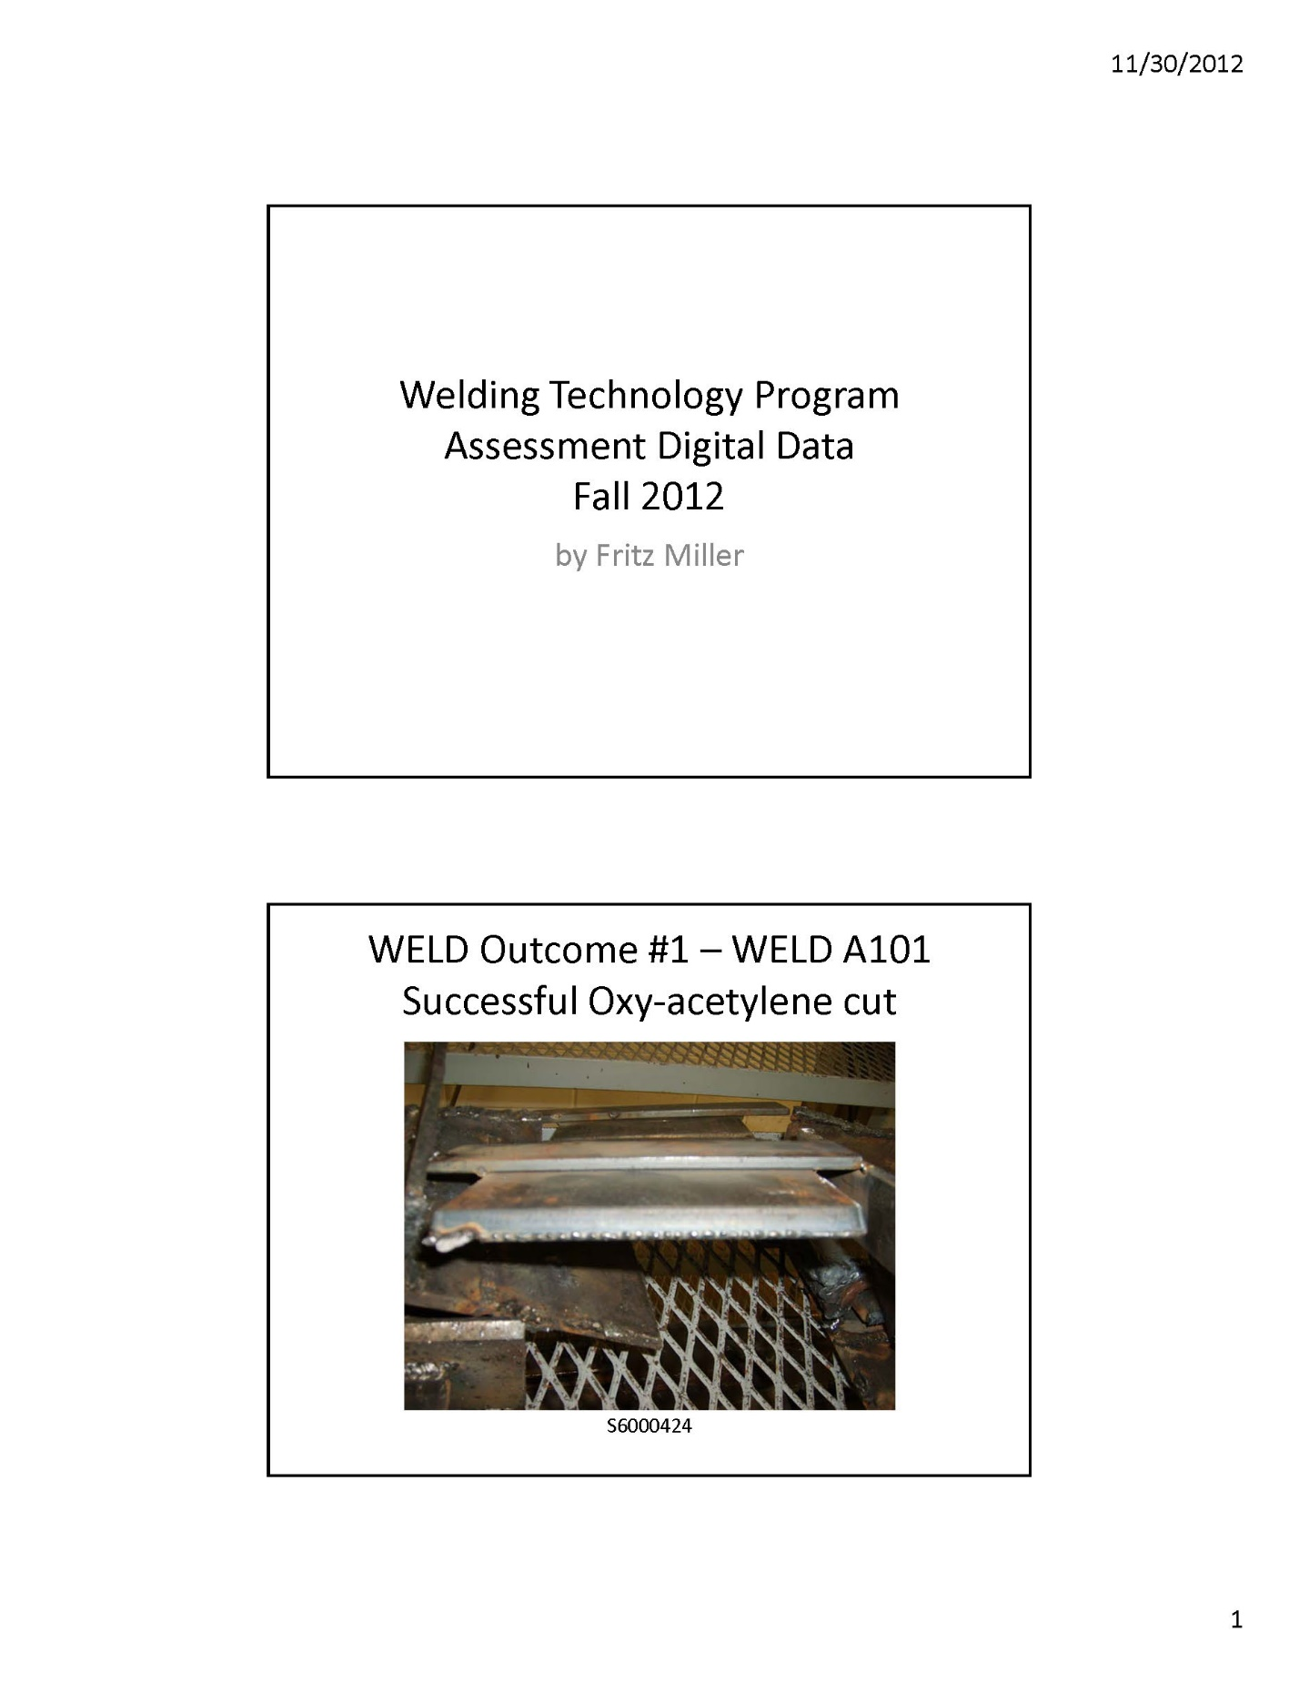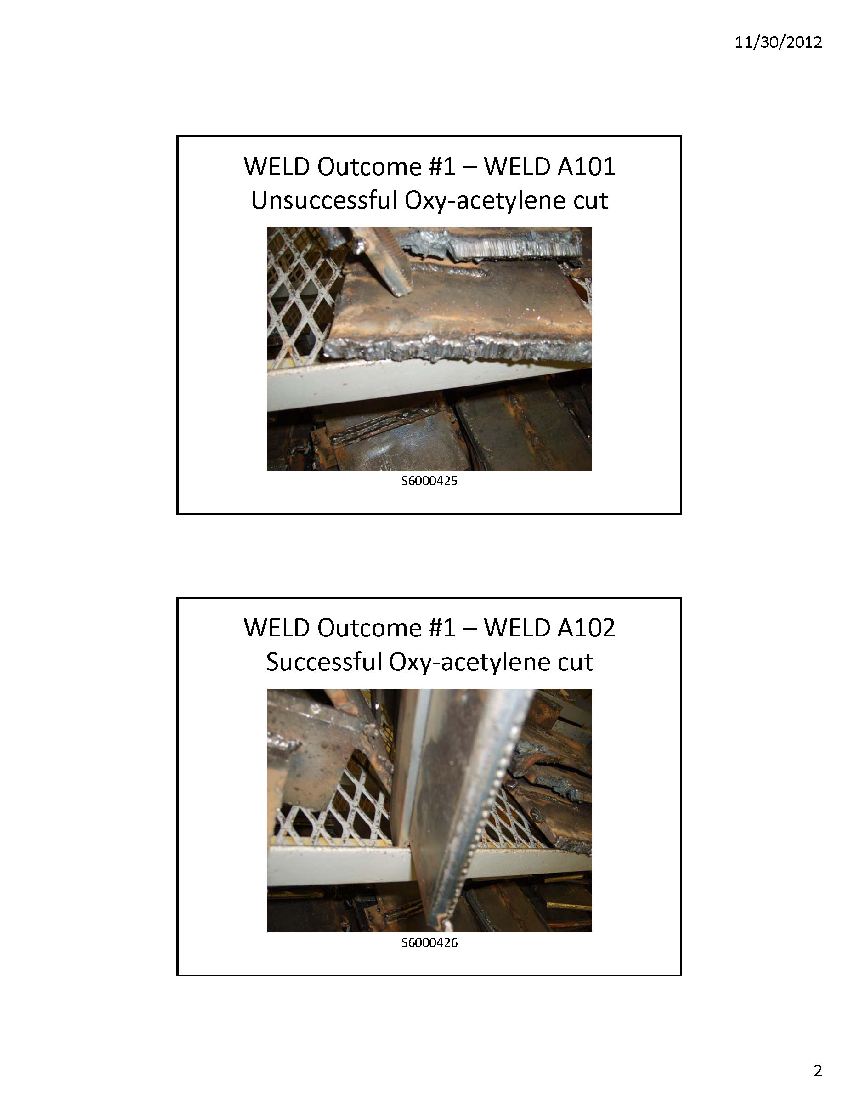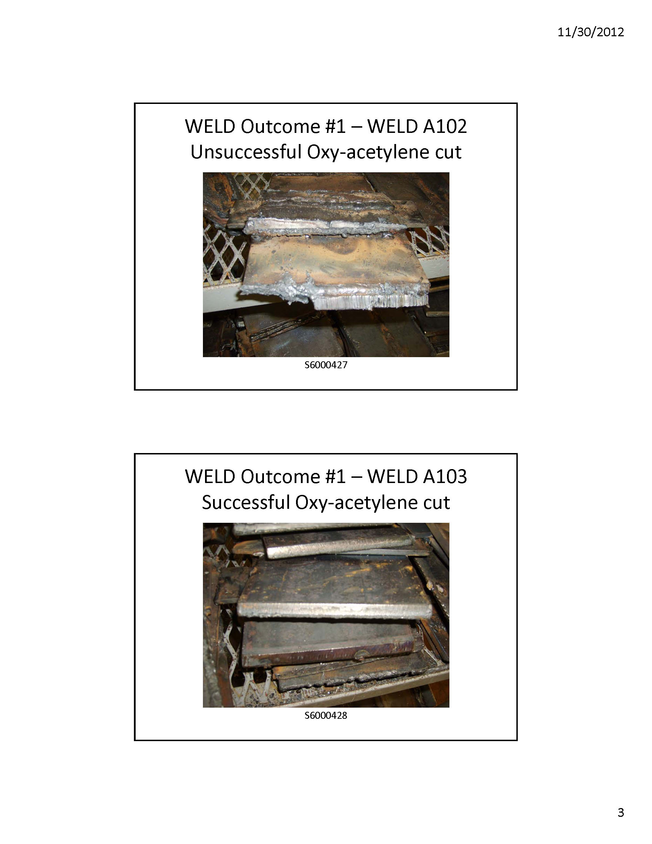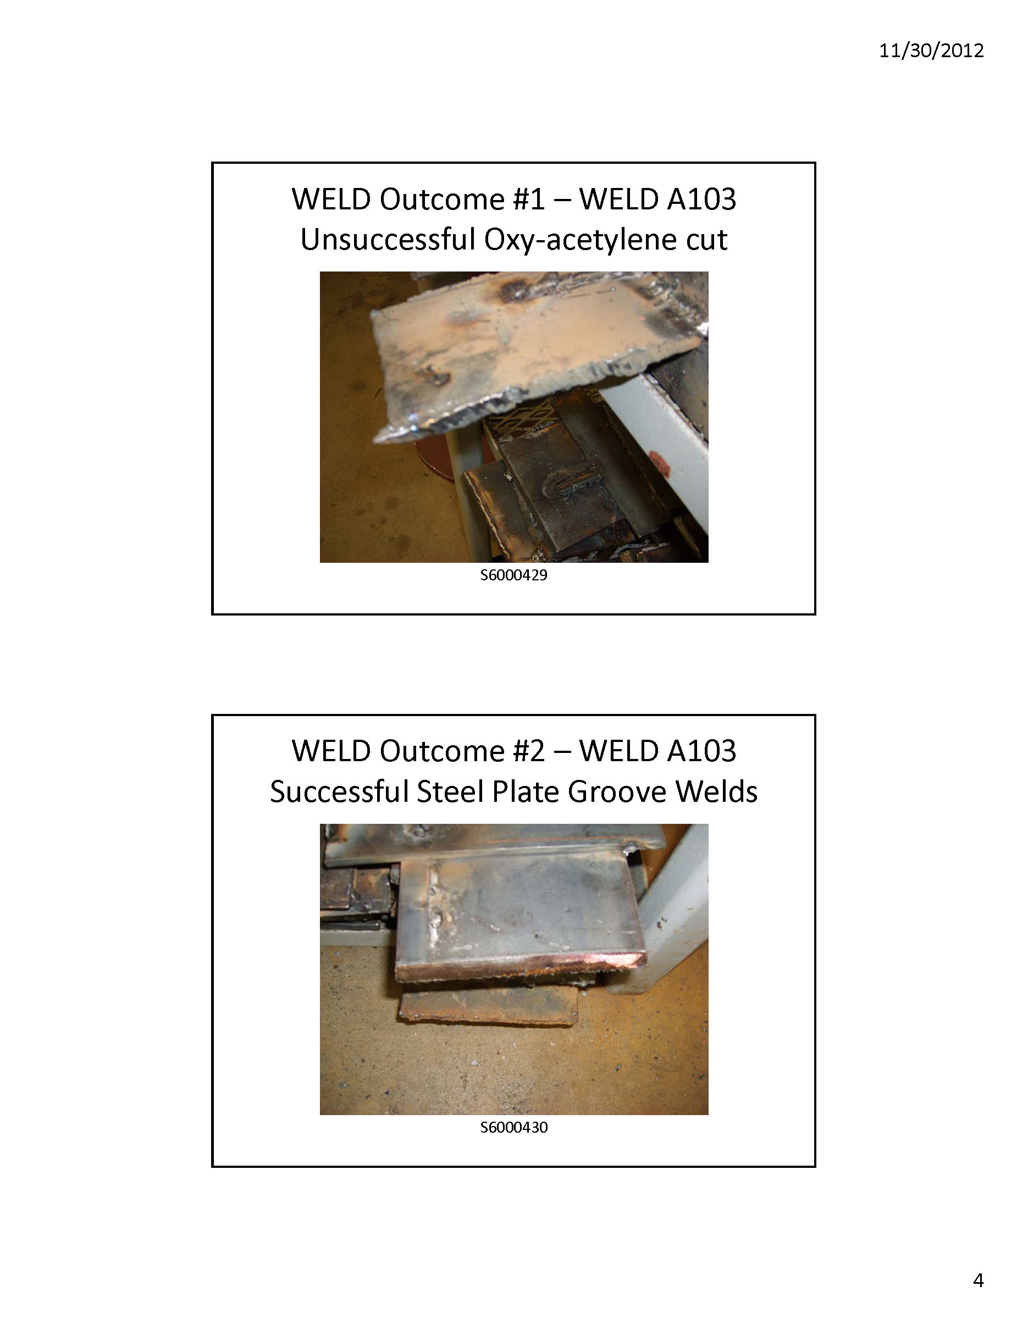

Appendix B: Grade Data (Suspended except for PSLO cover sheet data)

Tool Description:

While many factors may affect a student’s grade in a course, a student’s proficiency in the subject matter is generally indicated by the grade that the student earns in the course. A student’s proficiency in a subject area can be determined by looking at the student’s grades in all relevant courses. When looking at the proficiency of the student body as a whole, the course GPA may give an indication of the proficiency of the students and the quality of the course.

To evaluate many of its educational goals, the Welding Technology program will maintain a database of course grade point averages (GPA’s) each semester and a historical graph of these GPA’s. Courses to be included in the database are those courses that apply to the Welding Technology program and are taught by the UAA Community and Technical College. The course instructor’s name and the number of students in the course are to be clearly associated with each course GPA record and on the graph.

Factors that affect the collected data:

In evaluating the resulting data it must be noted that the factors influencing course GPAs are numerous and difficult to separate. Some of the factors include the preparation and basic academic abilities of the student, the quality of the presentation of the material by the instructor, the quality of reference material, student participation, and the grading philosophy of the instructor.

How to interpret the data:

The data will not be a very precise indicator of student performance until the faculty come to a consensuses regarding grading philosophy and performance standards. Spikes and dips in the data should be viewed in relation to the instructors who where assigned to the courses. As with other data, this should be compared with other data used to assess the same outcomes.

Sample data: (this is only sample data – not actual data for any particular course)

WELD 103 – Arc Welding | Student Statistics
Average Grade | 3.36
# Passed | 18
# Audits | 2
# Failed/Withdrawn | 2
# Incompletes | 1
Tabulating and Reporting Results:

The staff prepares a summary of grade data on all Welding courses taught each year, by section. The staff also computes the GPA, for the year, over the course groupings identified below.

This tool is currently suspended and the PSLO Data Collection Cover Sheet is used instead.

Appendix C: Welding Certification Test Results

Tool Description:

Welding Certification Test Results

AWS D1.1 structural
ASME Section IX pipe welding

Factors that affect the collected data:

The Welding Certification test is conducted by a nationally certified welding tester and should be an accurate reflection of skill level for this outcome.

How to interpret the data:

A passing result on a certification test indicates completion and mastery of this outcome.

This is a national certification and therefore no sample is included in this packet.

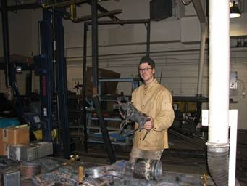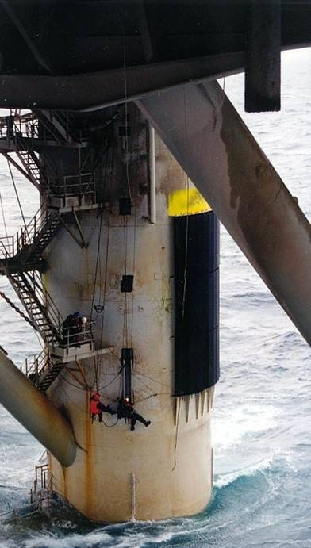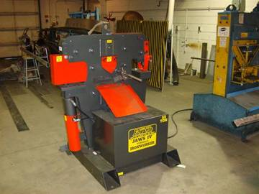

Appendix D: Exit/Graduate (Alumni) Survey

Tool Description:

The exit survey asks graduates of the program to rate their performance relative to the program’s outcomes. Additionally, graduates are asked to rate the program’s delivery of the material related to the objectives from their viewpoint. A sample of the survey instrument is included on the following pages.

Surveys may be distributed to students when they apply for graduation, or later by mail. The students return the surveys by mail or to the staff. The results are not examined until after graduation.

Factors that affect the collected data:

A number of factors need to be taken into consideration when analyzing the data. The following factors are those that we have identified.

- Low return rates. It has proven difficult get a good return rate from the graduates. This reduces the accuracy of the results.
- Timing may be an issue. Most students are given the survey before embarking on their final semester. They have not yet completed the program or have had the chance to apply their education in the capstone course.

How to interpret the data:

Care should be taken to investigate and discuss the factors influencing the results before interpreting the results. The results of the surveys should also be compared against the other indicators to get good picture of program performance relative the expected outcomes.

Sample Survey:

A sample survey is provided on the next page. An electronic version may be developed to replace this version. The questions and data collected will be the same.

Tabulating and Reporting Results:

The survey is prepared by the faculty. The survey is administered by the staff. Staff receives the results and tabulates them for use in faculty outcomes review.

Welding Technology Certificate Program
Spring 2008 Exit/Graduate (Alumni) Survey (suspended)

The Welding Technology program has received mandates from the university to implement an outcomes-based assessment program. As a part of the program, we are surveying graduating students to find ways of improving our program. Your feedback will go a long way in helping us determine how well we are doing and what we can do to better serve our students, alumni, and the engineering community. Please return in the provided envelope. These surveys will be opened after our Spring final exam week.

Please enter the year that you received your certificate _________

Have you accepted a permanent Welding Technology position? □ Yes □ No

Primary Welding Technology Field that you hope to work in:

Welding Shop Machine Shop Construction
Oil Field Water & Wastewater
No Welding Technology function
Other Welding or Mechanical Technology: ___________________________

The KPC Welding Technology Certificate program has adopted six expected outcomes, please rate your knowledge/skills and the program’s effectiveness in teaching you knowledge/skills relative each objective.

The graduates of the KPC Welding Technology program will have the ability to:

 |  | Importance of this objective to your employment |  |  |  |  |  | How well are you able to function in this objective
 |  | Not Important | Somewhat Important | Important | Very Important | Extremely Important |  | Unacceptable | Poor | Good | Very Good | Outstanding
1 | the oxy-acetylene cutting process | □ | □ | □ | □ | □ |  | □ | □ | □ | □ | □
2. | the preparation of steel plate certified groove welds | □ | □ | □ | □ | □ |  | □ | □ | □ | □ | □
3. | the welding of steel-plate all position groove welds | □ | □ | □ | □ | □ |  | □ | □ | □ | □ | □
4. | the oxy-acetylene cutting process of steel pipe (both with freehand and machine cutting) | □ | □ | □ | □ | □ |  | □ | □ | □ | □ | □
5. | the preparation of steel pipe to be welded with the stick-electrode process for common sizes of pipe used in industry | □ | □ | □ | □ | □ |  | □ | □ | □ | □ | □
6. | the welding of steel pipe per Procedure KPC-I for testing and will also have welded common schedules and sizes of pipe used in industry | □ | □ | □ | □ | □ |  | □ | □ | □ | □ | □

How would you rate the overall preparation of KPC Welding Technology graduates to: | No Opinion | Extremely Satisfied | Very Satisfied | Satisfied | Somewhat Satisfied | Not Satisfied
be a welder or mechanical technician? | □ | □ | □ | □ | □ | □
compete professionally as a welder or mechanical technician? | □ | □ | □ | □ | □ | □

 | Yes |  | No |  | Maybe
Would you recommend KPC welding technology education to a friend or relative? | □ |  | □ |  | □

Please indicate your satisfaction with each of the following aspects of your experience at UAA/KPC. Please feel free to use the space after the list to briefly explain any of your responses, especially if you feel less than satisfied.

Quality of the Advising: □ poor, □ fair, □ good, □ excellent, □ outstanding, □ No opinion

Quality of Instruction: □ poor, □ fair, □ good, □ excellent, □ outstanding, □ No opinion

Quality of Physical Facilities: □ poor, □ fair, □ good, □ excellent, □ outstanding, □ No opinion

Quality of Computer Laboratories: □ poor, □ fair, □ good, □ excellent, □ outstanding, □ No opinion

Quality of Physical Laboratories: □ poor, □ fair, □ good, □ excellent, □ outstanding, □ No opinion

Optional Explanations:
Please list up to three major strengths of your welding technology education or other UAA/KPC experiences.

Please list up to three areas for improvement in KPC’s Welding Technology program or other aspects of KPC.

With respect to the previous question, do you have any suggestions on how KPC could address these improvements?

Appendix E: Employer Survey (suspended)

Tool Description:

The employer survey asks employers to rate the performance of their employees who have graduated from UAA relative to the program’s objectives. Additionally, employers are asked to rate the importance of the program objectives from their viewpoint. A sample of the survey instrument is included on the following pages.

Employers of our graduates are obtained from Alaska Department of Labor reports, faculty lists in industry contacts, or other local means. Approximately third of the employers are surveyed each year, not to exceed more than one printed survey per three years per employer. The results are gathered by the school staff.

Factors that affect the collected data:

A number of factors need to be taken into consideration when analyzing the data. The following factors are those that we have identified.

- Low return rates. It has proven difficult get a good return rate from the employers, even with follow up phone calls. This reduces the accuracy of the results.
- Some employers resent or are bombarded by surveys and will not fill them out.
- Some classification groups may not respond to the survey. The result is that the data is skewed to the viewpoint of a subset of the employers of our graduates.
- It may be possible that the employer is not aware of all the UAA graduates in their employ. This leads to an assessment that is not representative across the group.

How to interpret the data:

Care should be taken to investigate and discuss the factors influencing the results before interpreting the outcome. The results of the surveys should also be compared against alumni surveys to get good picture of program performance. Be aware that there is not a direct connection in the two surveys between the employers and the alumni that work for them.

Sample Survey:

A sample survey is provided on the next page. An electronic version may be developed to replace this version. The questions and data collected will be the same.

Tabulating and Reporting Results:

The survey is prepared by the faculty. The survey is administered by the staff. Staff receives the results and tabulates them for use in faculty outcomes review.

UAA /Kenai Peninsula College
Certificate of Welding Technology
2008 Employer Survey (suspended)

The UAA/Kenai Peninsula College Certificate of Welding Technology Program has received mandates from the University and to implement an outcomes-based assessment program. As a part of the program, we are surveying alumni and employers of alumni to find ways of improving our program. Your feedback will go a long way in helping us determine how well we are doing and what we can do to better serve our students, alumni, and the Process Industries. Please contact Fritz Miller at Kenai Peninsula College Welding Technology Department (907 262-0344) if you have any questions regarding this survey.

The KPC Welding Technology Certificate program has six educational objectives. In this survey, we ask for your opinion relative to each of these four objectives. First, rate how important each is relative to your organization. Please note that importance relates to the needs of your organization and not to the importance of the item as it may apply to other organizations. Second, rate each item relative to how well you think our graduates are able to function relative to each objective. Please feel free to use the space after the list to briefly explain any of your responses, especially if you feel the preparation of the graduates was less than adequate.

The objectives of the KPC Welding Technology Certificate Program are to produce graduates who:

 |  | Importance of this objective to your firm |  |  |  |  |  | How well is the KPC graduate able to function in this objective
 |  | Not Important | Somewhat Important | Important | Very Important | Extremely Important |  | Unacceptable | Poor | Good | Very Good | Outstanding
1. | the oxy-acetylene cutting process | □ | □ | □ | □ | □ |  | □ | □ | □ | □ | □
2. | the preparation of steel plate certified groove welds | □ | □ | □ | □ | □ |  | □ | □ | □ | □ | □
3. | the welding of steel-plate all position groove welds | □ | □ | □ | □ | □ |  | □ | □ | □ | □ | □
4. | the oxy-acetylene cutting process of steel pipe (both with freehand and machine cutting) | □ | □ | □ | □ | □ |  | □ | □ | □ | □ | □
5. | the preparation of steel pipe to be welded with the stick-electrode process for common sizes of pipe used in industry | □ | □ | □ | □ | □ |  | □ | □ | □ | □ | □
6. | the welding of steel pipe per Procedure KPC-I for testing and will also have welded common schedules and sizes of pipe used in industry | □ | □ | □ | □ | □ |  | □ | □ | □ | □ | □

How would you rate the overall preparation of KPC Welding Technology graduates to: | No Opinion | Extremely Satisfied | Very Satisfied | Satisfied | Somewhat Satisfied | Not Satisfied
be a welder or mechanical technician? | □ | □ | □ | □ | □ | □
compete professionally as a welder or mechanical technician? | □ | □ | □ | □ | □ | □

 | Yes |  | No |  | Maybe
Would you recommend KPC welding technology education to a friend or relative? | □ |  | □ |  | □

Please list up to three major strengths of your KPC Welding Technology employees.

Please list up to three areas for improvement in our Welding Technology programs or other aspects of KPC.

With respect to the previous question, do you have any suggestions on how KPC could address these improvements?

What can the KPC Welding Technology program do to better serve the needs of your organization?

Demographics:

Type of Organization:
Federal Gov. State Gov. Design Consulting
Construction Sales Other Consulting
Educational Testing/Reliability Research & Development
Other: ________________________________________

Welding Technology or related Field(s) that your firm works in (check all that apply):
Welding Shop Machine Shop Construction
Oil Field Water & Wastewater
No Welding Technology function
Other Welding or Mechanical Technology: ___________________________

Primary Job Function of Welding Technology graduates (check all that apply):
Mechanic
Welder
Operator
Other: __________________________

Number of total employees at your work site:
< 10 10 – 25 26-50 51-100 101-500 501-1000 > 1000

Approximate number of employees with UAA Welding Technology Certificate at your work site:
< 10 10 – 25 > 25

Number of total employees at worldwide sites: no other sites
< 10 10 – 25 26-50 51-100 101-500 501-1000 > 1000

Thank you for taking the time to complete this survey. Please return it in the enclosed self addressed, stamped, envelope to:

Kenai Peninsula College
34820 College Drive
Soldotna, AK 99669

Appendix F: Instructor Impression Survey
(Added as questions to KPC’s PSLO data collection cover sheets)

Tool Description:

Instructors will receive the tabulated results of the student impression data (student course-level assessments). The instructor will evaluate the course based on the same course-level outcomes that the students rated.

Instructors will evaluate outcomes for each course he or she teaches and express his or her opinion of how well that outcome was taught and/or received by the students. Instructors will also indicate the value of each outcome to the overall objectives of the program.

Factors that affect the collected data:

In evaluating the resulting data it must be noted that the factors influencing an instructor’s impression or opinion will be subjective. Welding Tech faculty should meet to discuss the significance of any impressions, opinions, and recommendations, and include any actions or recommendations in the assessment plan report.

Sample Survey: can be found in the KPC Assessment folder – both tabulated student data, grade data, and class statistics, as well as the instructor impression surveys for each course.

Tabulating and Reporting Results:

The staff prepares a survey for each course to be completed by the instructor of each course. The staff (and/or assessment coordinator) will tabulate results if appropriate (for courses with more than one section taught in a given semester), or provide the assessment to the Welding Tech faculty to review.

Appendix G: Course Groupings Associated With Each Outcome
WELDING PLAN OUTCOMES “LAST PAGE”
The specific educational student learning outcomes that support the program are to produce graduates who demonstrate competence in:

Outcome #1: the oxy-acetylene cutting process

WELD 101 – Gas & Arc Welding (structural)
WELD 102 – Gas Welding (structural)
WELD 103 – Arc Welding (structural)
WELD 104 – Arc Welding: Low-Hydrogen Electrodes (structural)

Outcome #2: the preparation of steel plate certified groove welds

WELD 103 – Arc Welding (structural)
WELD 104 – Arc Welding: Low-Hydrogen Electrodes (structural)

Outcome #3: the welding of steel-plate all position groove welds

WELD 103 – Arc Welding (structural)
WELD 104 – Arc Welding: Low-Hydrogen Electrodes (structural)

Outcome #4: the oxy-acetylene cutting process of steel pipe (both with freehand and machine cutting)

WELD 105 – Pipe Welding (pipe)
WELD 106 – Pipe Certification (pipe)

Outcome #5: the preparation of steel pipe to be welded with the stick-electrode process for common sizes of pipe used in industry

WELD 105 – Pipe Welding (pipe
WELD 106 – Pipe Certification (pipe)

Outcome #6: the welding of steel pipe per Procedure KPC-I for testing and will also have welded common schedules and sizes of pipe used in industry

WELD 106 – Pipe Certification

Note: These elective courses have not yet been placed in the outcomes by faculty

WELD 108 – Wire Welding (primarily aluminum & for boat shops & Coast Guard Certification)
WELD 109 – TIG Welding
WELD 207 – Industrial Welding Qualification

NOTE: All students must pass structural and pipe certification tests before receiving a certificate in Welding Technology.

