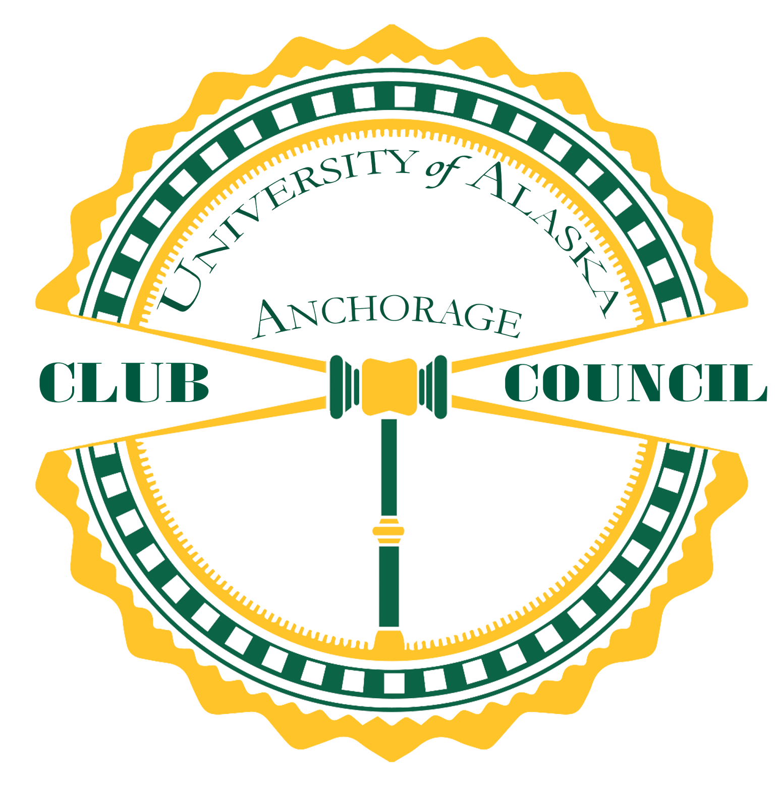
Club Council Meeting Minutes
Student Union South Cafeteria | 1:00PM
February 9th, 2018

- CALL TO ORDER 1:05pm
- APPROVAL OF AGENDA approved
- APPROVAL OF PREVIOUS MEETING’S MINUTES approved
    - Attendance waivers
      - Seawolf Cadet Club
      - Anime Club
    - Funding requests
      - Black Student Union
      - Seawolf Touch Rugby Club
      - Management and Marketing Club
      - Pre-Dental Society
- PERSONS TO BE HEARD
  - Mae Ditty- Alaska Democratic Party: Municipality Election’s deadline is on March 2nd 2018. To register to vote you need to register before that deadline or you will not get a ballad to vote this year. Seeking clubs and student organizations to collaborate with the Voter Registration Workshop. Please contact Mae Ditty at 907-947-4500 or email, mliditty@gmail.com.
  - Jennifer Weisel- Alumni Association; 9 in the Spine (Scholarship Fundraiser): Event is on Feb 28th, 2018. Alumni needs a total of 18 student clubs to help with 9 in the Spine. Your club would design a hole and get reimburse up to $100. 12 clubs registered currently, 6 more is needed. Sign-up at the Alumni Center.
- NOTES FROM THE CHAIR
  - This is a long meeting
- BUDGET REPORT
  - Amount Remaining: $10,071.03
  - Total Awarded: $12,595.18
  - Maximum: $2,556.40
  - Accessibility: $1,000
- USUAA REPORT
  - Rose Kruger: Addressing UA Budget and further planning for Little Black Dress.
- LEADERSHIP COORDINATOR
  - Cody Buechner/Jane Mastre
    - Student Commencement Speaker Deadline February 23, 2018. (Graduate Students Only). Student Life and Leadership is still looking for applicants for the large Student Commencement Ceremony and a graduate student for the Graduate Hooding Ceremony. Applications available online. Please refer to this link: https://www.uaa.alaska.edu/students/student-life-leadership/student-leadership/commencement-speaker.cshtml
    - Leadership Honor (Graduation Seniors Only). This honor is bestowed upon the top student leaders at UAA. They will be commemorated at the Spring Commencement Ceremony, receive a crimson honor cord, as well as a permanent notation on their academic transcript. Please visit this link for more information: https://www.uaa.alaska.edu/students/student-life-leadership/student-leadership/leadership-honors.cshtml
    - Seawolf Student Leader and Seawolf Community Service Award (Returning Students Only). These awards provided up to $1,500 in tuition waivers for the following semester. One award for student leadership and the other for community service. For more information please visit this link: https://www.uaa.alaska.edu/students/student-life-leadership/student-leadership/seawolf-student-leader-award.cshtml
    - Student Showcase: Applications for the 2018 Student Showcase are being accepted now through Sunday, February 11th, 2018 at midnight. The Student Showcase Conference will be on Thursday April 5th at 7:15-9:30pm and Friday April 6th at 10:30am-3:30pm. $300 cash prize and Showcase Journal! To apply please visit this link: http://www.uaa.alaska.edu/showcase
- COMMITTEE REPORTS
  - Special Projects Fund: none
  - Concert Board: none
  - Diversity Action Council: Current budget $7,714.00
  - Student Union Advisory Board: We need a representative! The board meets at 10am on Fridays
- NEW BUSINESS
  - Attendance waivers
    - Students United for Israel: The members work Fridays or commute from valley and cannot attend. Waiver approved. Majority of the vote was voted and approved by placards.
    - Chronicles of Yarnia: Members have jobs outside of college cannot attend. Waiver approved. Majority of the vote was voted and approved by placards.
    - Wolfpack Theater Club: Most of the members graduated in Fall 2017 and cannot find more members to attend meetings. Cannot find any replacements currently. Waiver approved. Majority of the vote was voted and approved by placards.
    - Cru in Alaska: The members work, have family and academic responsibilities. Yes 79%, No 19%, and Abstain 2%. Waiver approved.
  - Funding Requests
    - Chi Alpha: Requesting $2,556.40 for rental fees. Yes 68%, No 19%, and Abstain 13%. Approved.
    - Clay Body: Requesting $2,556.40 for NYC travel to visit art museums. Yes 79%, No 19%, and Abstain 2%. Approved.
    - AMSA: Requesting $2,550.00 for Washington D.C. Conference in March 2018. Yes 87%, No 11%, and Abstain 2%. Approved.
    - Psi Chi: Requesting $500 for Brain Bee event. Yes100%, No 0%, and Abstain 0%. Approved.
  - Bylaw Amendment
    - Discussion for Club Council Bylaws; Article Two: Membership, Section Three: Club Responsibilities 1A, “Clubs who fail to meet the re-registration deadline will be retroactively marked absent for any missed CC meetings when they do re-register.”
    - Voting. Yes, to strike and no to keep. Yes 100%, No 0%, and Abstain 0%.
- FOR THE GOOD
- ADJOURNMENT
  - Next Meeting: February 23th, 2018 2:08pm

